Table of Contents

Now we create a demo and download rest assured jars 4

Validate the scope 7

Validate header 8

Creating payload class to replace the body and just call it from there 8

Extract parameter from response and also how to find paths 10

Understanding nested json also use json editor online tool to check parent and child online to find path 14

Making a mock test 15

Build dynamic payload and parametize them so u can change the contents easily from a file 31

Multi arrays 33

Also remember the \\ handling them in eclipse you can use the website 35

Jira 35

How cool it is 8.44 of jira chapter 44 just a diversion that when rahul says it and 15.46 37

Create jira issue 38

Now to delete jira 46

Put in Jira 47

Automating it 52

Sending attachment 56

Now lets use Get to obtain the comments and attachments 61

Now lets check if its correct. 63

Certifications 68

Now we use authentication oauth 2.0 71

Now let automath auth 2.0 77

(shortcut)Now this is a basic way and another method to run the automation to do a get and string faster than the json . 78

The three step is now complete for dealing with auth but one problem rest assured cant handle special characters 86

2nd grant type…client credentials…. 88

Serialization 90

Now pojo code 91

Deserialization 94

External libraries for derilisation 95

DEserilise 107

dynamic way to get it with iteration for loop and if 111

Now get the titles for web automation and print it also use arraylist 112

Serialization 114

# 

# Now we create a demo and download rest assured jars

Now we create a demo

By the way we already have it in

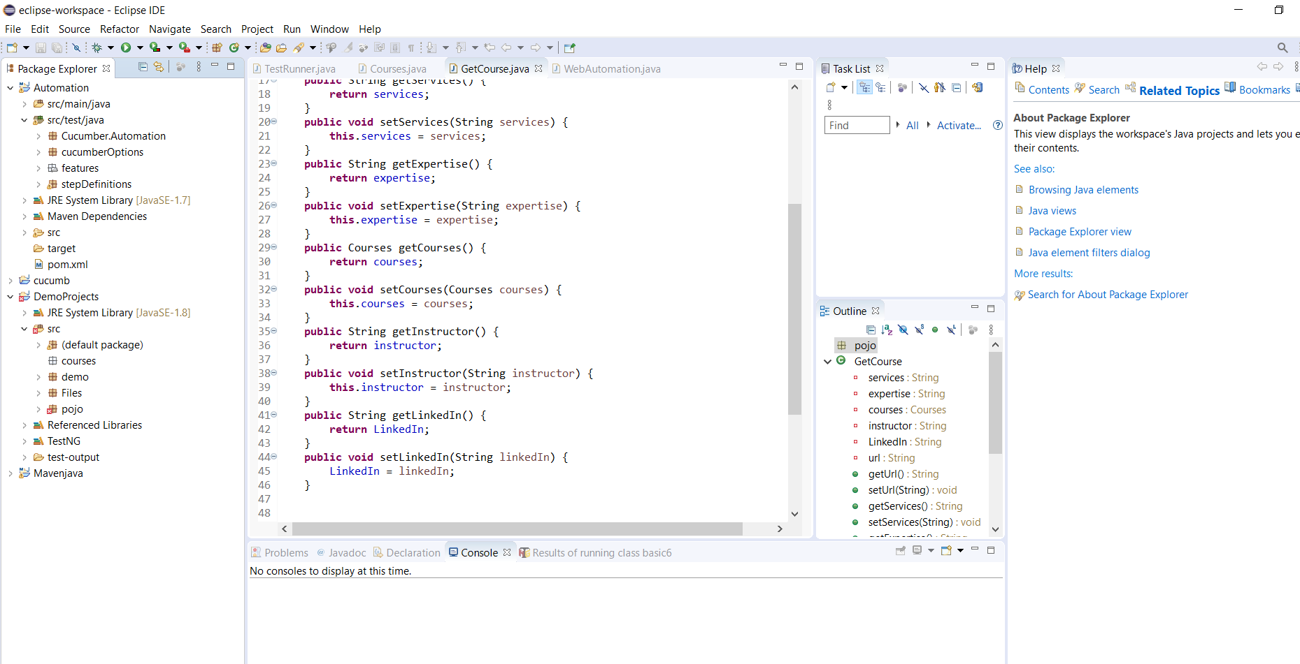

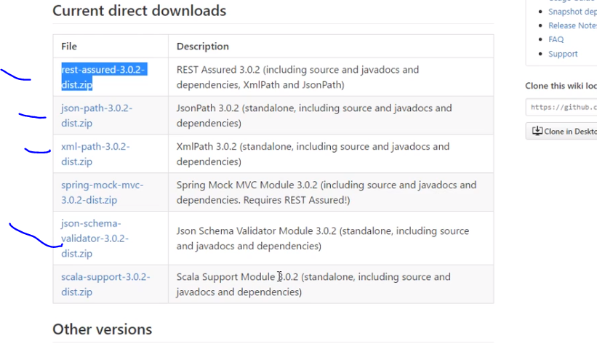

Import all

Now rest api follow this 3 methods

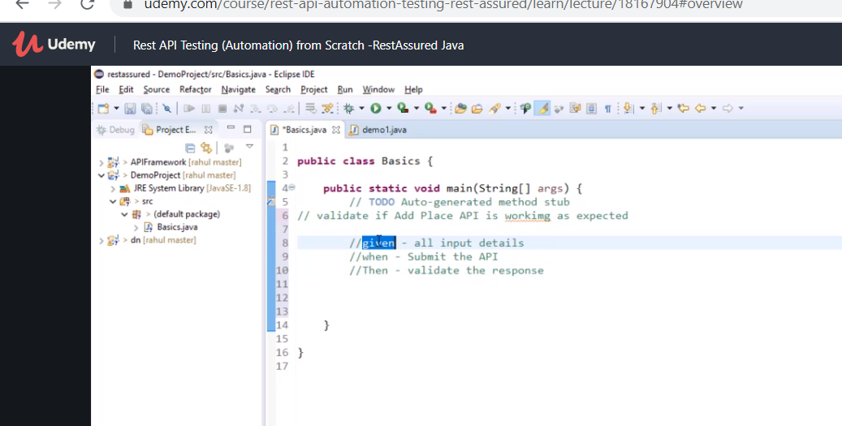

First write base url

Then next add query parameters

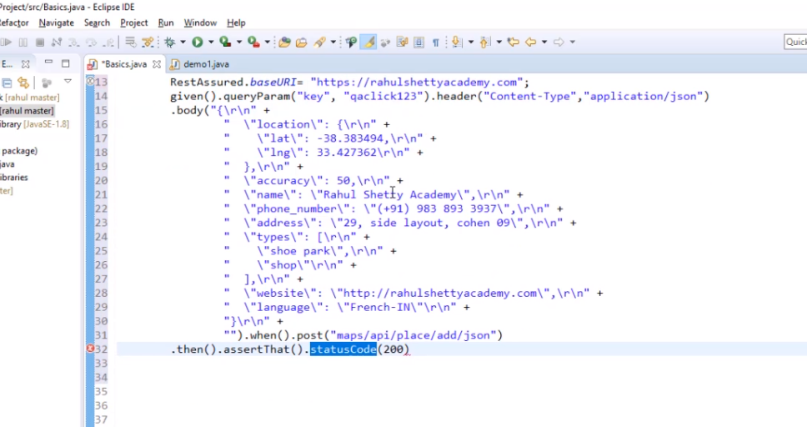

Now we add log to see the imput and output response

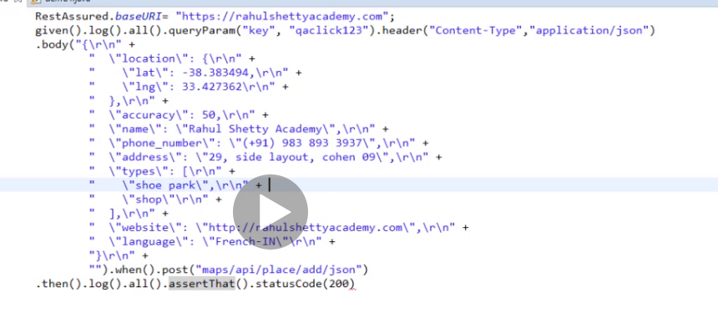

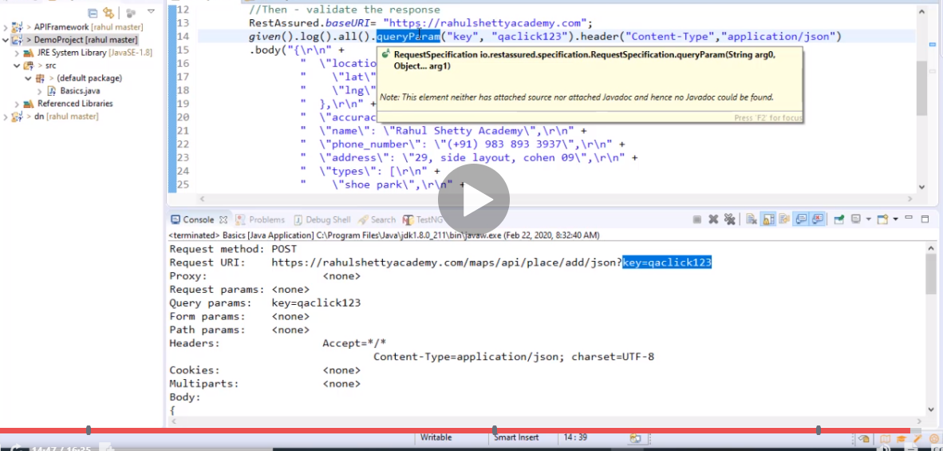

How cool it is

# Validate the scope

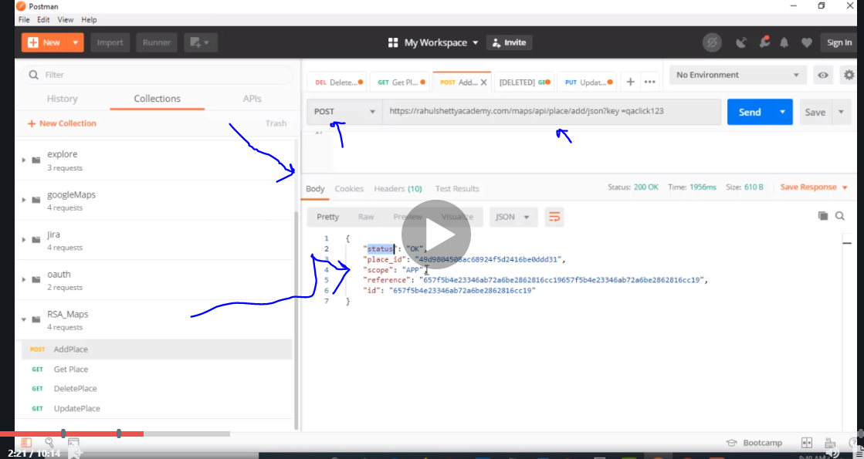

Check scope is equal to app from the body

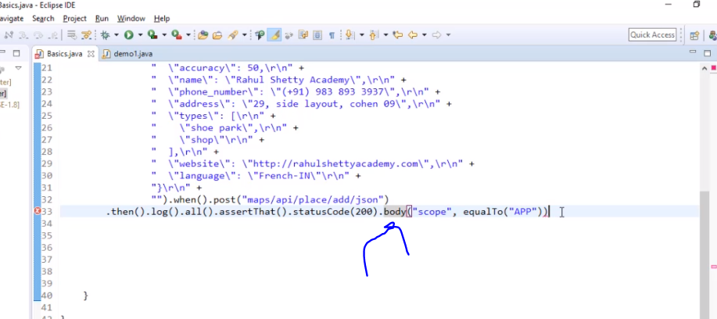

# Validate header

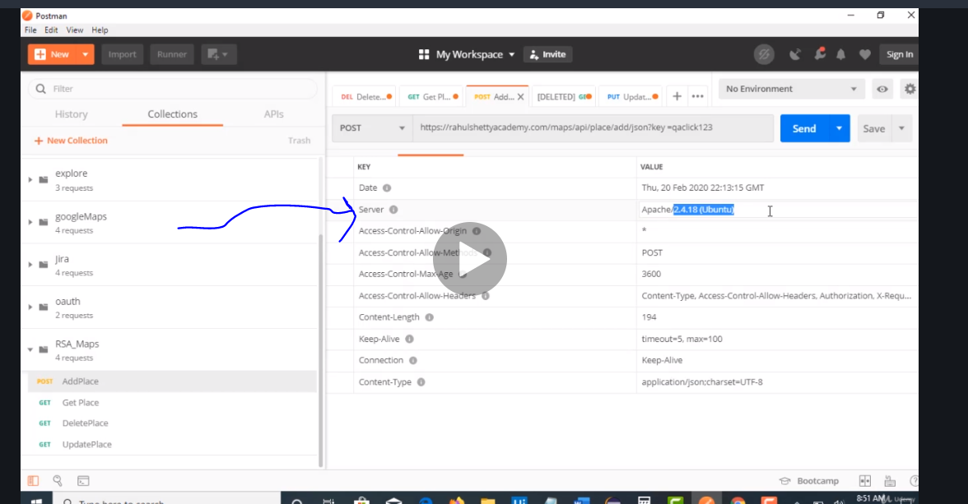

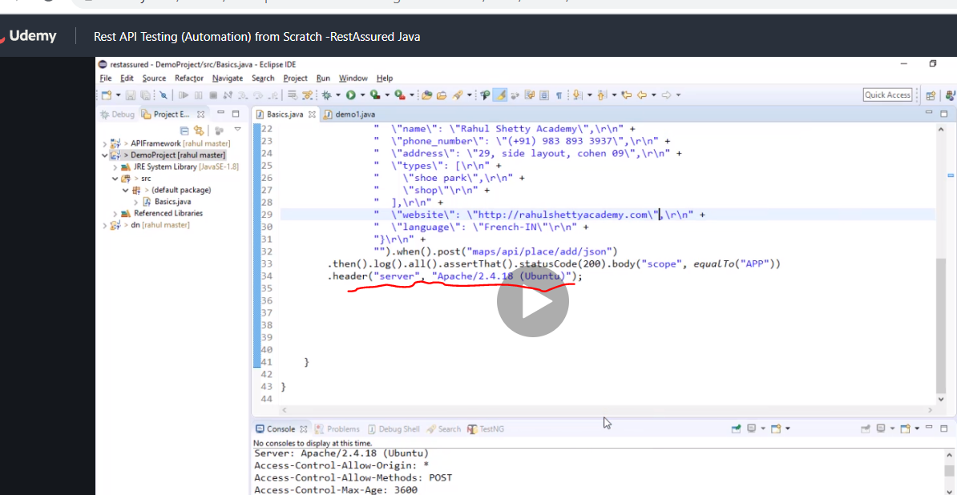

# Creating payload class to replace the body and just call it from there

So all we did is create another file and add a class called payload with the body and now instead of having the body in the main text we have it in payload file and just call it from there

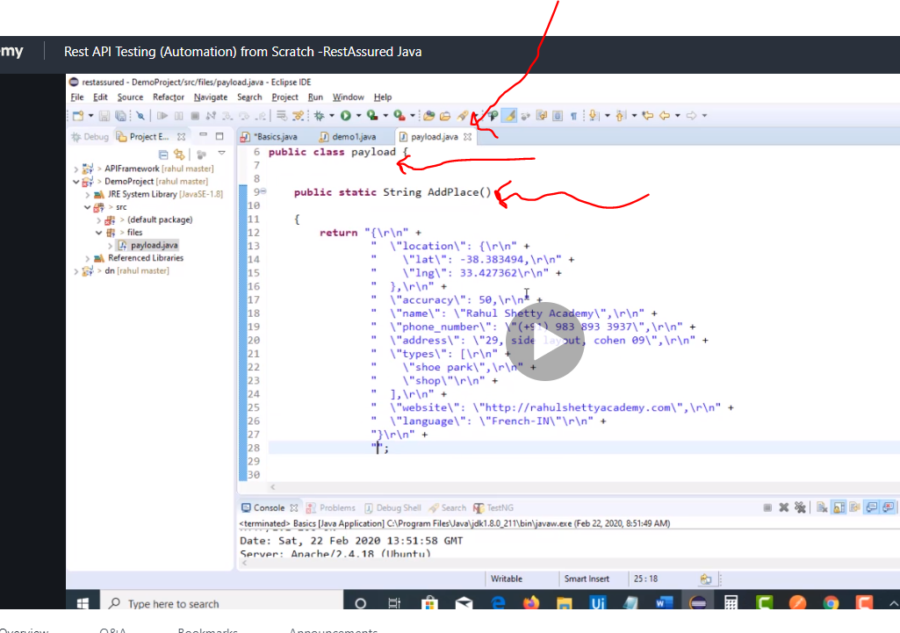

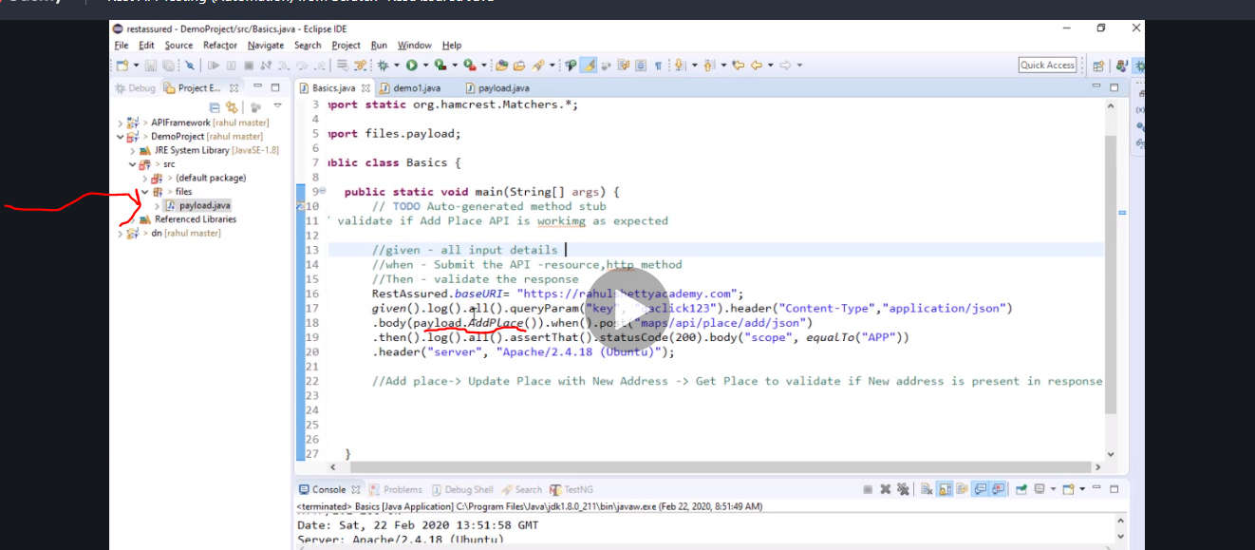

# Extract parameter from response and also how to find paths

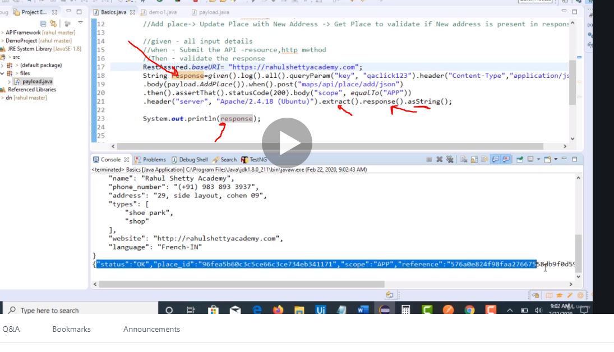

From the response we want to extract placeid

First we convert string response into json response.

We take the path and put it in

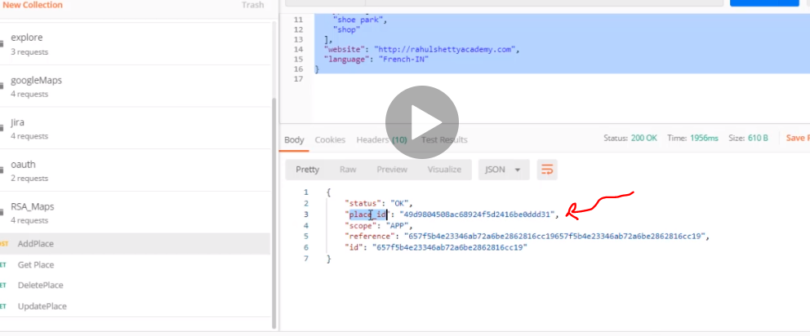

Note here the path is placeid because it has no parent

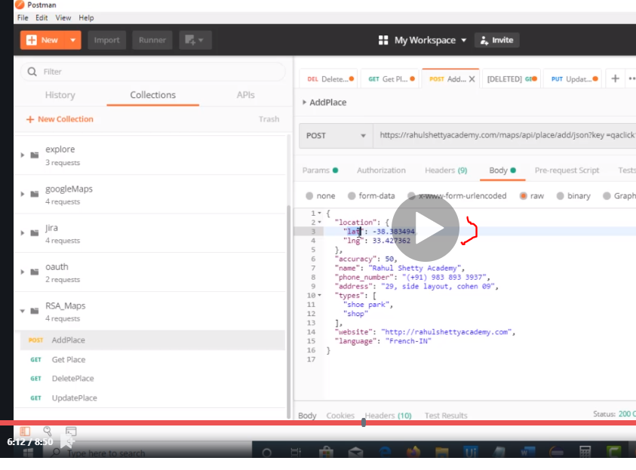

In this case the path is location.lat has a parent location hence location.lat

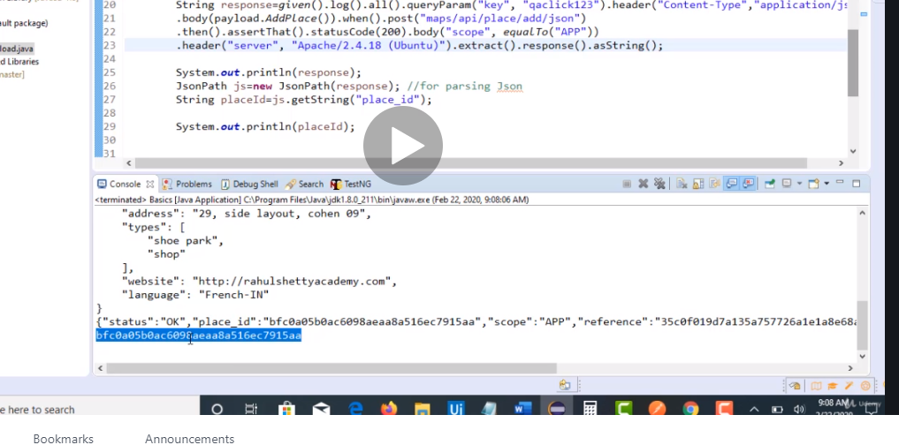

Placeid extracted

Now next we want to update the address so

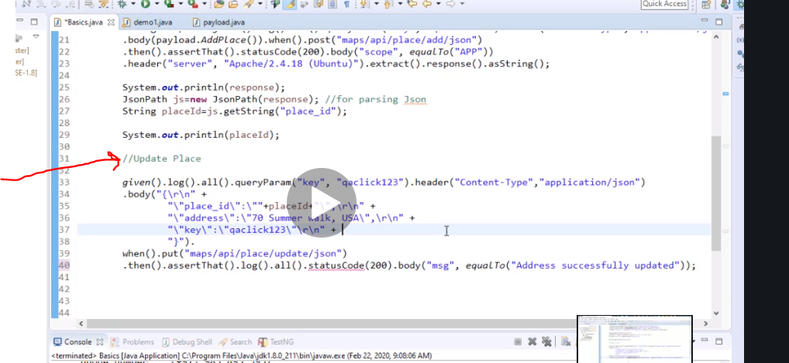

Assertion here is for the body

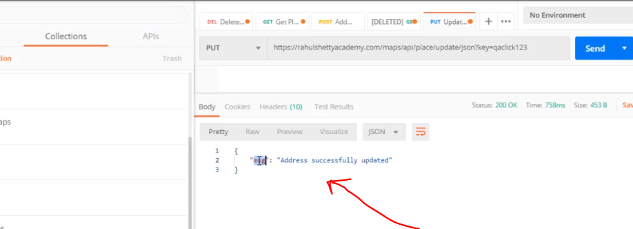

Now we have just updated it but to check

Note if its not post no need for header

But add placeid as query parameter

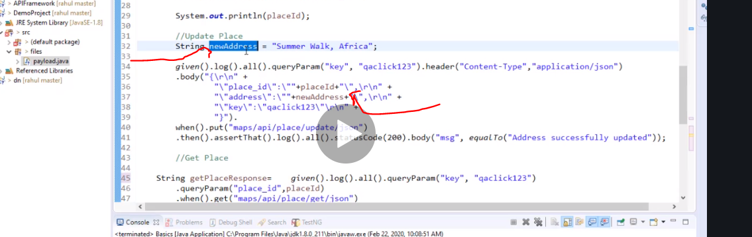

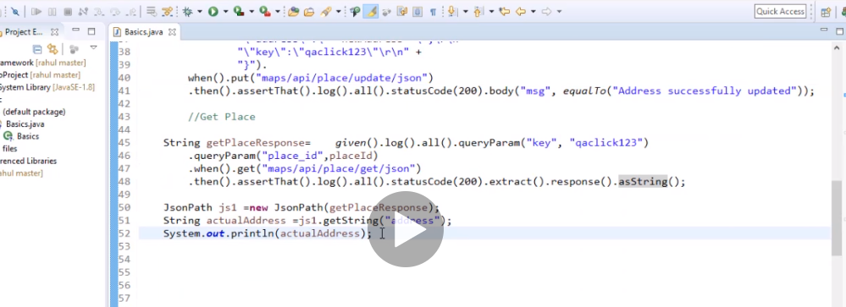

Using testng to validate

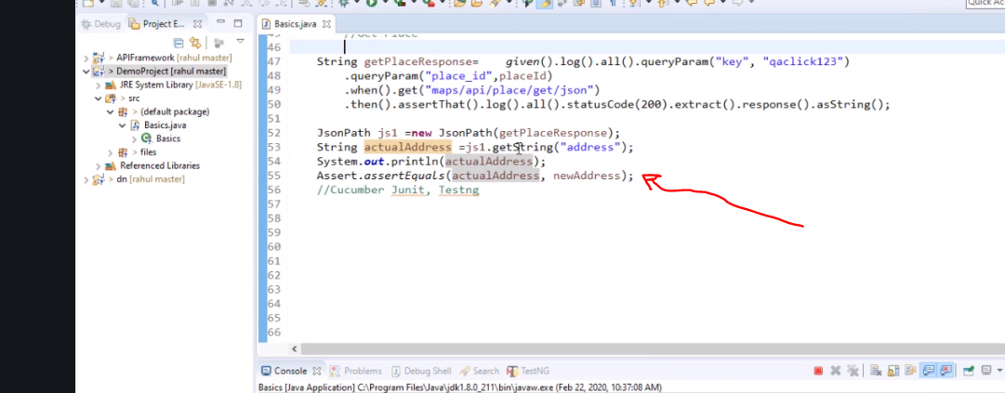

We created reusable method and changed this

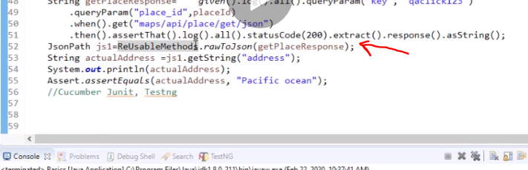

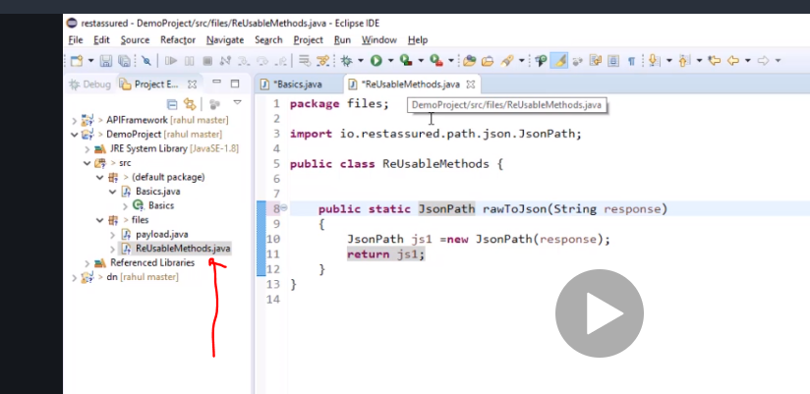

# Understanding nested json also use json editor online tool to check parent and child online to find path

Now we want

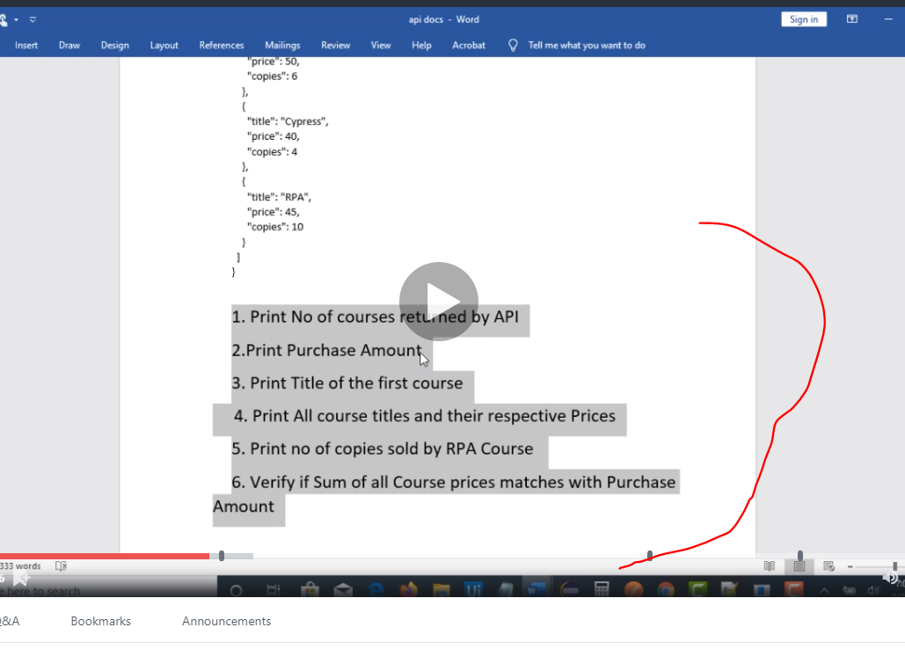

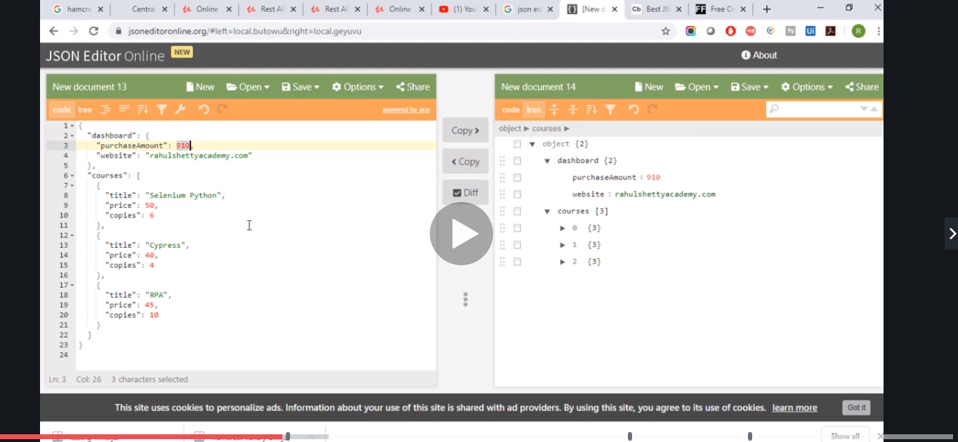

Note when you see [] its an array a collection of elements

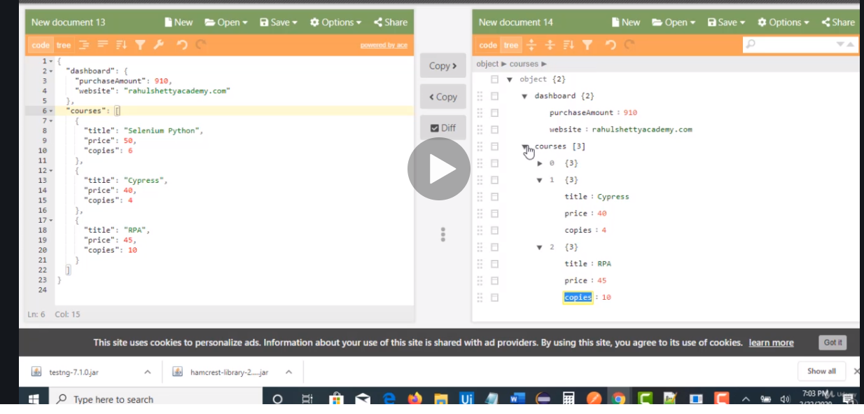

Interprete your json like this first

This is what needs to be done. Use the down triangle as parent to child

# Making a mock test

Now he went to payload created a method, copied and pasted the required like expect format of what the body should look like even before the developers made it

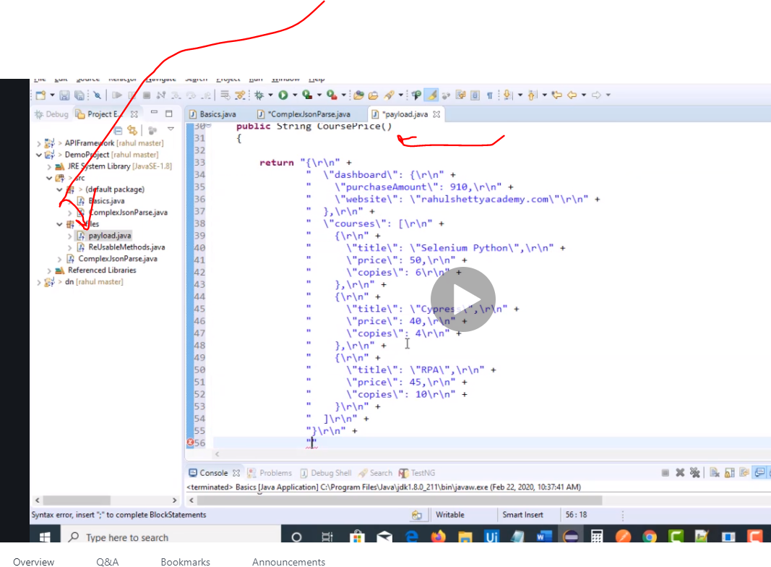

Remember to put column at the end.

Also make it static

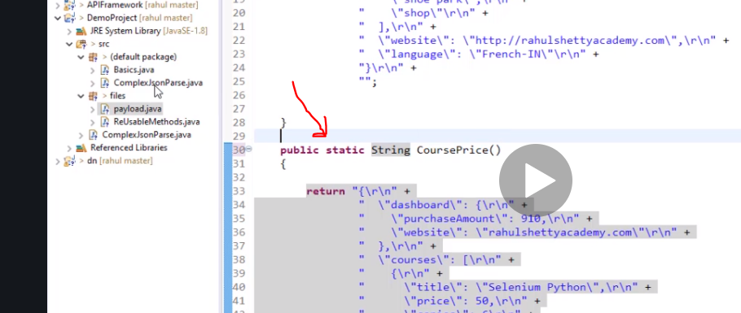

Now you create a class and just put this method in it and you have a mock

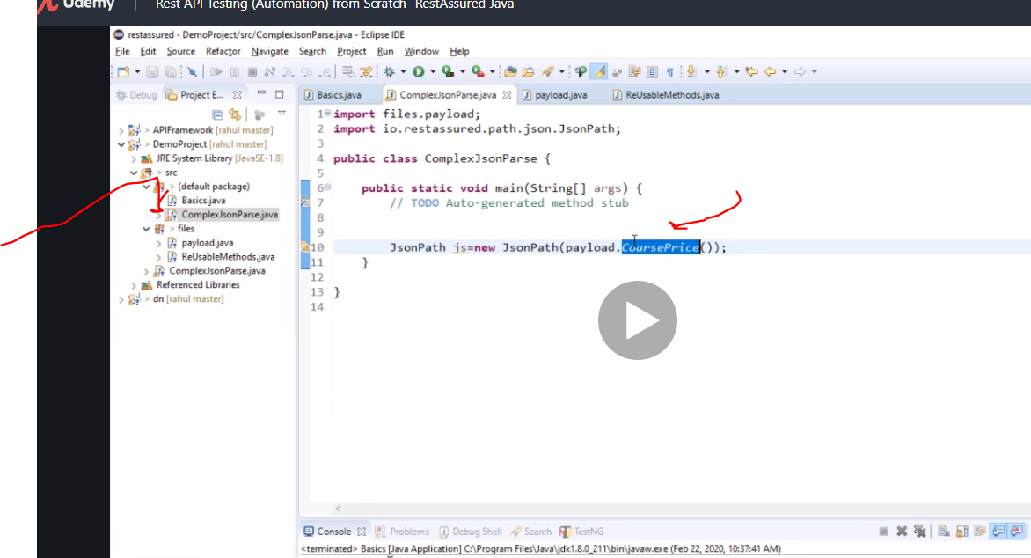

So this was the json copied to courseprice

Json used in this Section with Queries to solve

{

"dashboard": {

"purchaseAmount": 910,

"website": "rahulshettyacademy.com"

},

"courses": [

{

"title": "Selenium Python",

"price": 50,

"copies": 6

},

{

"title": "Cypress",

"price": 40,

"copies": 4

},

{

"title": "RPA",

"price": 45,

"copies": 10

}

]

}

1. Print No of courses returned by API

2.Print Purchase Amount

3. Print Title of the first course

4. Print All course titles and their respective Prices

5. Print no of copies sold by RPA Course

6. Verify if Sum of all Course prices matches with Purchase Amount

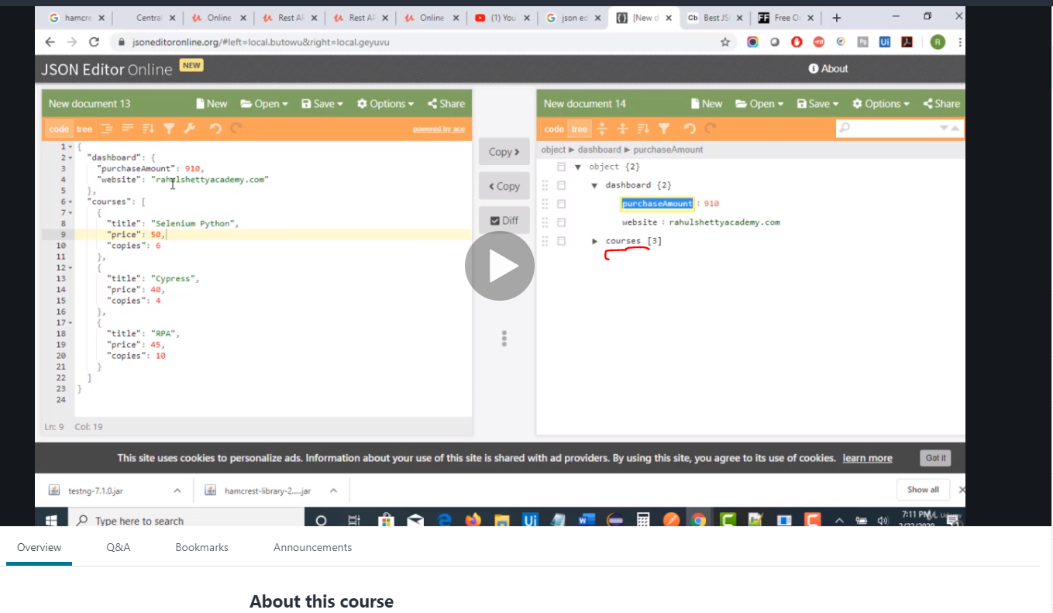

To count courses this method only works for array

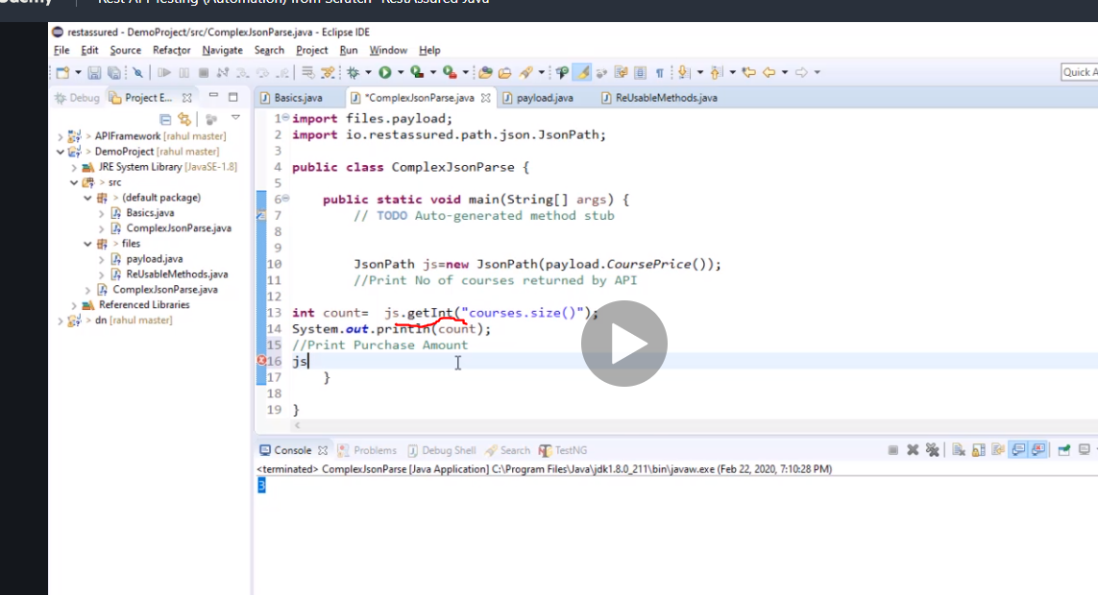

Now the second question is purchase amount so we go from parent to child and get this

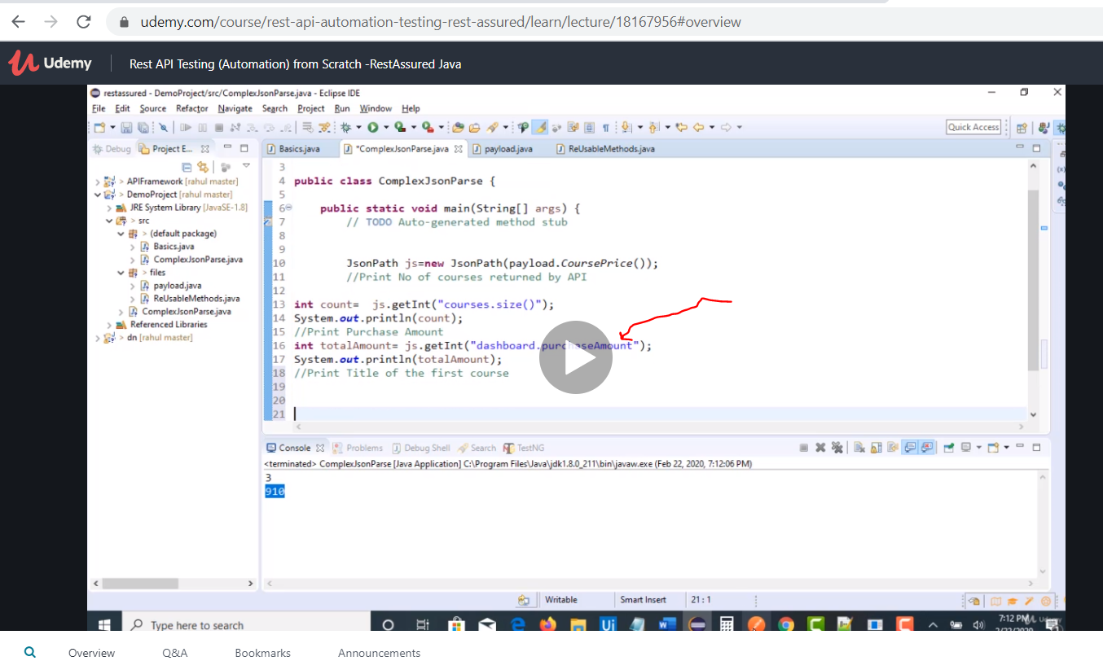

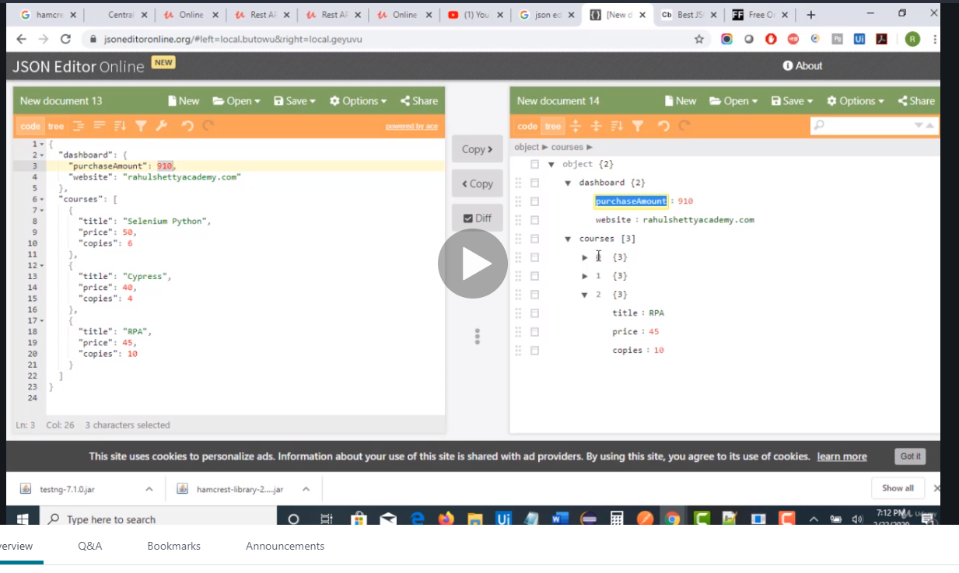next we need to print the title of the first course

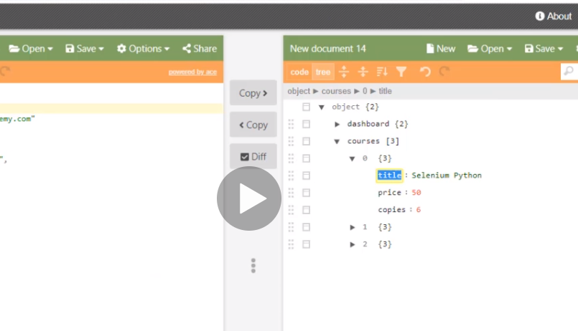

So

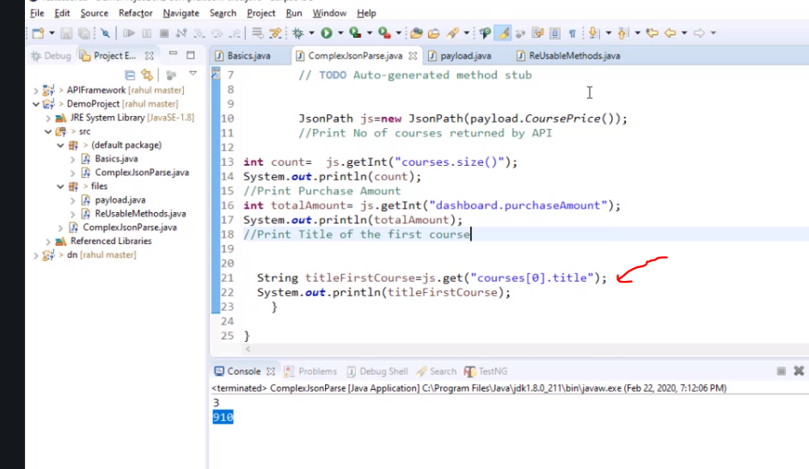

If you want the thrid one just change it [2] for rpa title

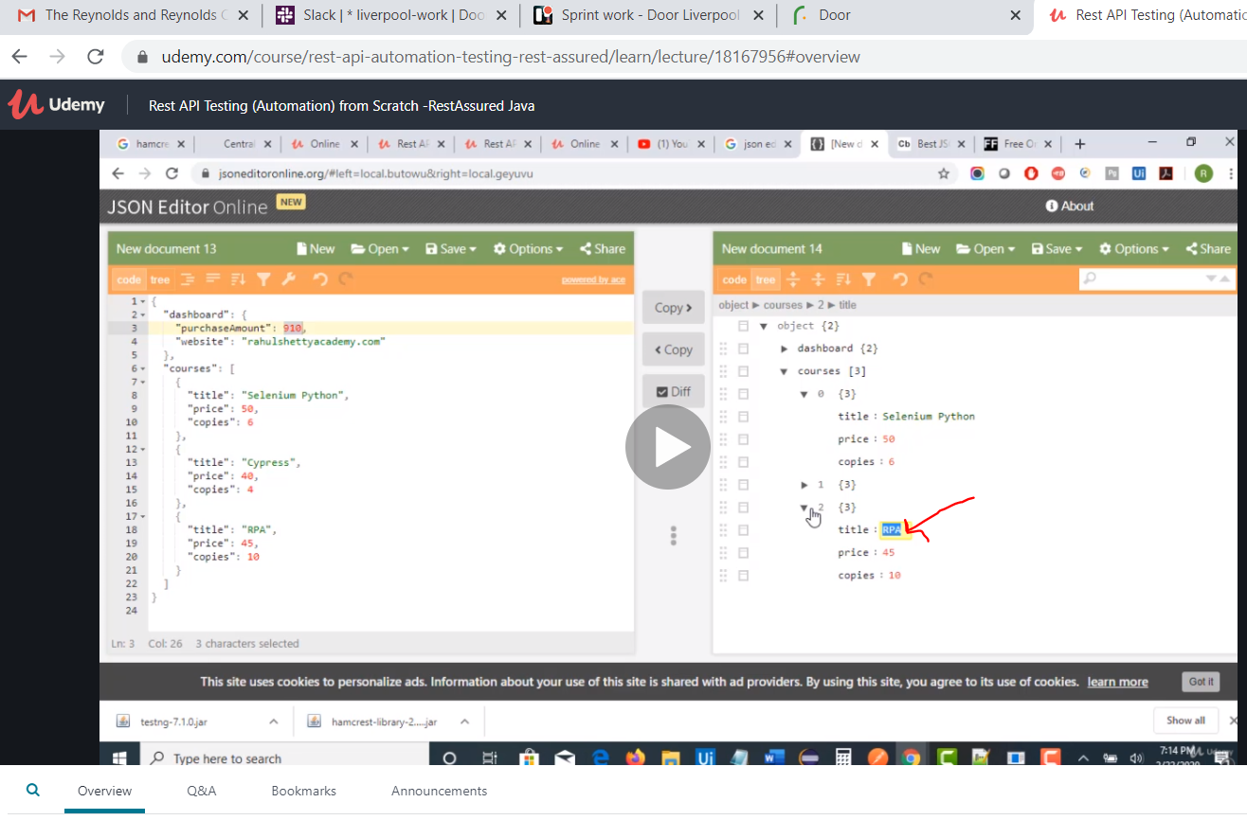

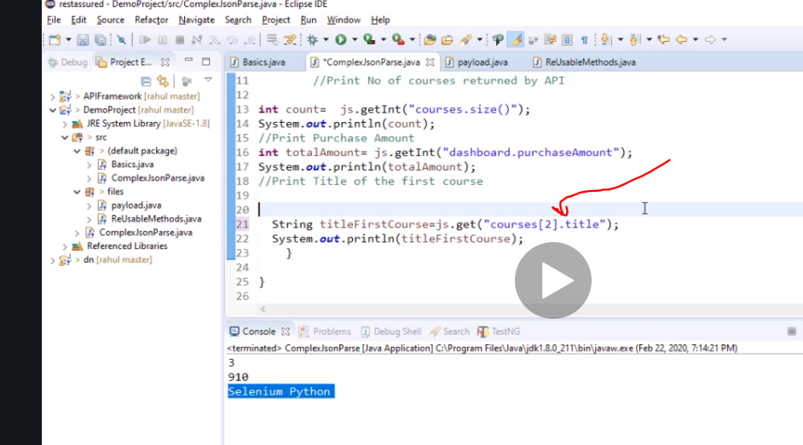

Nested have stuff wrapped in an array

Next we want print the course title and prices…just incase it is dynamic and changes

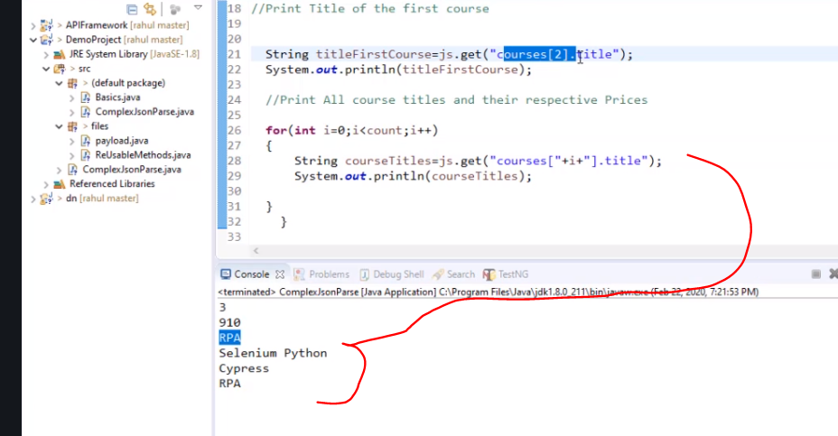

Now print prices

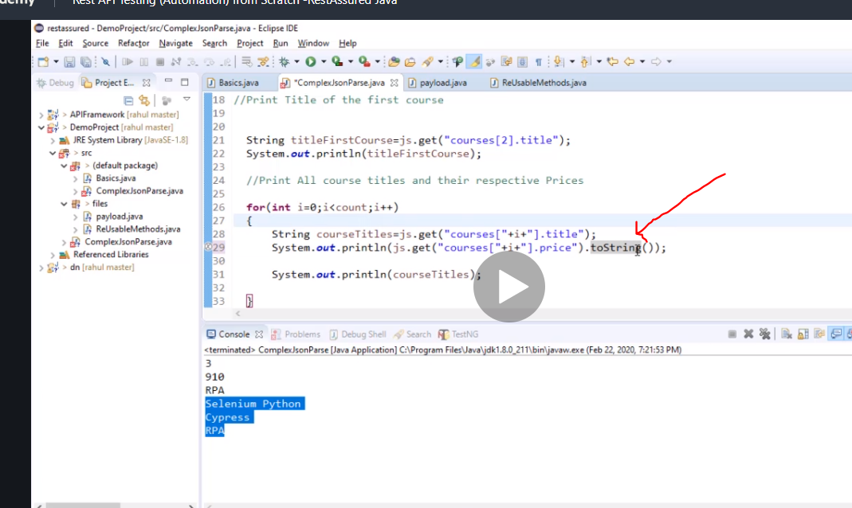

To string converts whatever your answer is to string format so it doesn’t fail

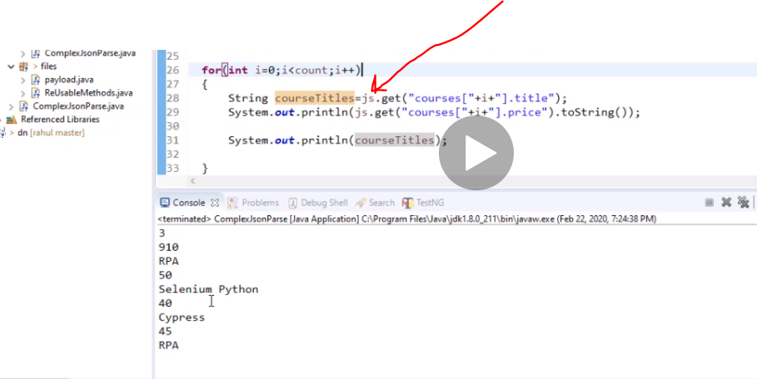

Also notice by doing this we have used one variable to produce two methods

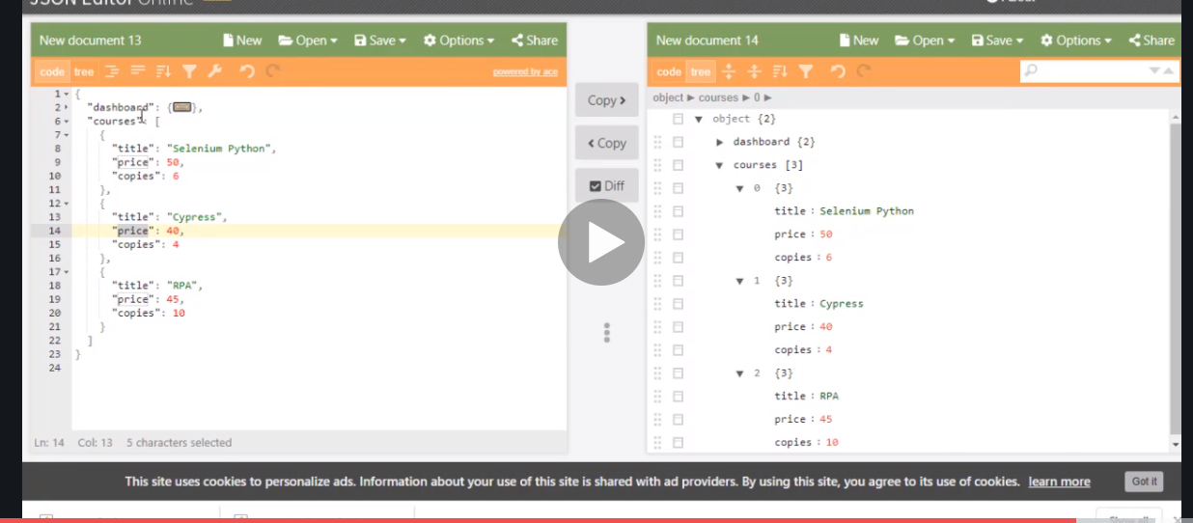

Now add more arrays to it …copy it and paste in your payload save it and run it to see if it dynamically pics it up

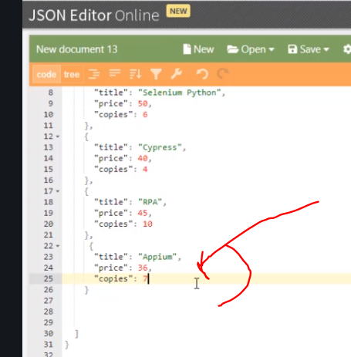

ADD APIUM

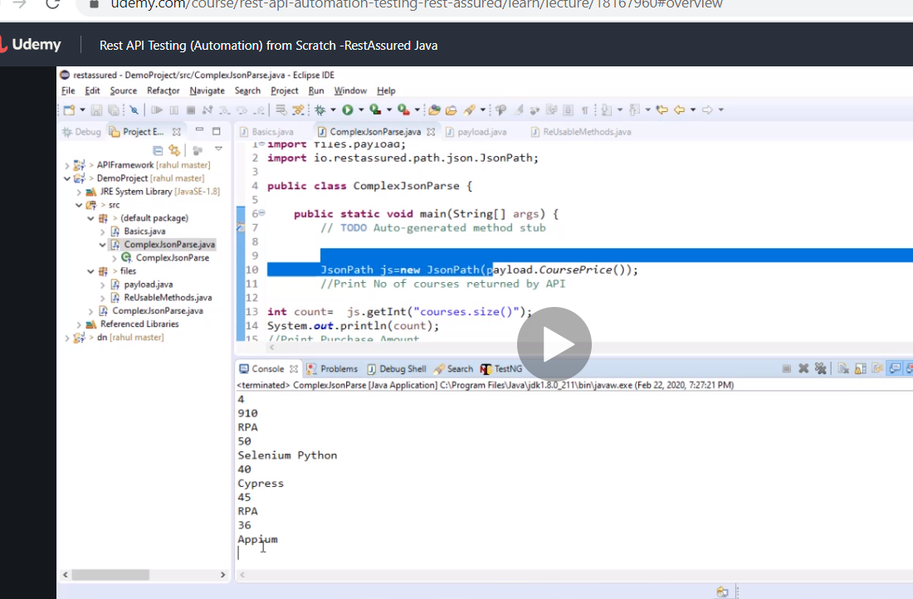

It does

Next we want to print copies sold by rpa

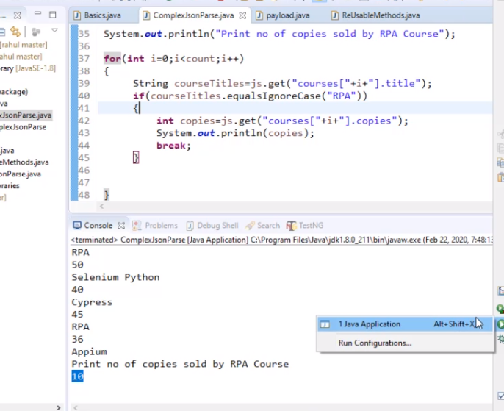

Now verify if some of all new price is equal to purchase amount

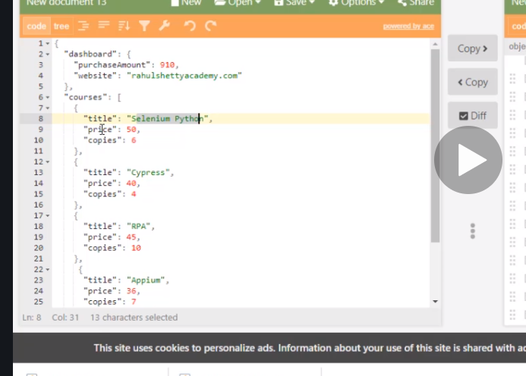

We need to multiply each of them 50 x 6 for selenium to get total purchase for selenuim and add to all the rest to get final result.

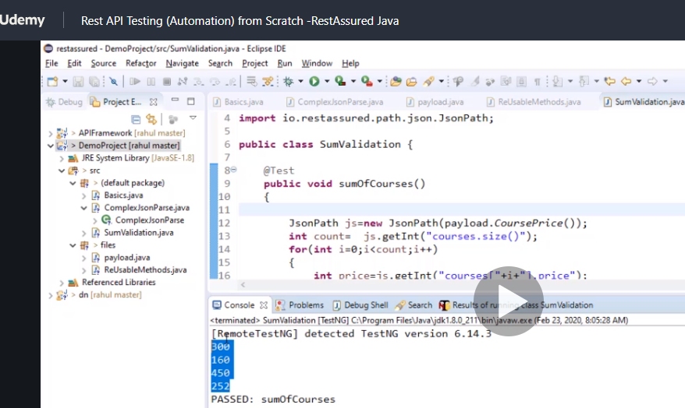

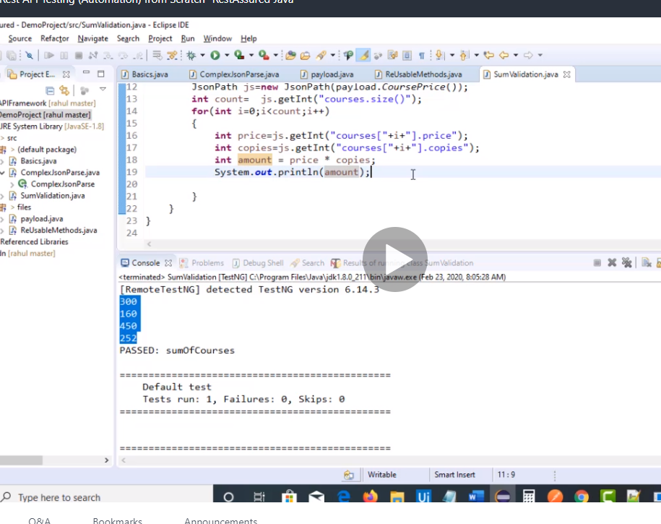

Now we created another class and instead of using main we use testng.

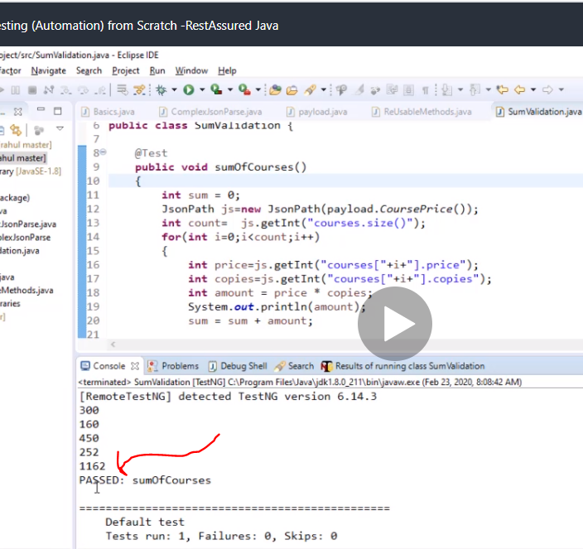

Now finally we compare them

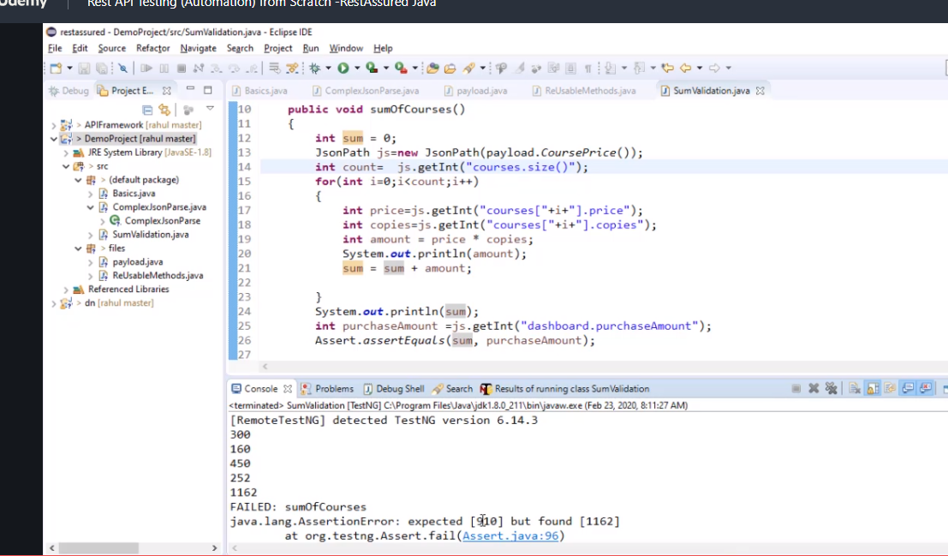

Joshuaidetest+testrfp@gmail.com

# Build dynamic payload and parametize them so u can change the contents easily from a file

Header is just the format your are sending request in that’s all dnt worry bout it.

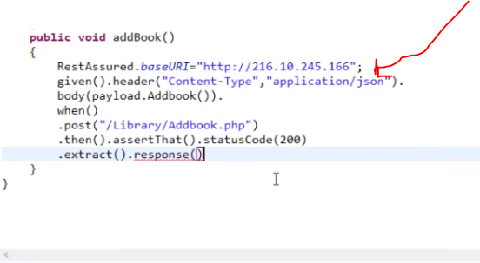

We always extract the response which is in json and convert to string or so something like that.

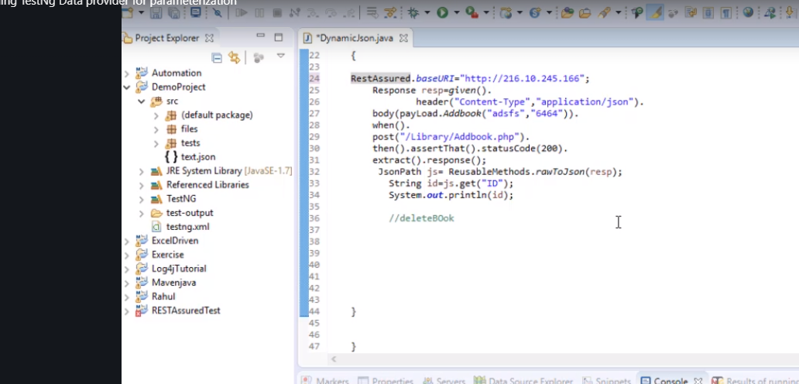

Now concantenate +aisle+ so it changes dynamically.

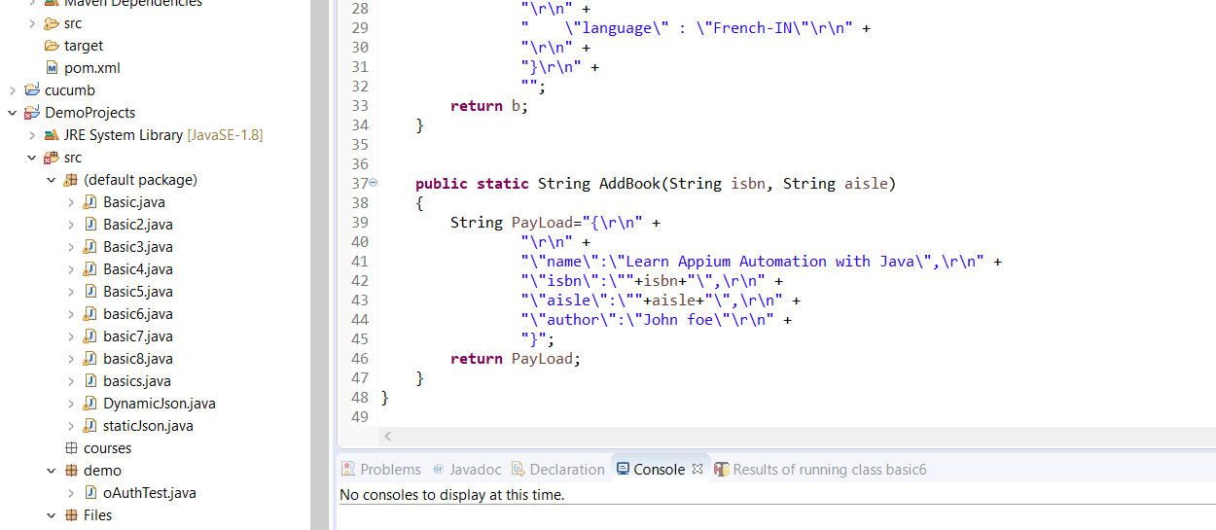

Now lets parametise with more data

# Multi arrays

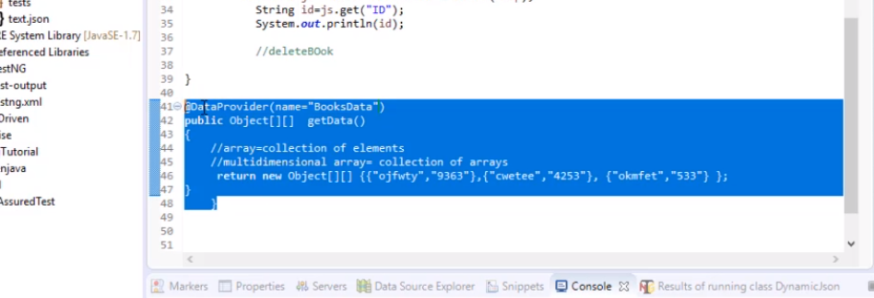

Here use [][] two parameters that will run {}{}{} 3 times as you can see above so if it was a table

7 8

6 9

8 9

That’s the array u just created.

Now connect it to the test with

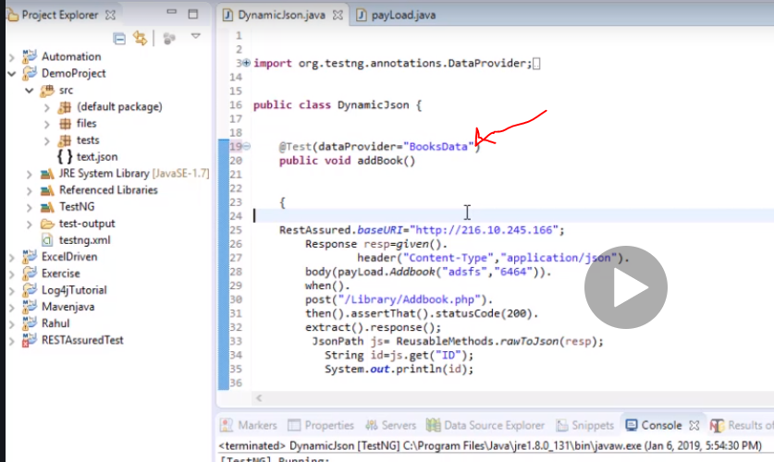

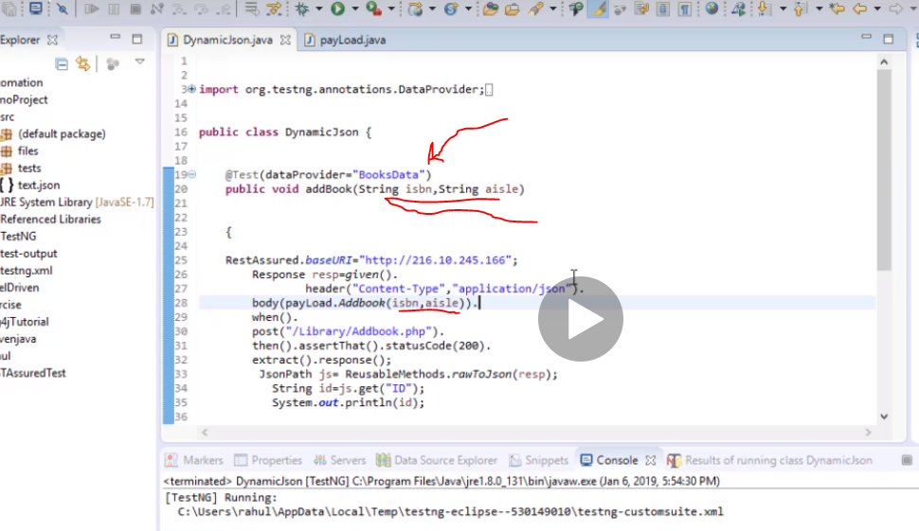

Now it has been connected and made dynamic

# Also remember the \\ handling them in eclipse you can use the website

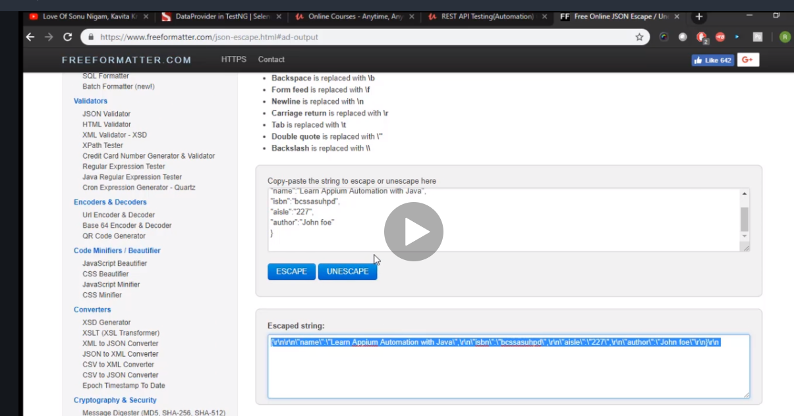

# Jira

Payload is post body

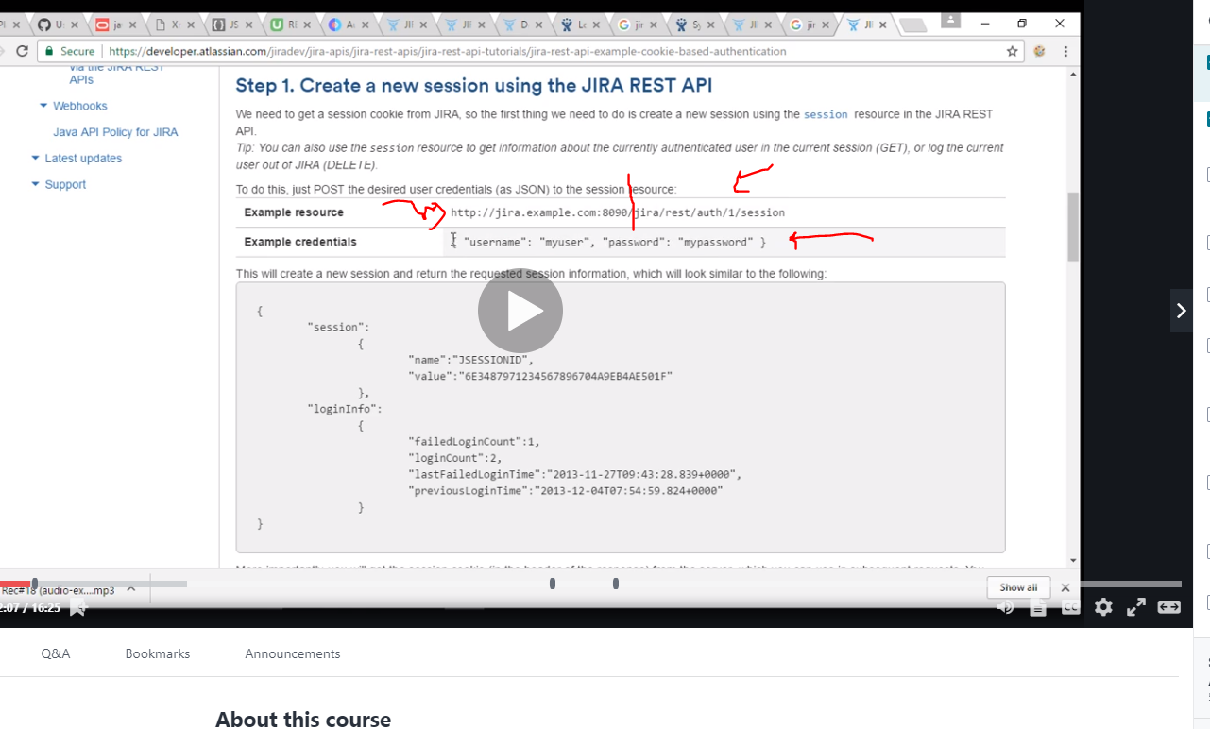

Jira is baseurl and the otherside is resources . in json usually

So to get the key for jira first authenticate urself by hitting the url and putting your username and password and then obtain the value

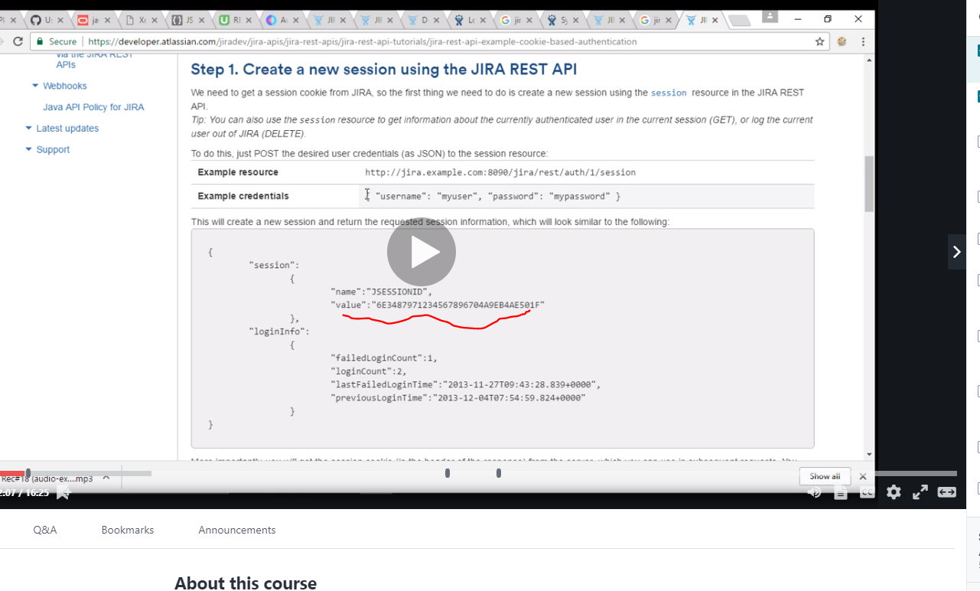

Note cookie name and value are same.

Headers are used to authenticate yourself and cookies

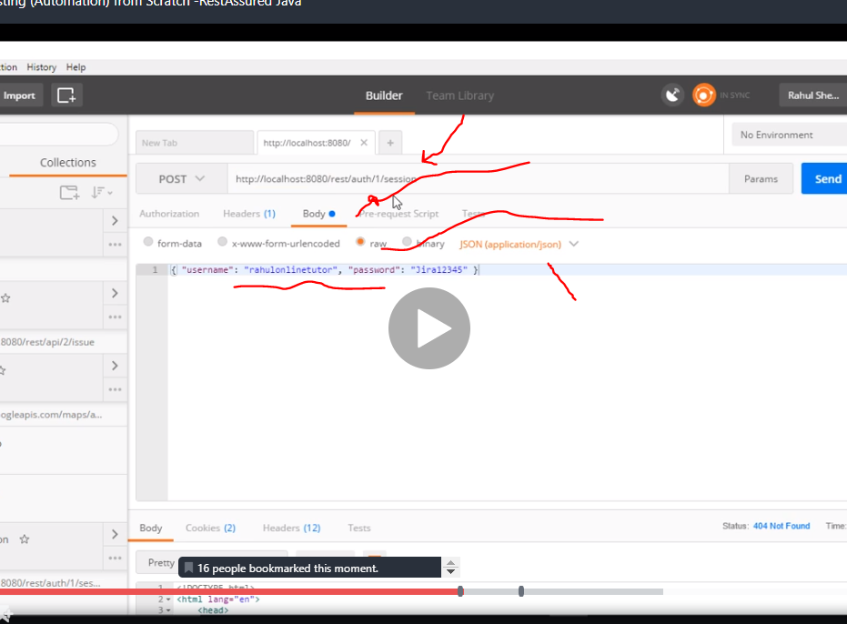

Now once you hit the baseurl u dnt need jira that’s why we took it out of the request to work

# How cool it is 8.44 of jira chapter 44 just a diversion that when rahul says it and 15.46

# Create jira issue

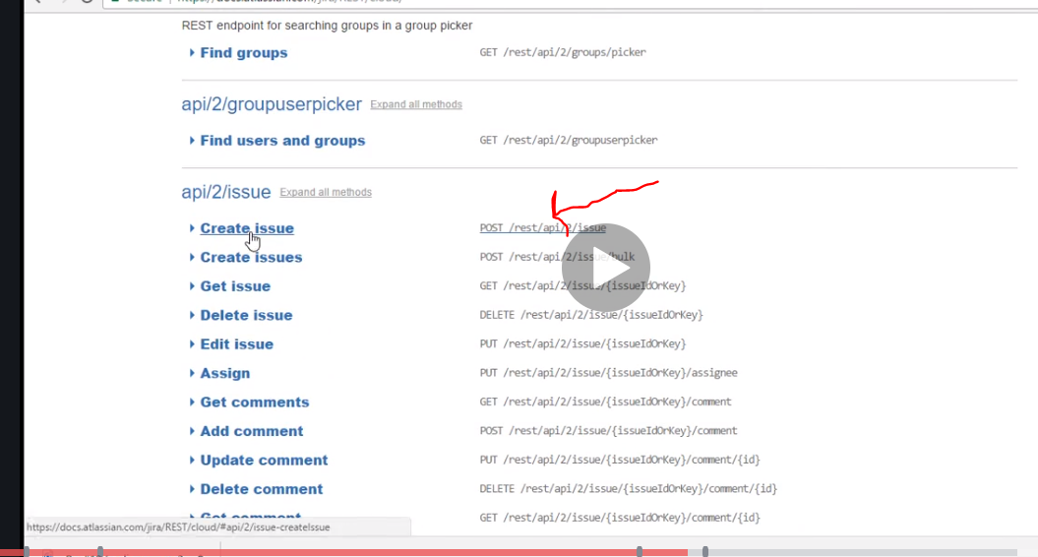

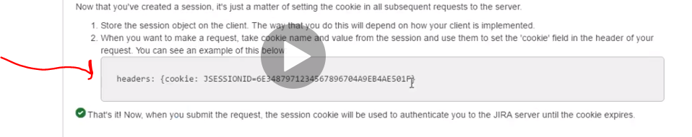

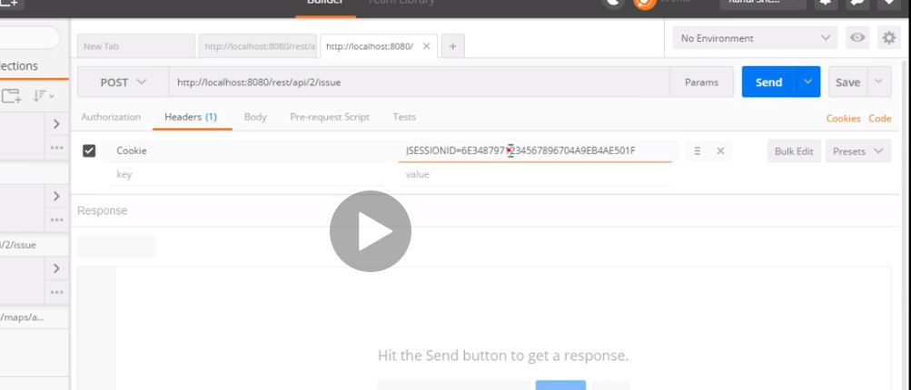

To create an issue we need a body to explain the bug

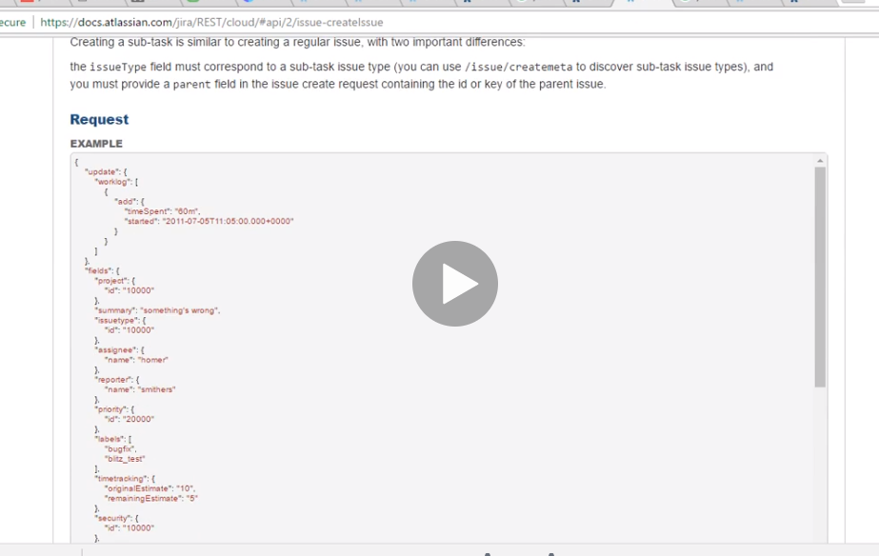

So he filtered it to the relevant ones

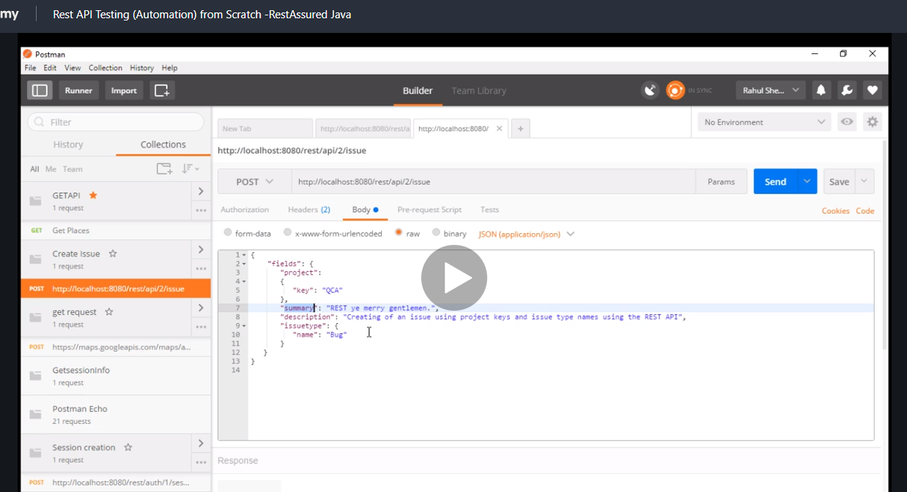

Now note when you start a jira project you are asked for the name and a key is generated for you

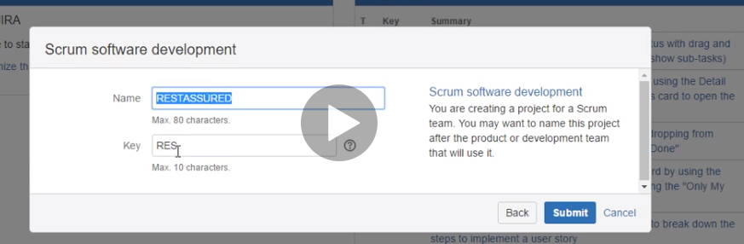

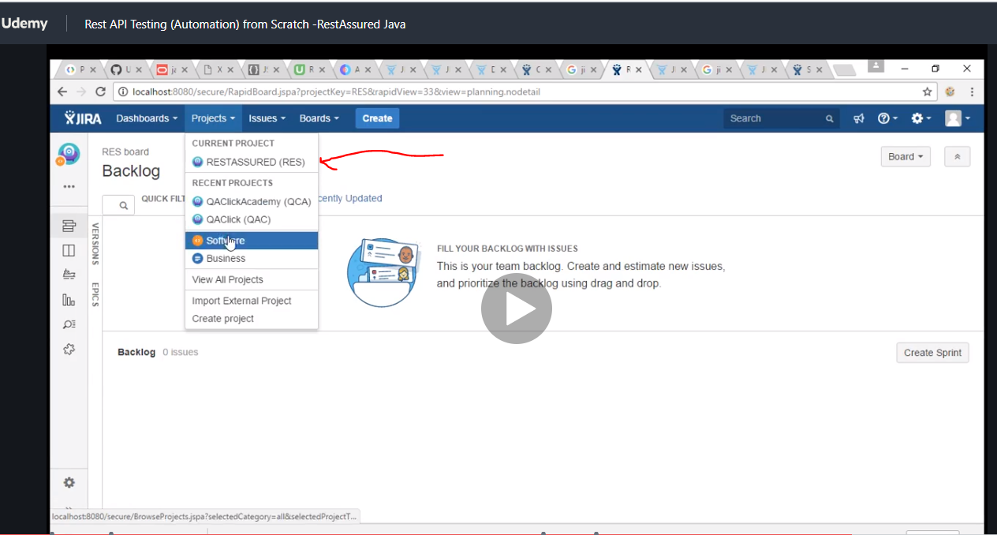

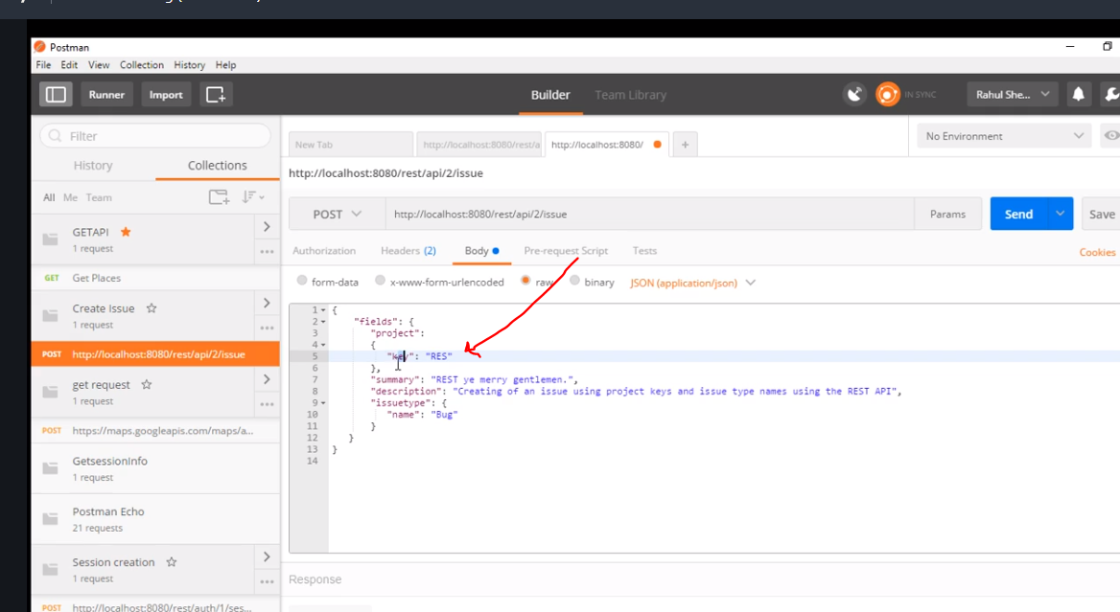

Now hit send again just to get session ID value key that is still valid

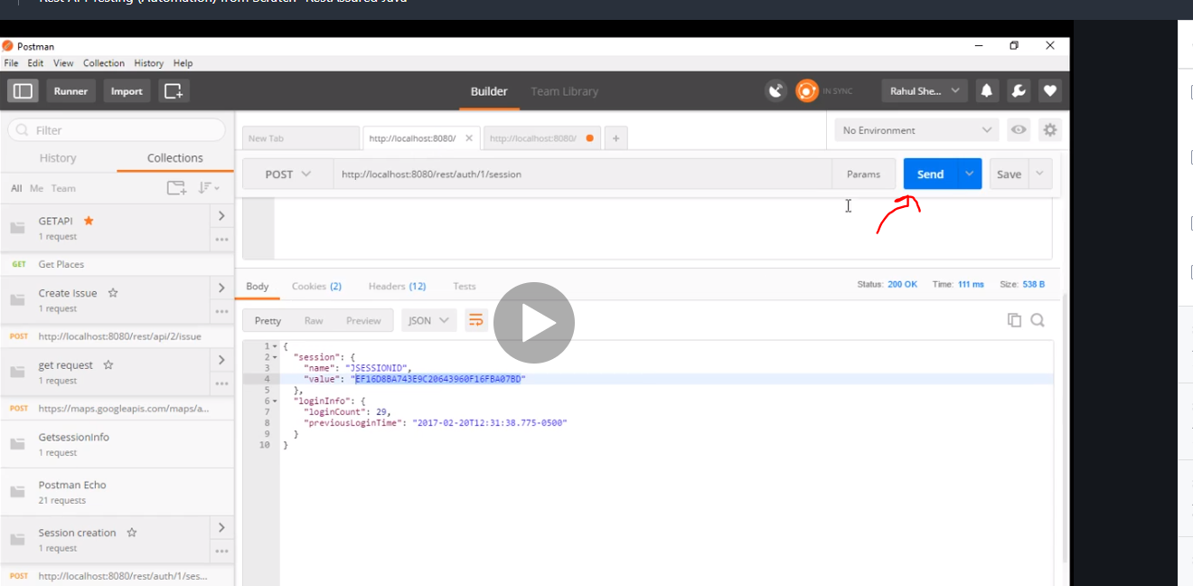

Now copy the key and use it. Well it didn’t change though the session ID think we just did it to be sure

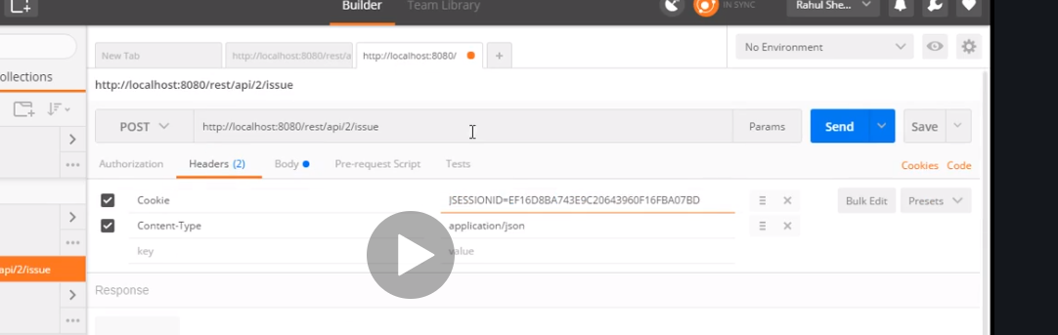

Hit send now

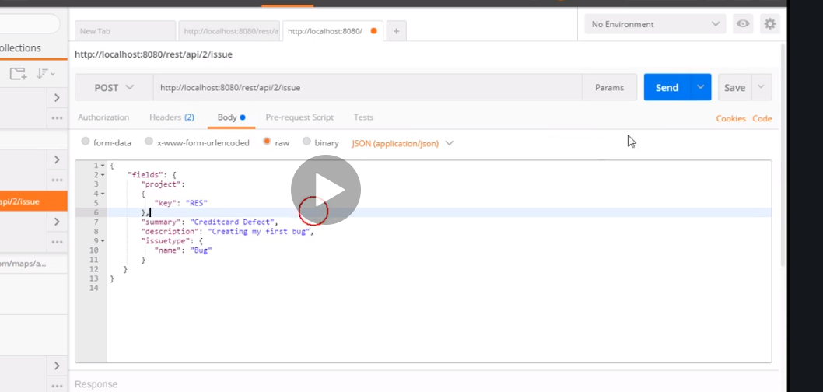

This is the result

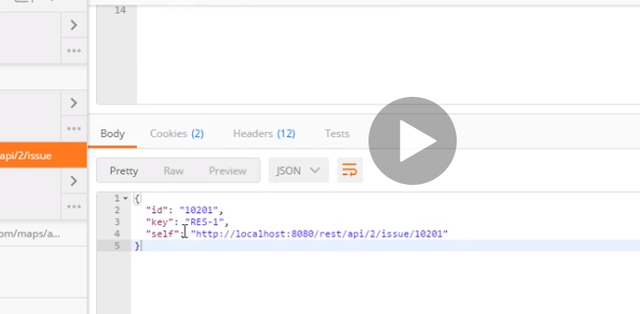

It successfully created an issue

Refresh and you can see it has been created.

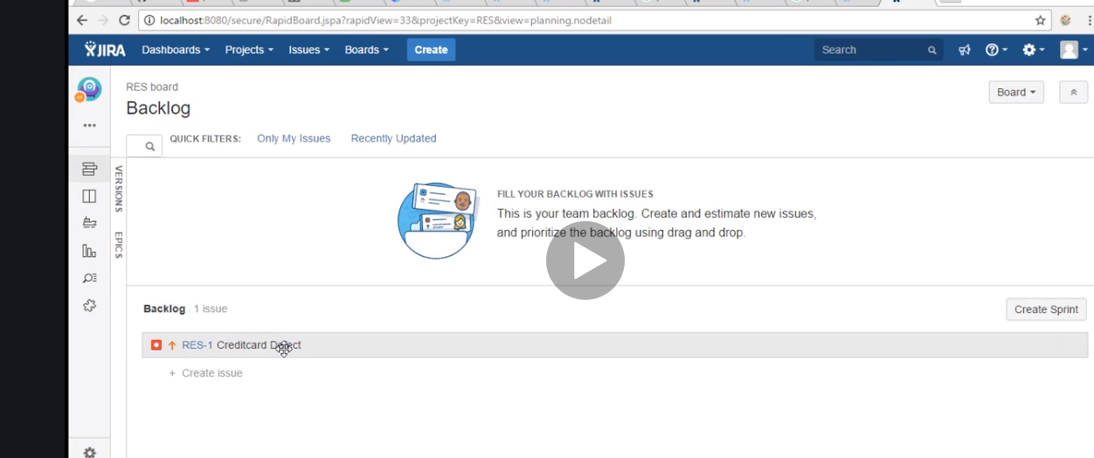

So if you keep hitting send you will get more cards

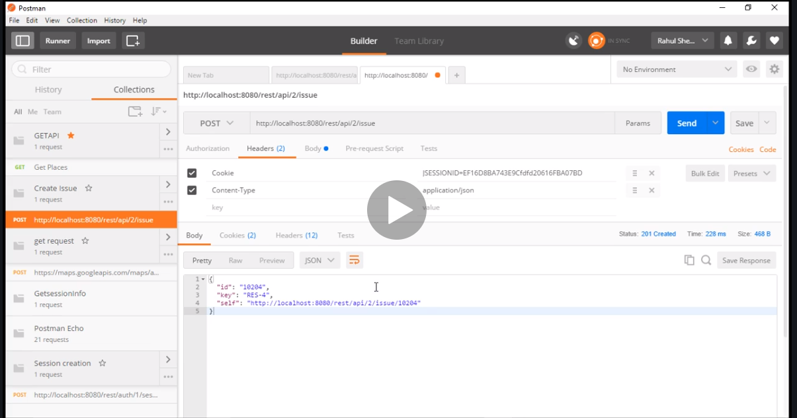

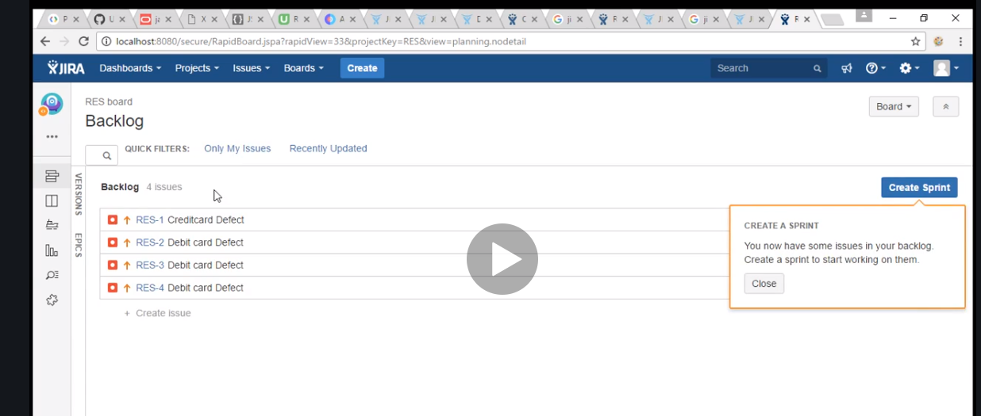

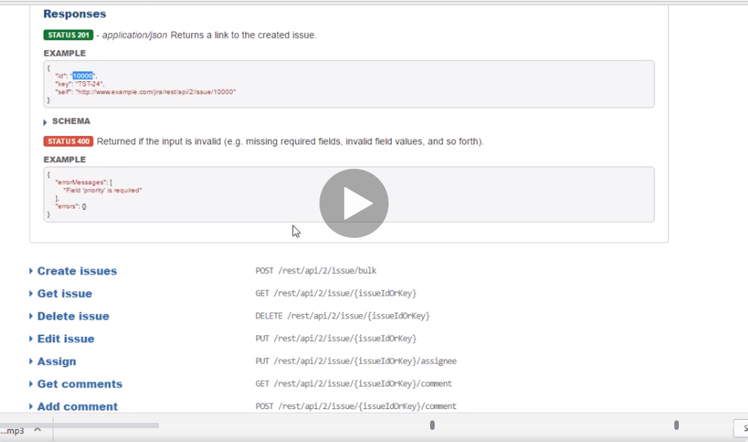

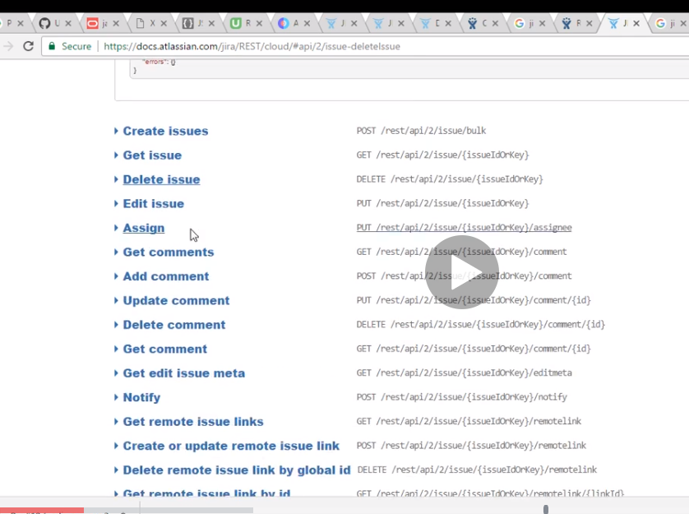

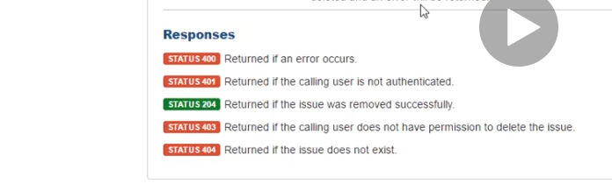

# Now to delete jira

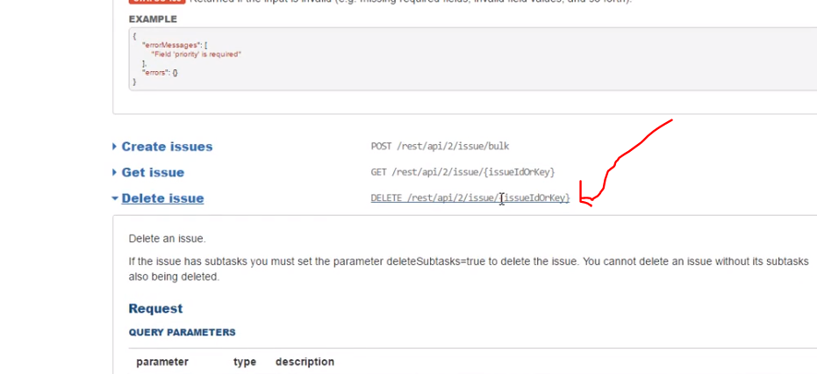

The issue id is

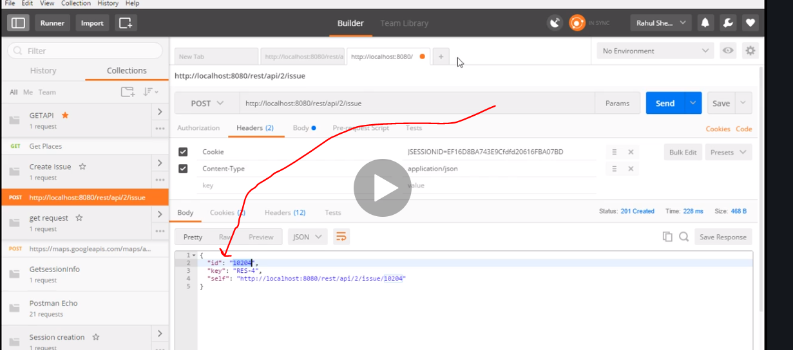

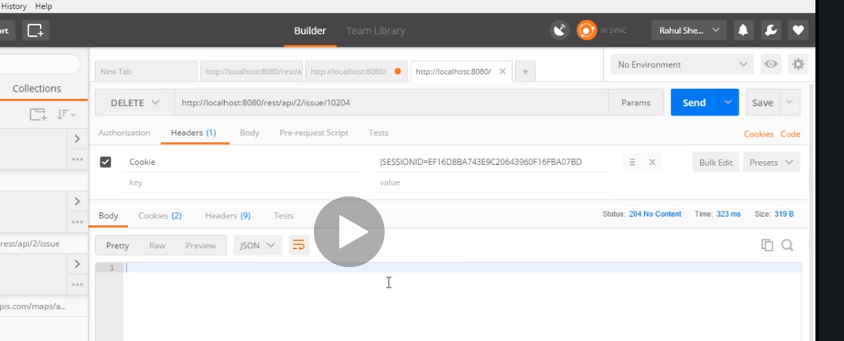

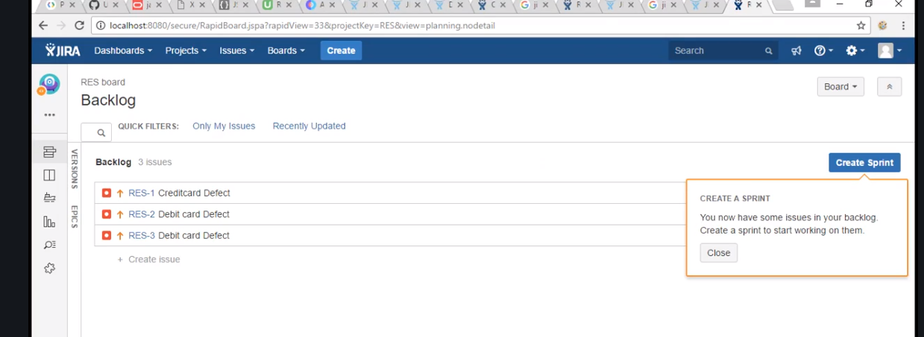

See three

# Put in Jira

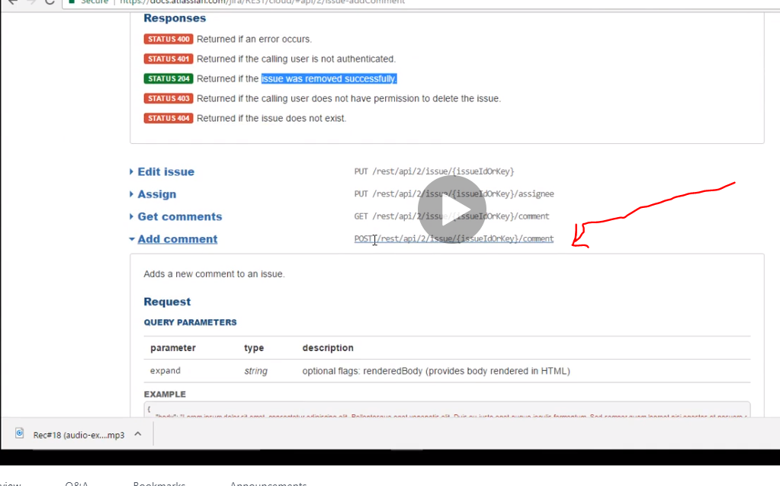

This is an example of what the body should look like

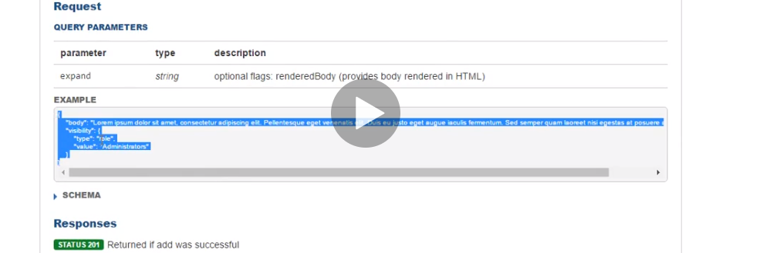

Remember to check and add header

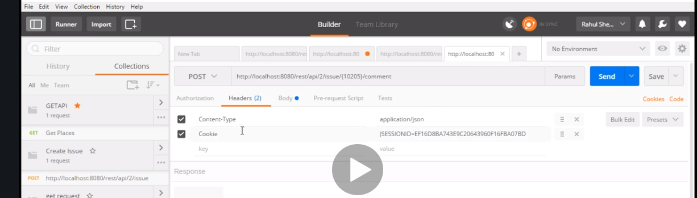

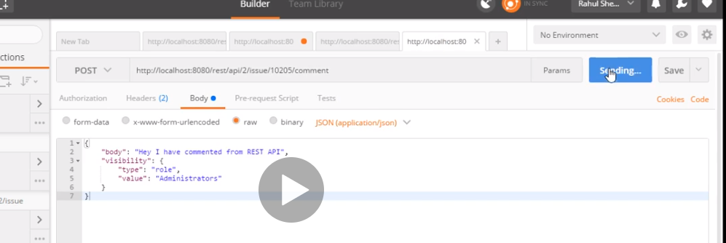

Now lets check response

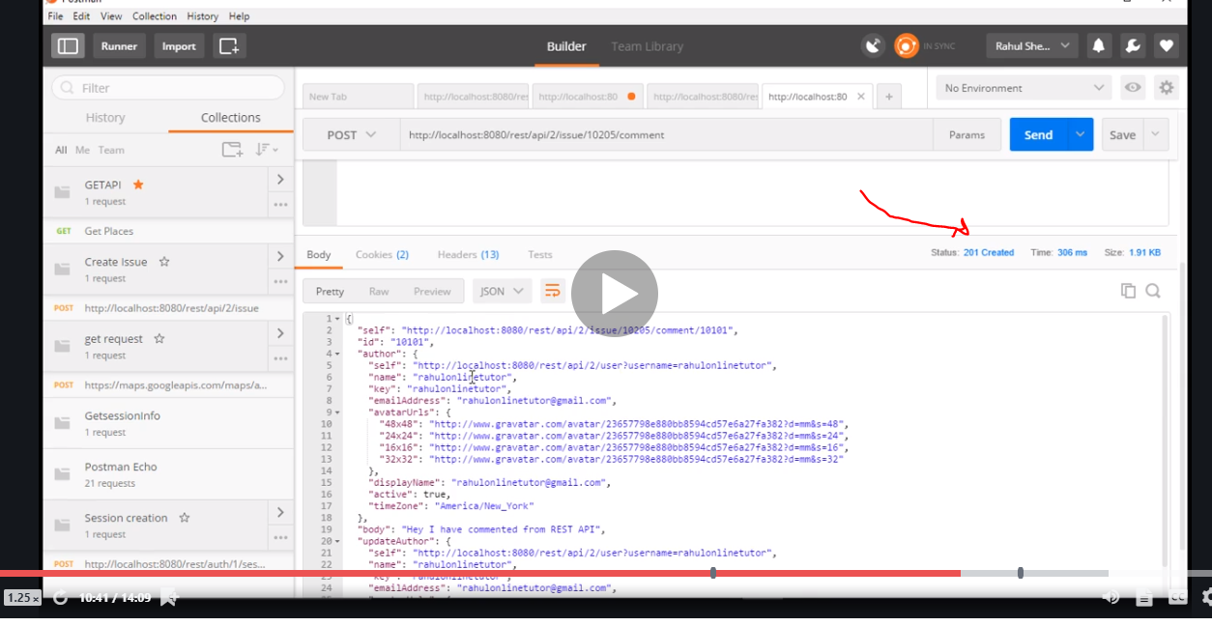

As expected.

Go back to jira…I didn’t show it but same procedure we created an issue but notice it has no comment

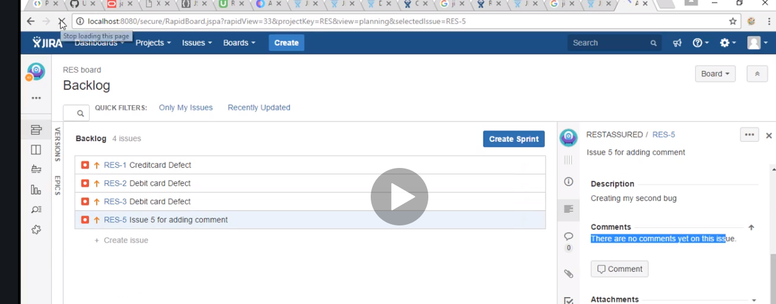

Now refresh the page after sending the comment in postman with this id and we get

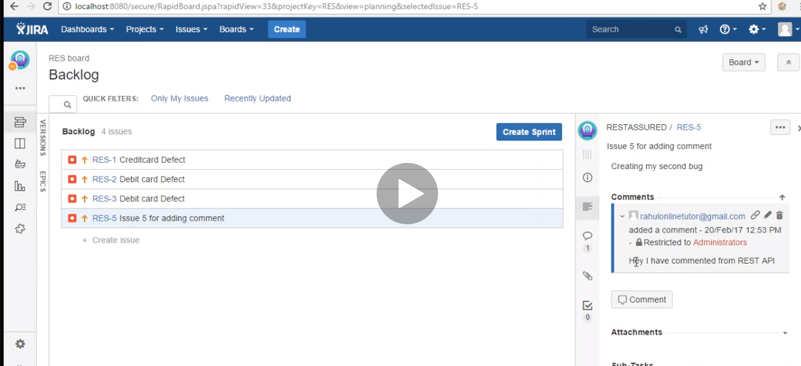

Now put is used to update so to update the comment

Now you need the id of the comment you want to update

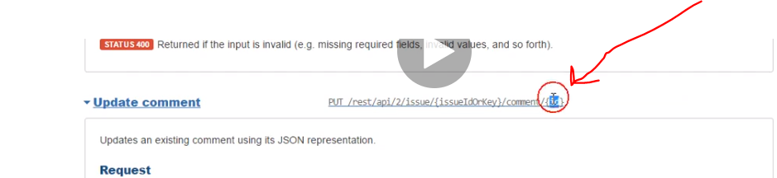

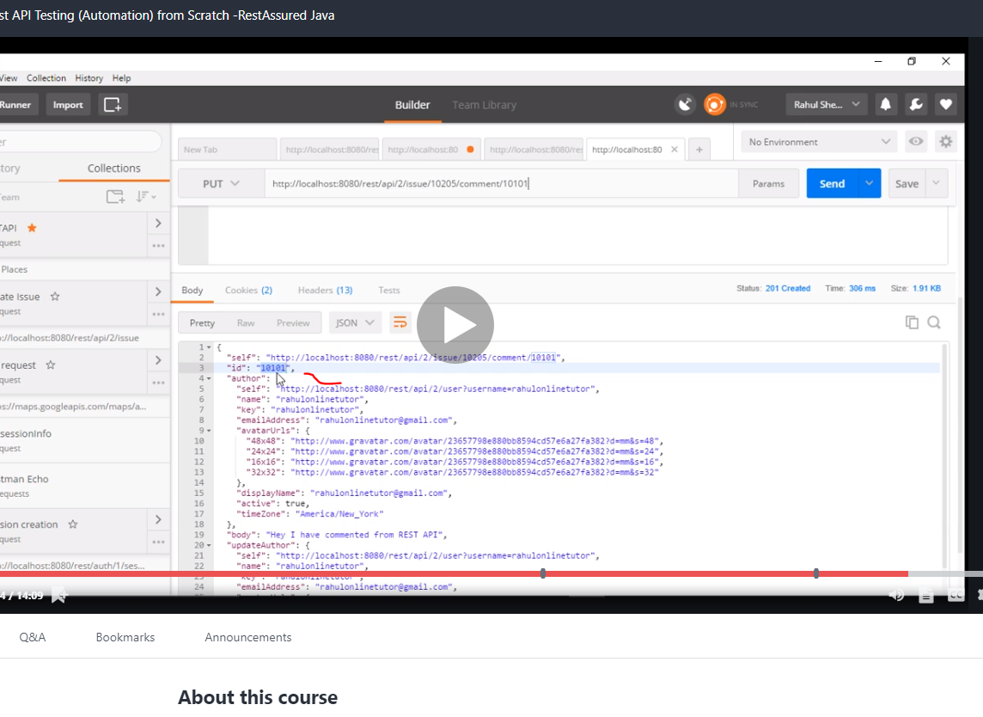

That was the result we got from above 10101 was the id so we put it in

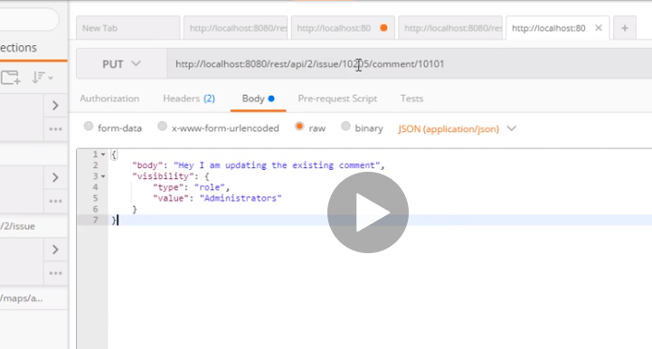

Now check jira

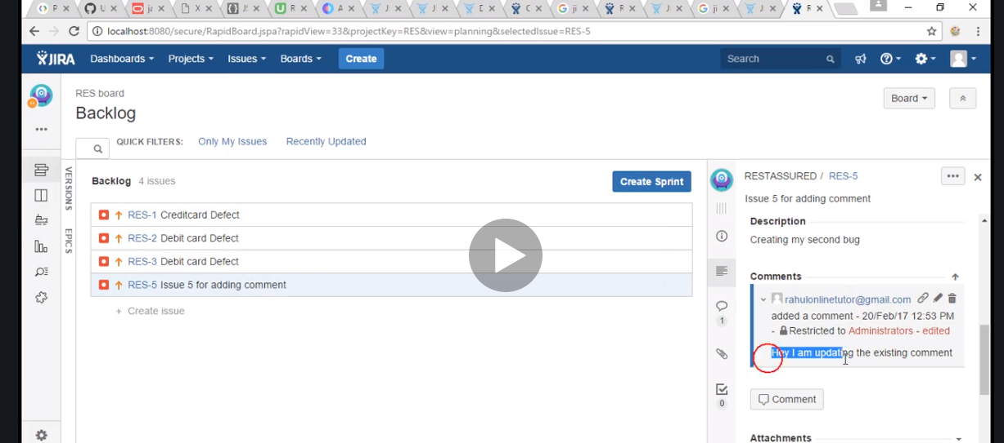

# Automating it

Get the key which is res as we already showed for the issue created

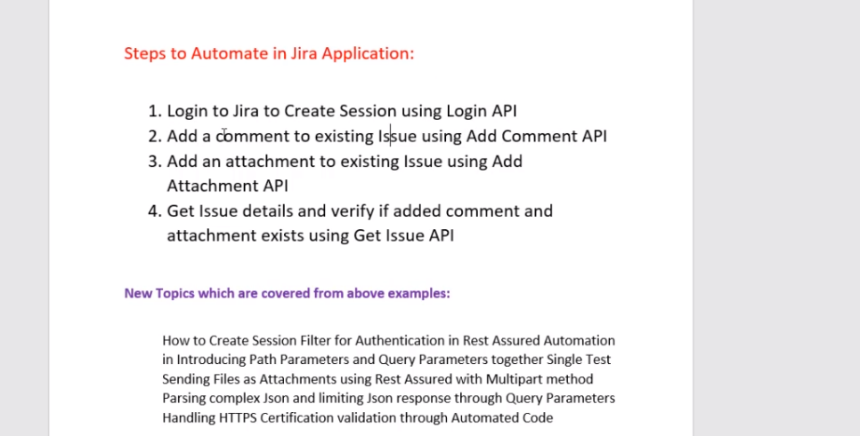

Form parameter is {} or part parameter and ? is query parameter .

Now we are adding comment to the issue with eclipse

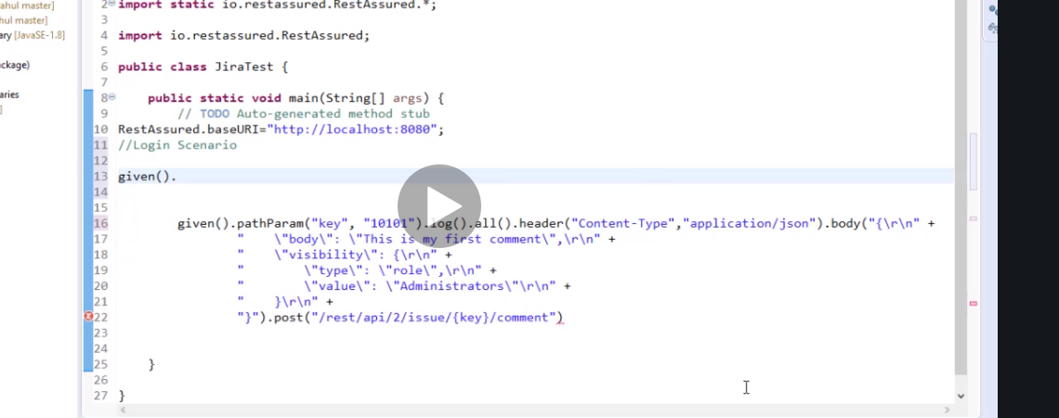

Next we need to extract session ID

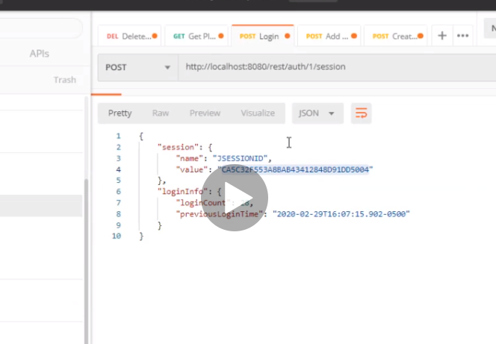

This like before but with eclipse.

In body remember to send credentials

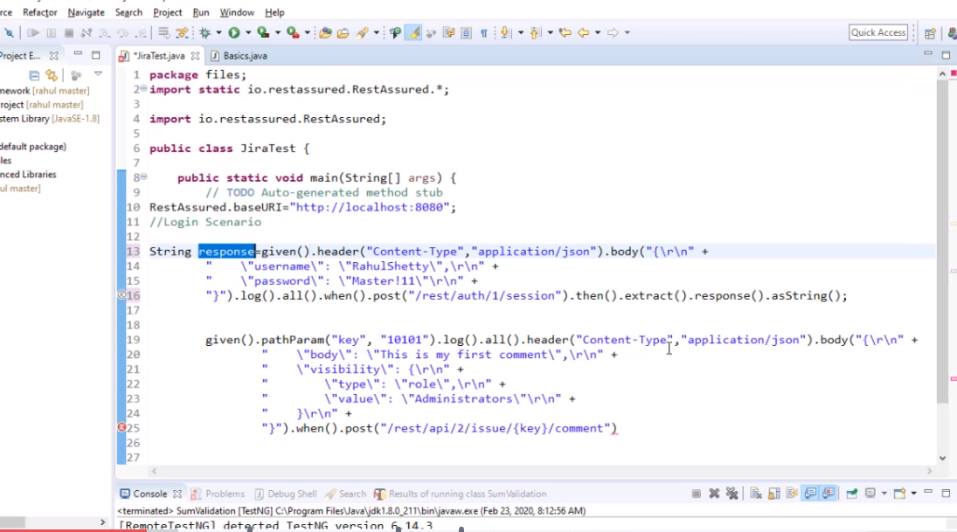

Now lets create a method called session filter, this method will help us faster in extracting variable and save it to string I think. Also import it to the library

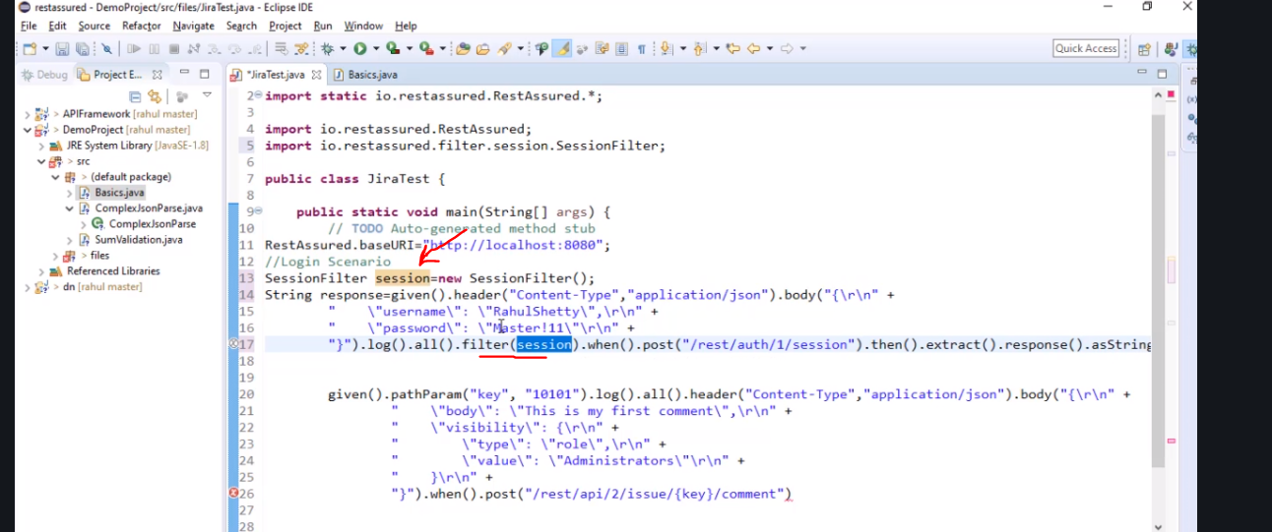

Its like a listener

So instead of the whole back and forth convert to json and shit, this just does the job

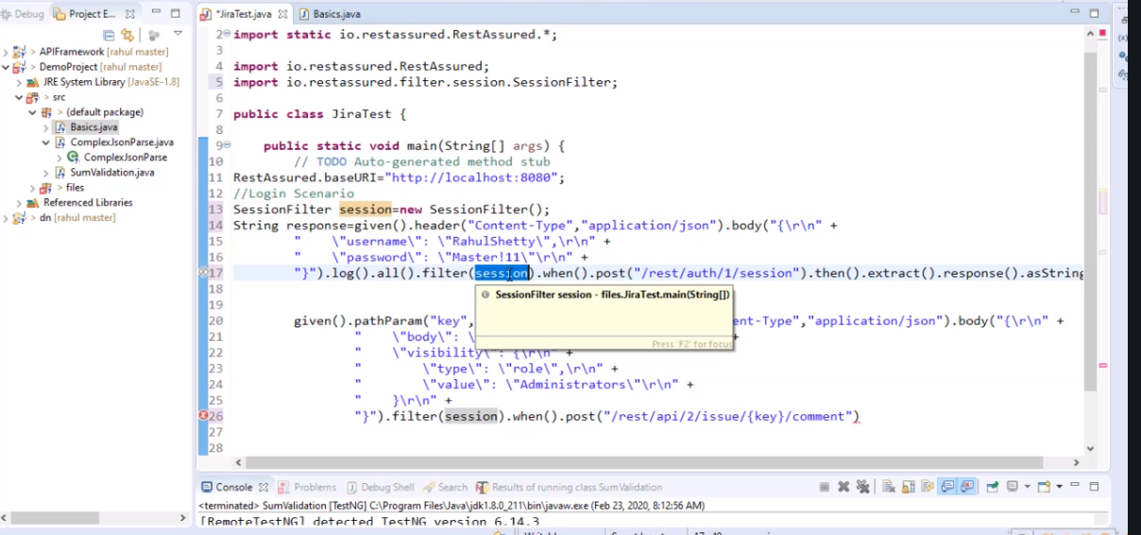

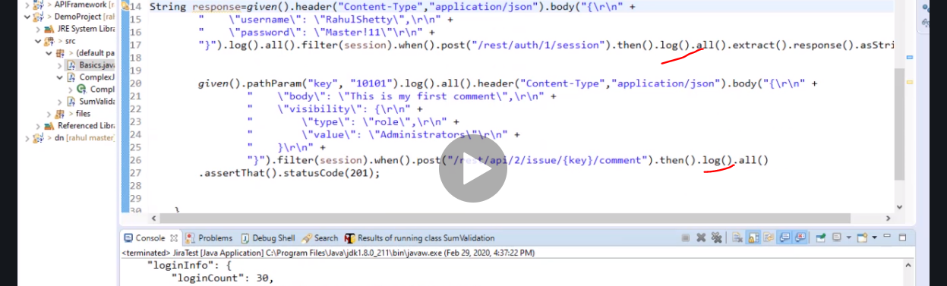

You can also add logs above

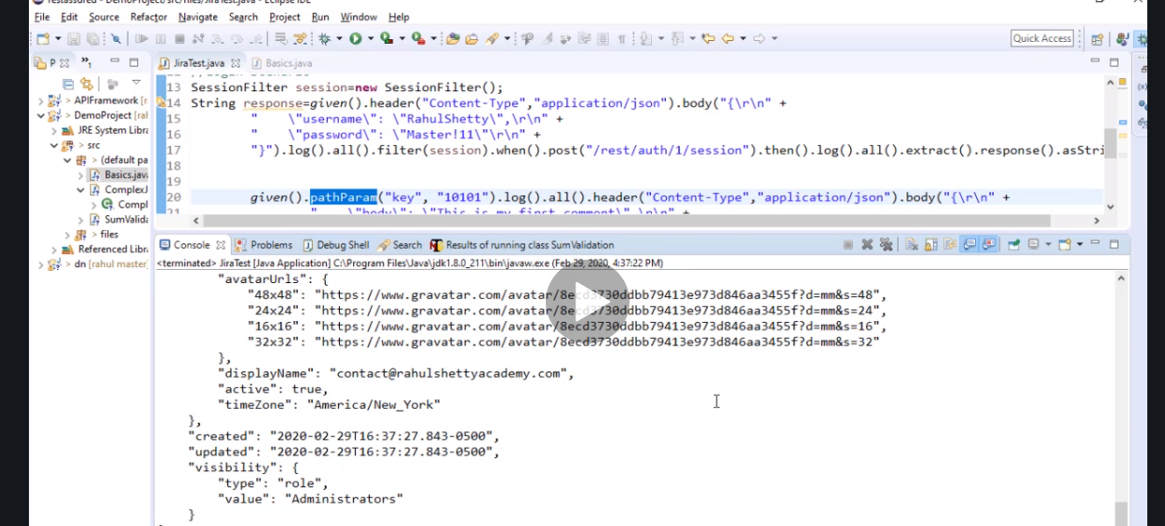

Now lets check jira

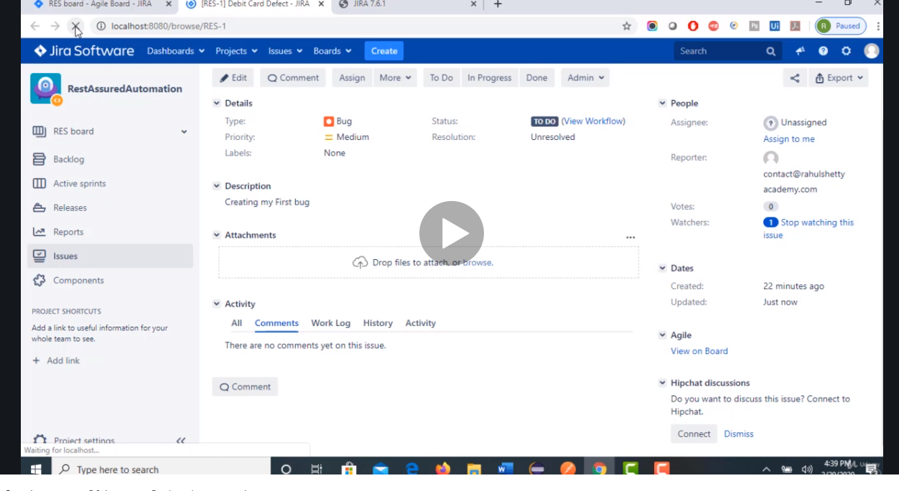

# Sending attachment

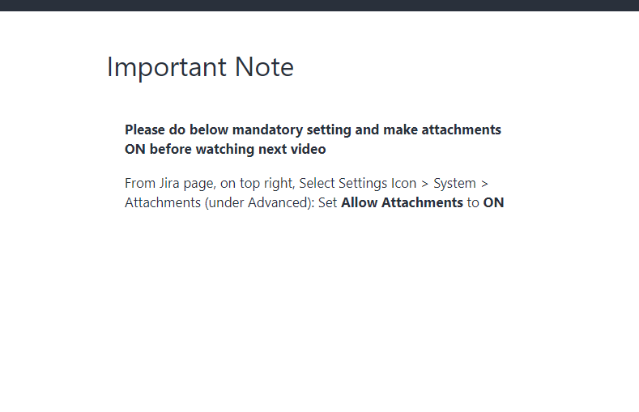

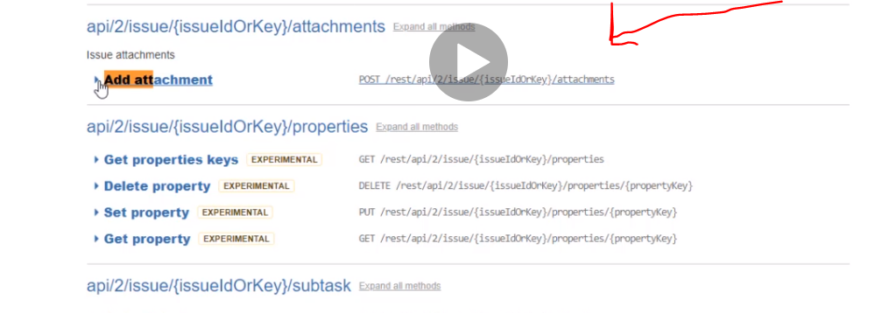

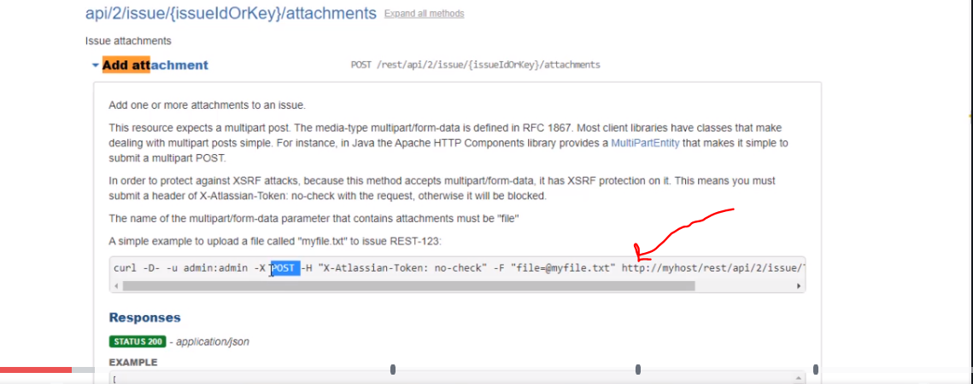

Next create a file

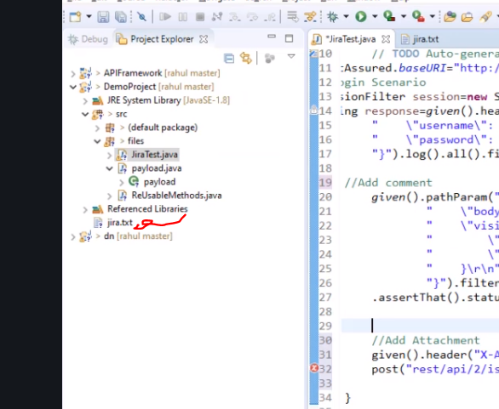

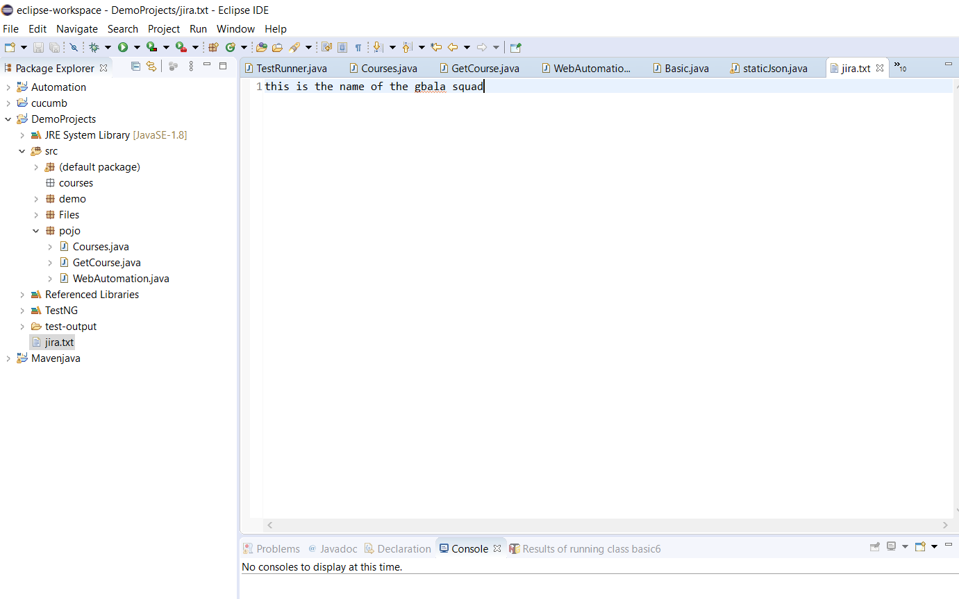

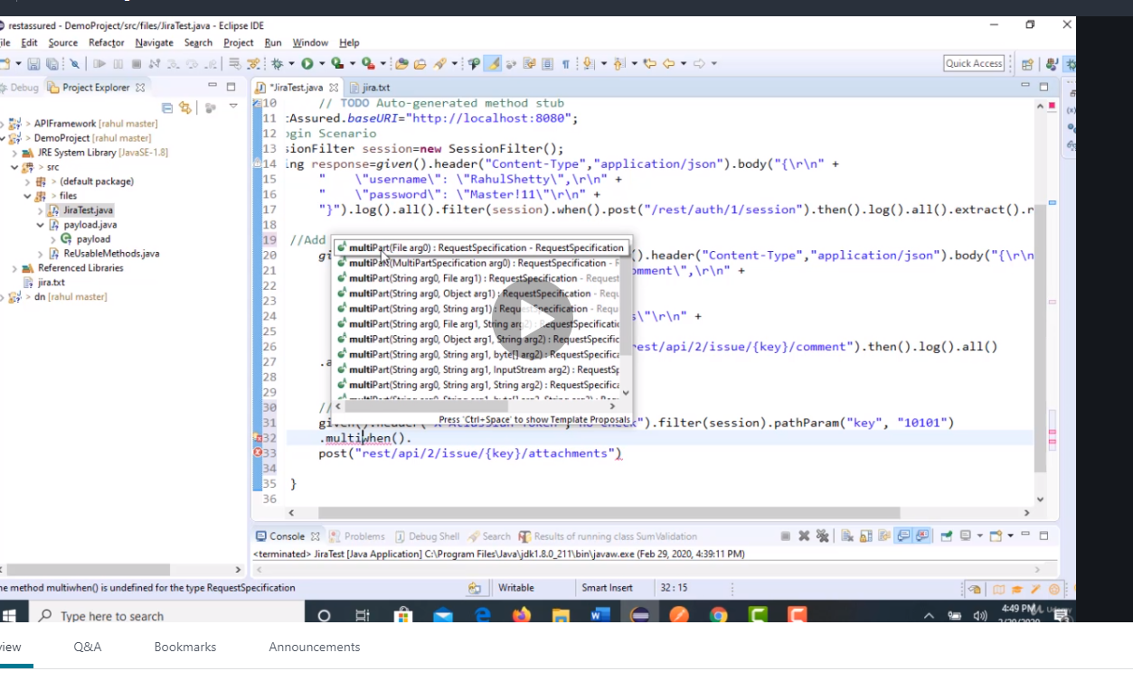

When dealing with files

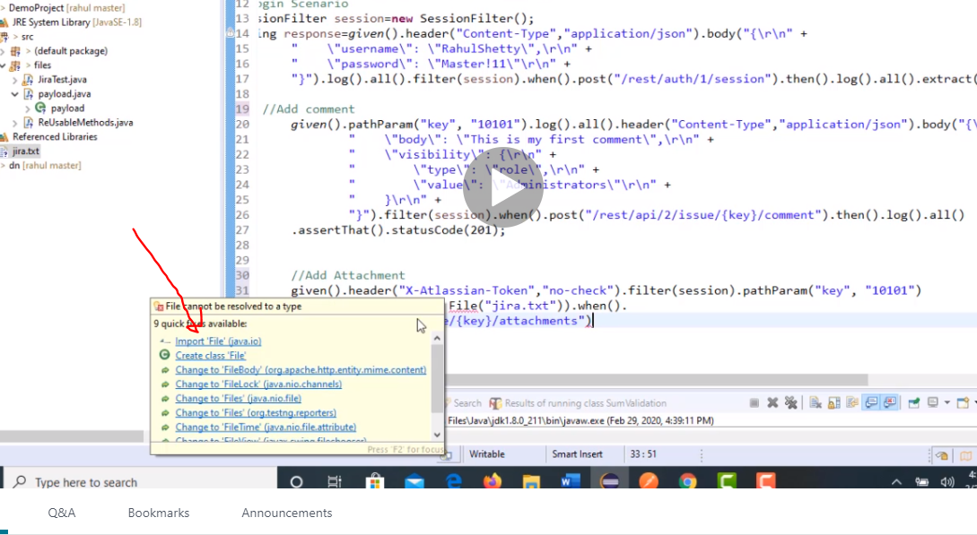

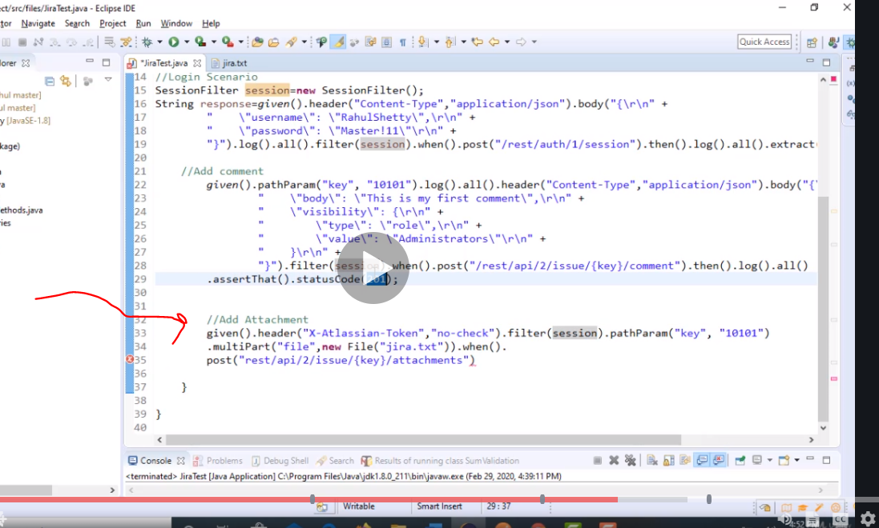

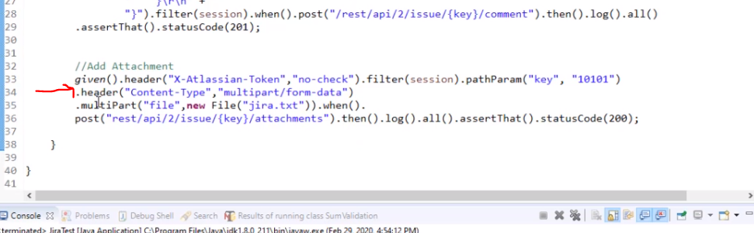

That’s it the header as I said before its just the format you are sending.

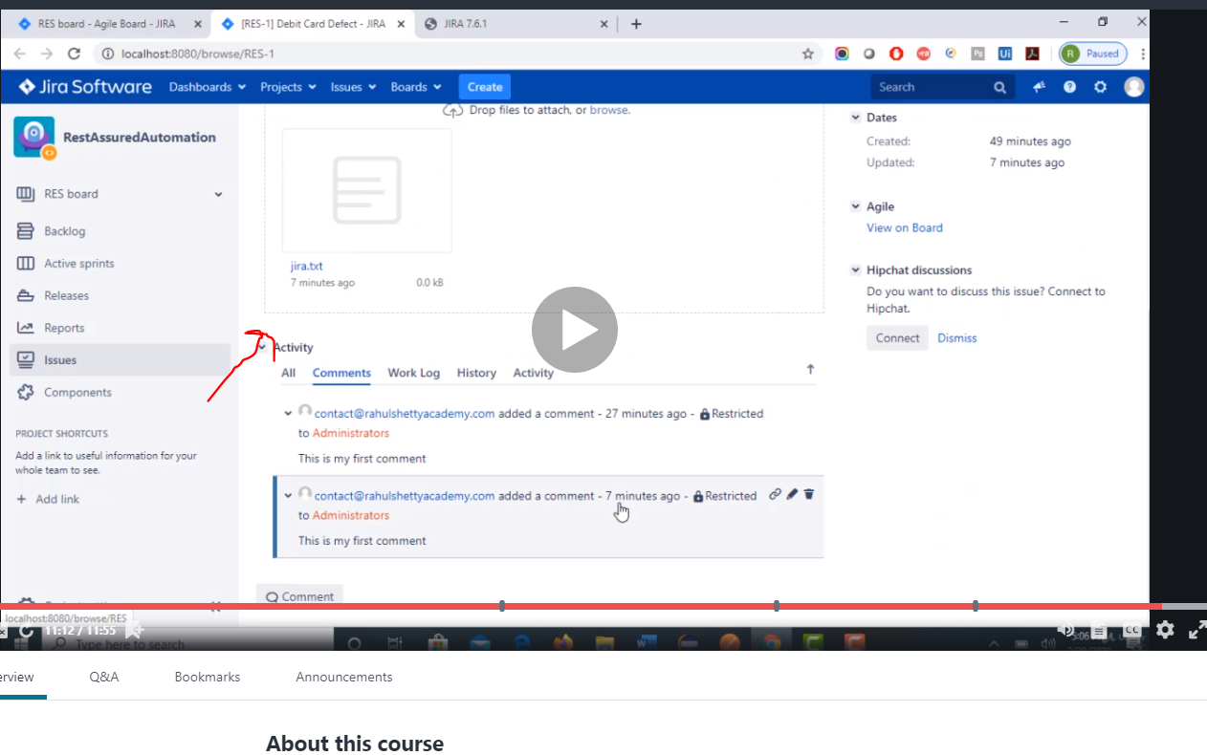

Doneeeeee……

# Now lets use Get to obtain the comments and attachments

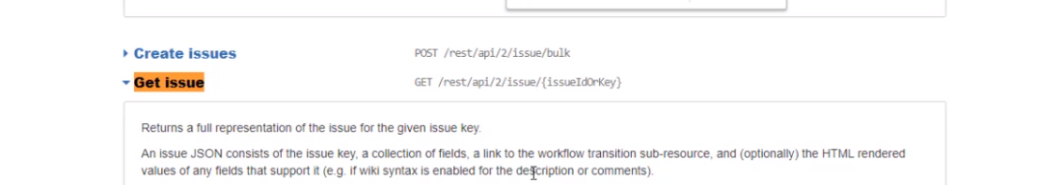

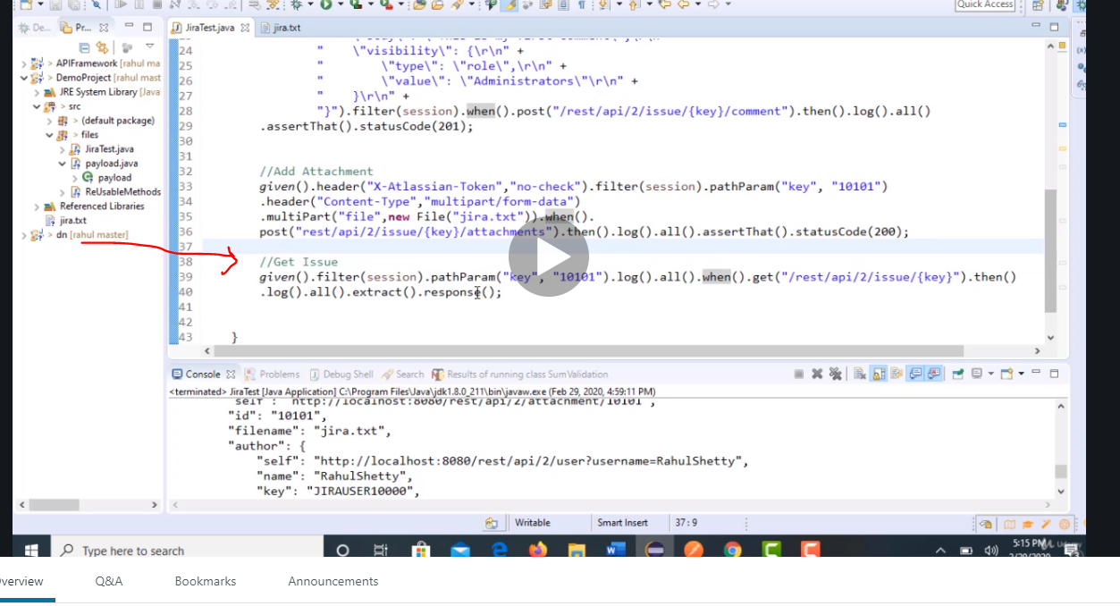

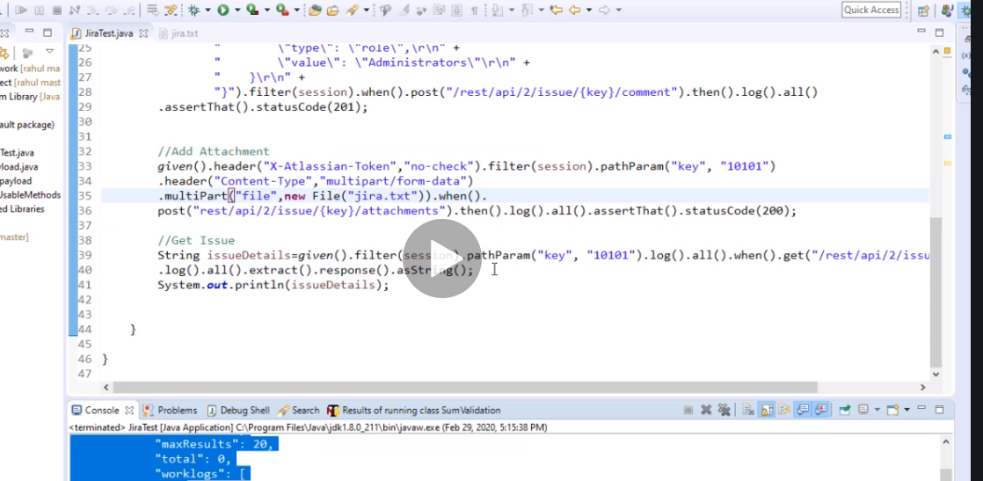

Note we use path parameter and the body is huge and full of nonsense and too much information but we will use query parameter to find the exact thing we need

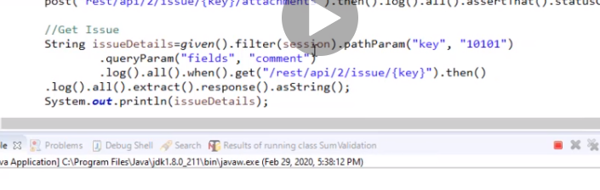

So copy your answer and put it here

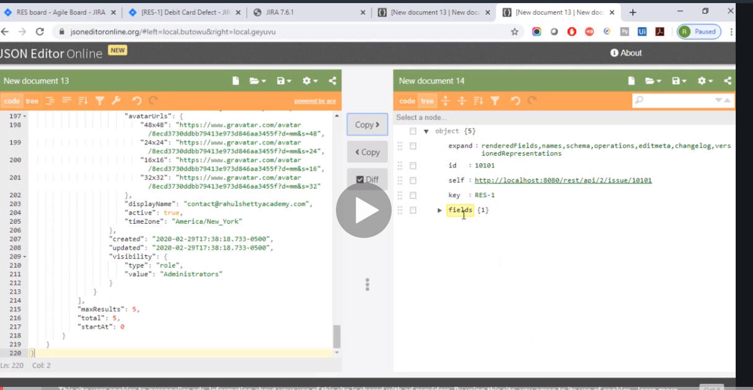

See just 1.

# Now lets check if its correct.

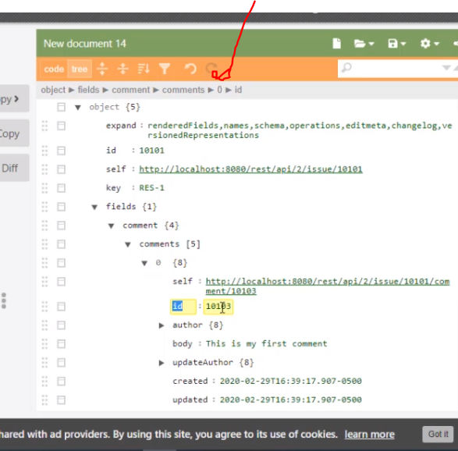

That’s how to get to comment

Now we extract the response and then compare it if it exist

Now take note when we added comment we did not extract anything

Basically json js=new json I think is used to get the json as string in order for us to use it. Without doing so we cannot manipulate the variables as string.

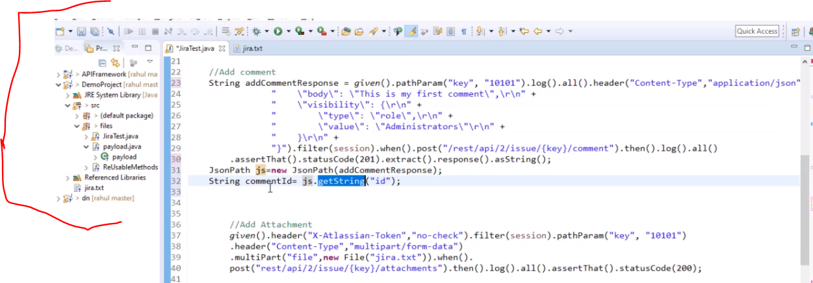

Our goal now is to check if the string comment ID is present in our response when you get the issue details…

So back to the issue

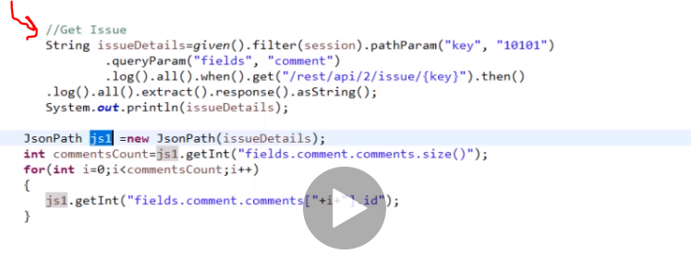

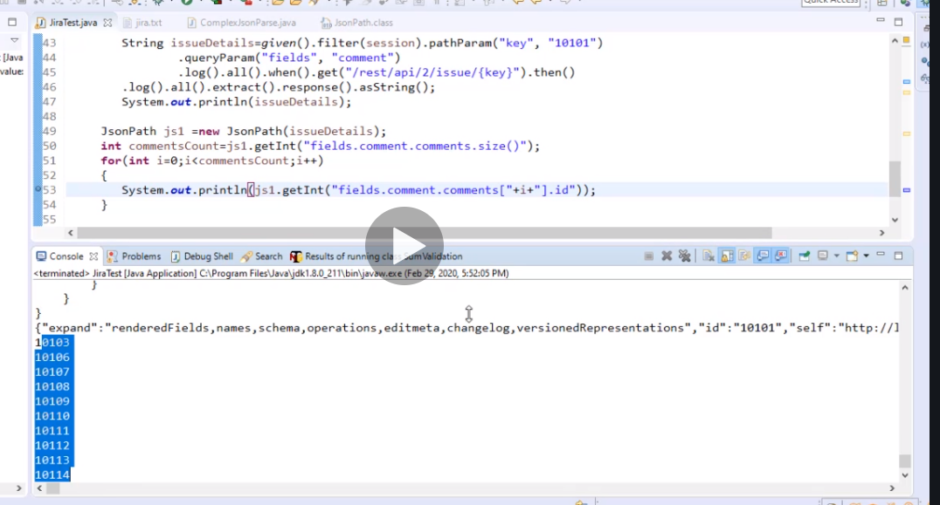

Quick note few changes

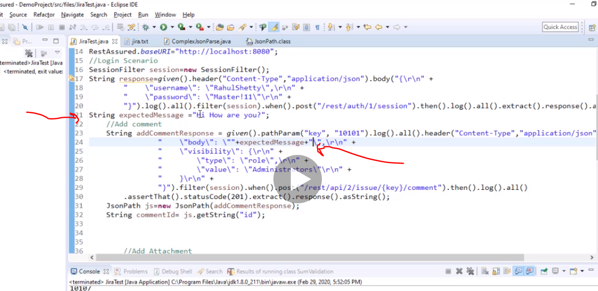

So basically instead of hardcoding he did that. I think it will help verify it.

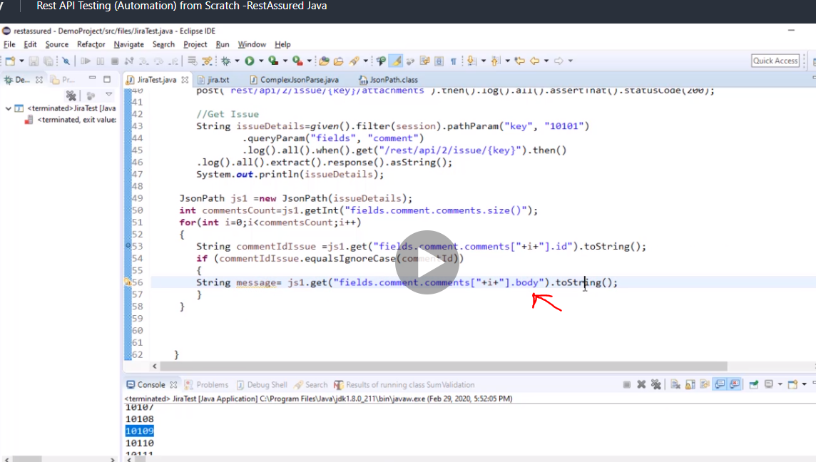

Now we have extracted id…

The for loop says if those two are equal go into the loop and extract the body and save it as a string message….

Finally compare the string message with the message we created originally in the body…. (expected message)

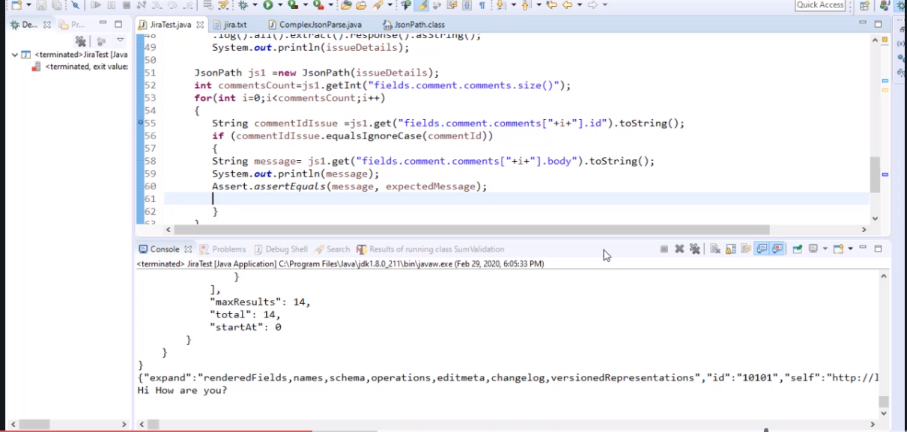

# Certifications

Just add it to the beginning of your code

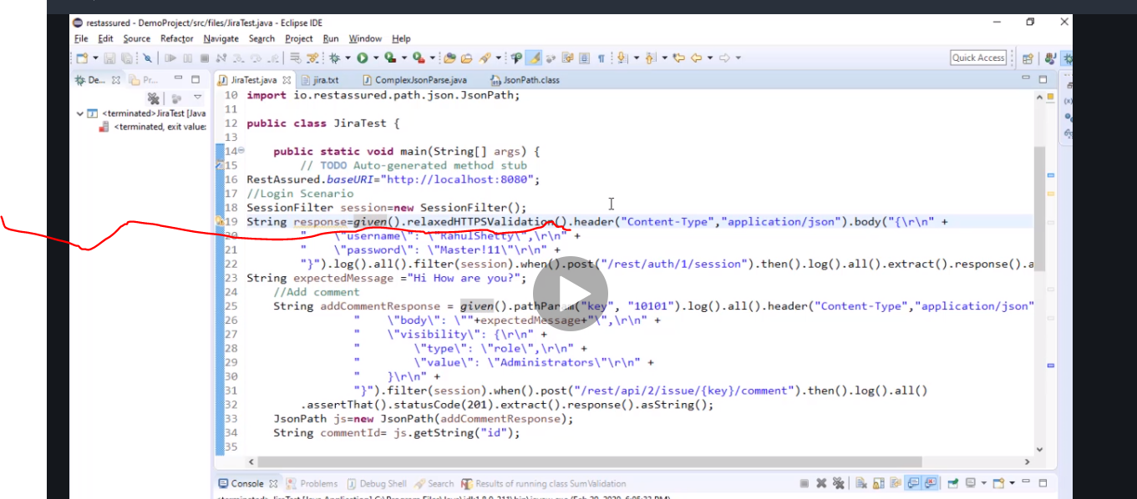

Complete code

package files;

import static io.restassured.RestAssured.*;

import java.io.File;

import org.testng.Assert;

import io.restassured.RestAssured;

import io.restassured.filter.session.SessionFilter;

import io.restassured.path.json.JsonPath;

public class JiraTest {

public static void main(String[] args) {

// TODO Auto-generated method stub

RestAssured.baseURI="http://localhost:8080";

//Login Scenario

SessionFilter session=new SessionFilter();

String response=given().relaxedHTTPSValidation().header("Content-Type","application/json").body("{\r\n" +

"    \"username\": \"RahulShetty\",\r\n" +

"    \"password\": \"XXXX11\"\r\n" +

"}").log().all().filter(session).when().post("/rest/auth/1/session").then().log().all().extract().response().asString();

String expectedMessage ="Hi How are you?";

//Add comment

String addCommentResponse = given().pathParam("key", "10101").log().all().header("Content-Type","application/json").body("{\r\n" +

"    \"body\": \""+expectedMessage+"\",\r\n" +

"    \"visibility\": {\r\n" +

"        \"type\": \"role\",\r\n" +

"        \"value\": \"Administrators\"\r\n" +

"    }\r\n" +

"}").filter(session).when().post("/rest/api/2/issue/{key}/comment").then().log().all()

.assertThat().statusCode(201).extract().response().asString();

JsonPath js=new JsonPath(addCommentResponse);

String commentId= js.getString("id");

//Add Attachment

given().header("X-Atlassian-Token","no-check").filter(session).pathParam("key", "10101")

.header("Content-Type","multipart/form-data")

.multiPart("file",new File("jira.txt")).when().

post("rest/api/2/issue/{key}/attachments").then().log().all().assertThat().statusCode(200);

//Get Issue

String issueDetails=given().filter(session).pathParam("key", "10101")

.queryParam("fields", "comment")

.log().all().when().get("/rest/api/2/issue/{key}").then()

.log().all().extract().response().asString();

System.out.println(issueDetails);

JsonPath js1 =new JsonPath(issueDetails);

int commentsCount=js1.getInt("fields.comment.comments.size()");

for(int i=0;i<commentsCount;i++)

{

String commentIdIssue =js1.get("fields.comment.comments["+i+"].id").toString();

if (commentIdIssue.equalsIgnoreCase(commentId))

{

String message= js1.get("fields.comment.comments["+i+"].body").toString();

System.out.println(message);

Assert.assertEquals(message, expectedMessage);

}

}

}

}

# Now we use authentication oauth 2.0

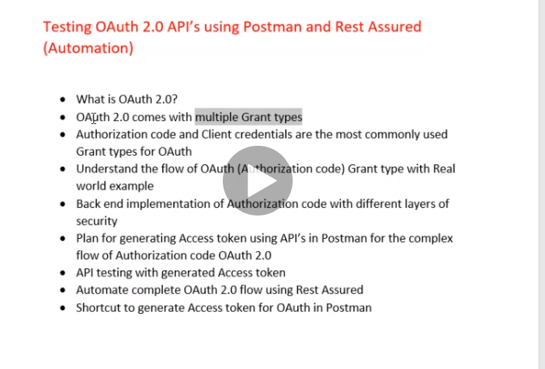

When you can do grant type with authorization code you are a big boy… there is also client credentials but authorization is more complicated I hear….

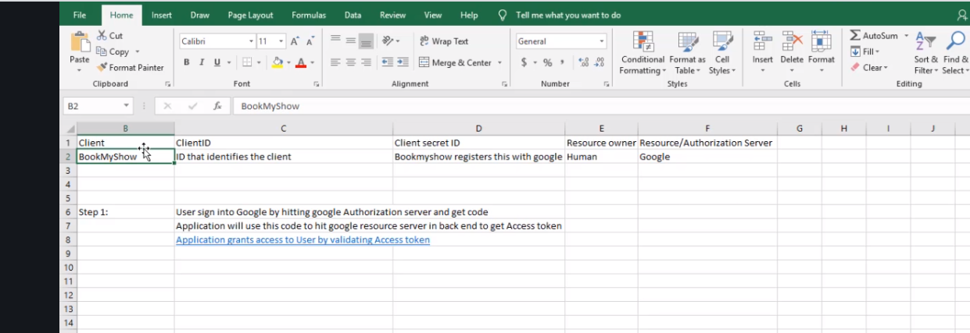

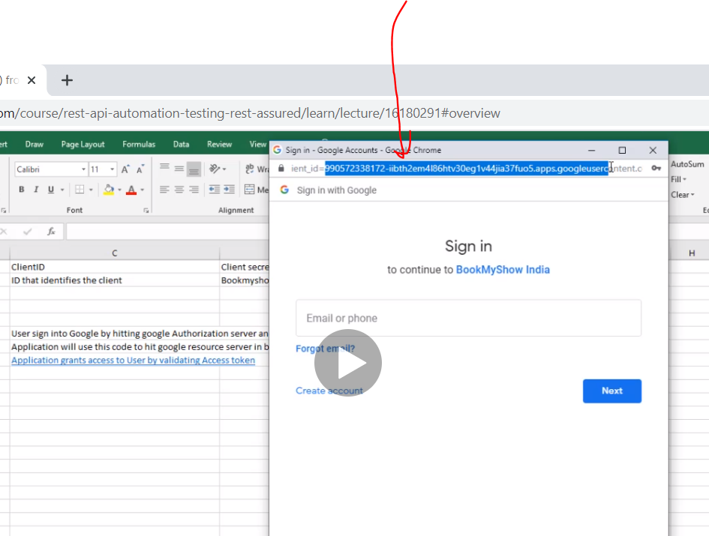

Client ID

This is public but client secret is not.

If the access token is wrong or expired it will not grant you access

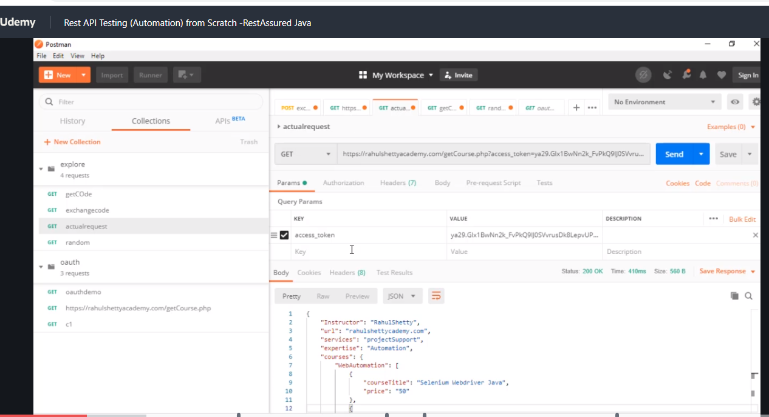

Now if it fails or expires without it

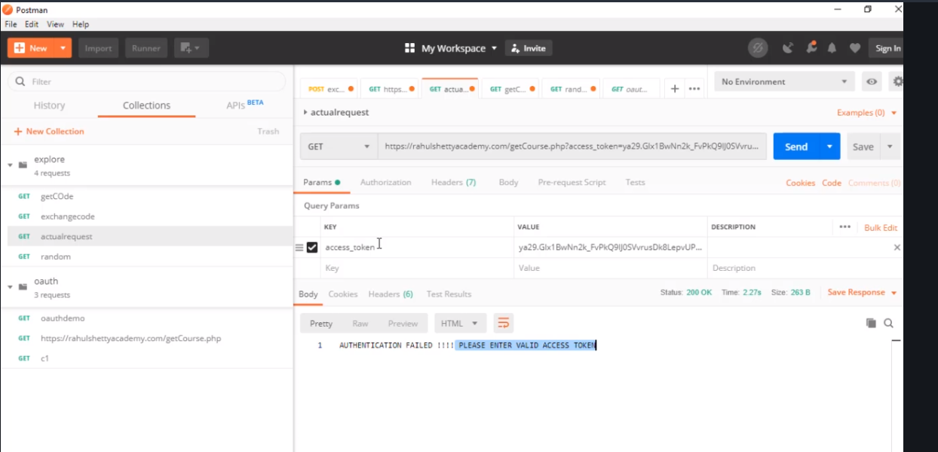

These are the required parameters

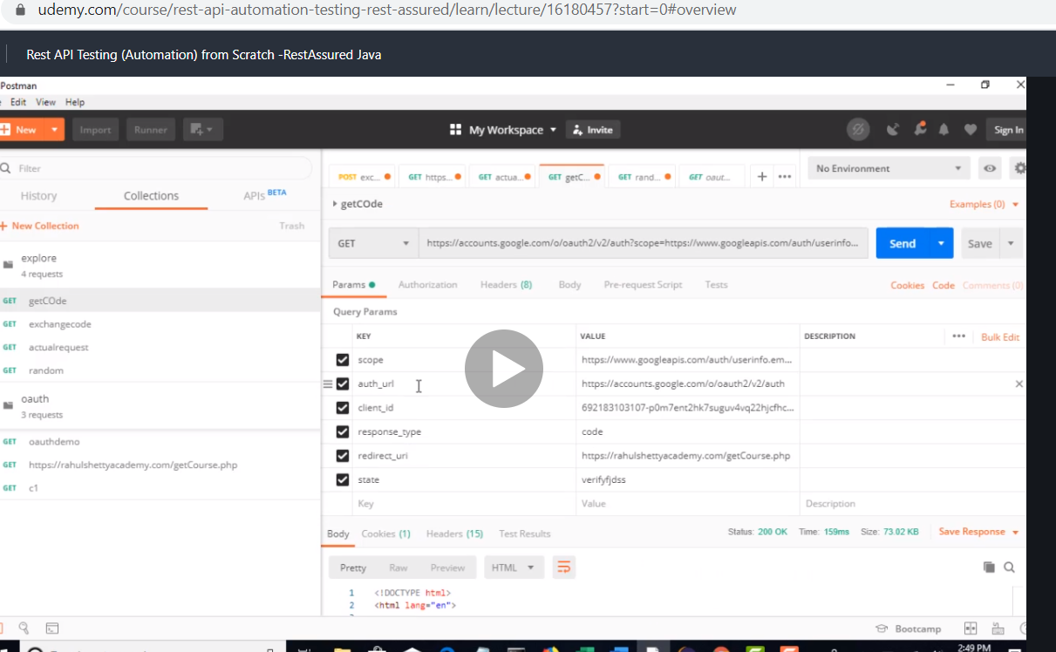

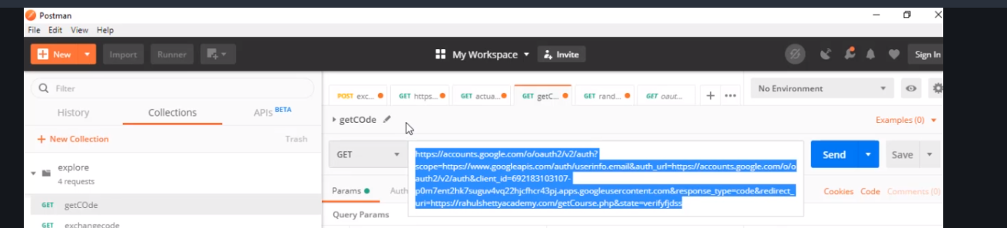

So first step get the url from your dev or whatever but take the code and then log in.

Once you log in the authoristion otp code with be present in your url

Copy it

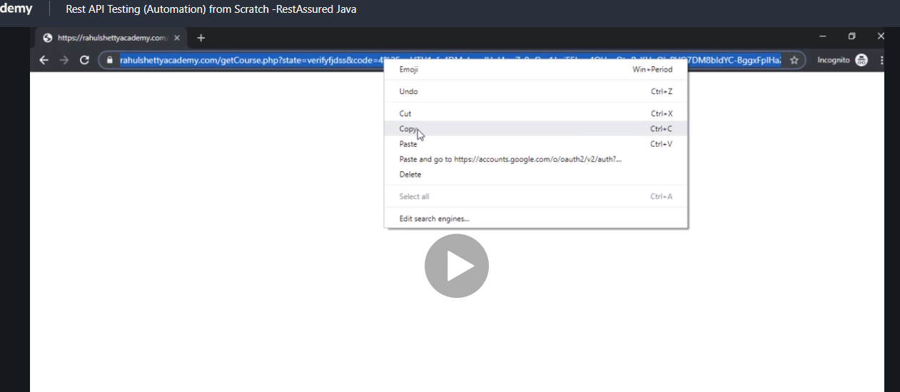

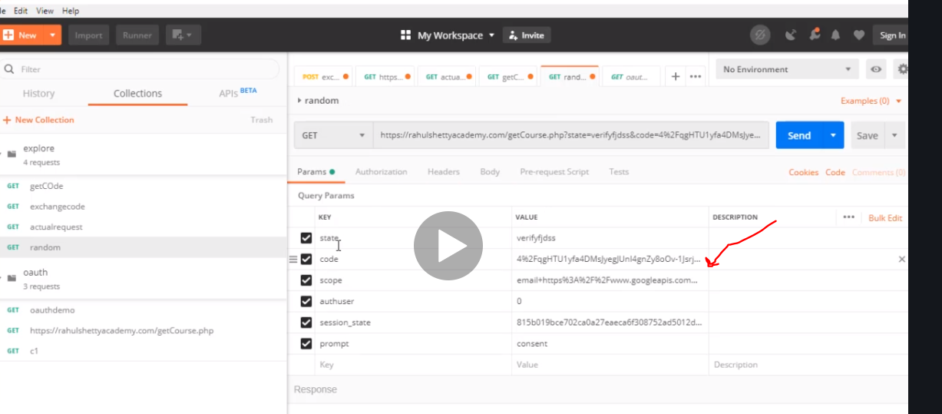

Paste it in postman so it gives you all the parameters. U can see we got the code.

State parameter should be same when u send it and when u get it

Next I think paste it and do a post to get the token

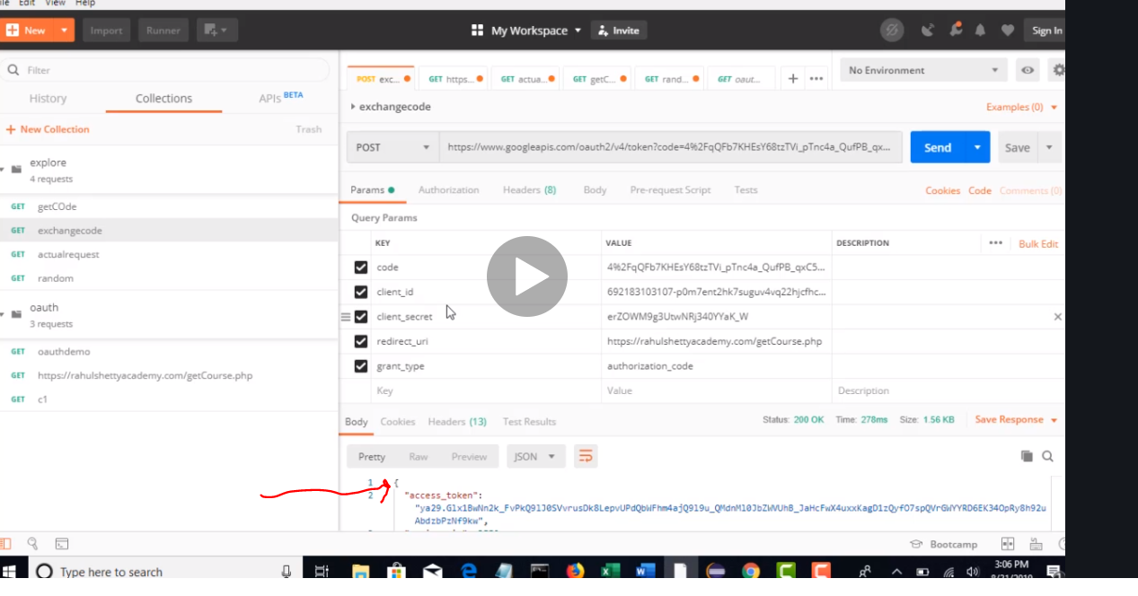

Now copy the token and go back to the actual request where u where initially denied because no token, now try it

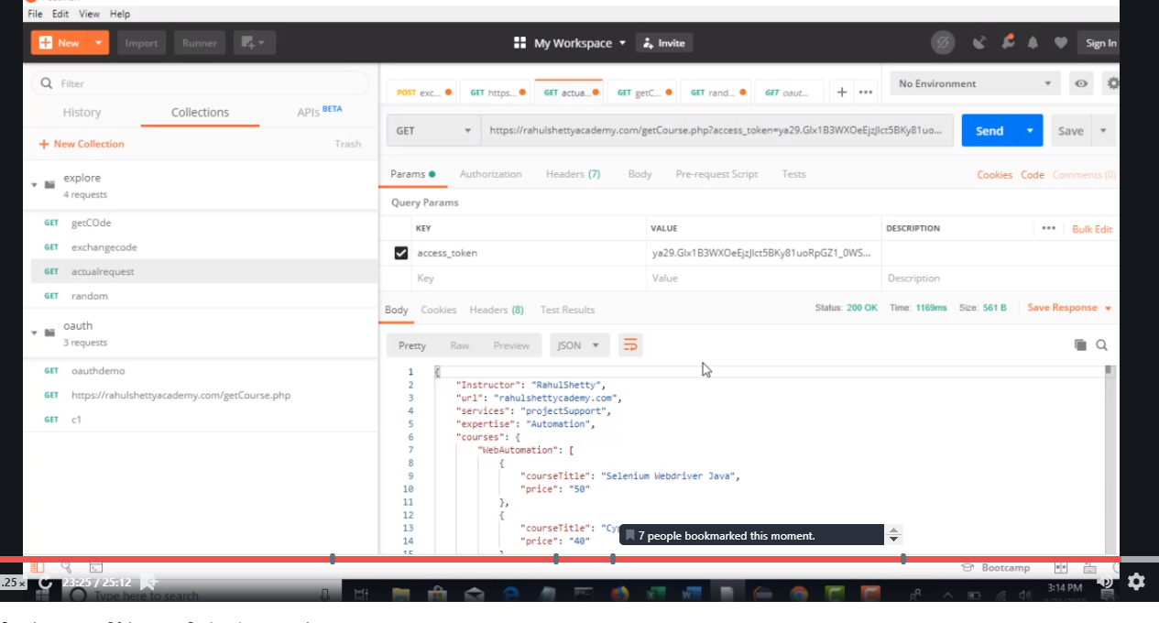

Success now.

Recap

Build the url from postman copy it and paste in browser. Then log in. once you log in, the access code is now in the browser. Now copy the browser url and post it in postman, with a (post) click send now when you do this you get a token…. Now with the token..go back to the original get request which we built and add the token to it and hit send now it wil give u the answer.

Always ask developers for contract details about the api

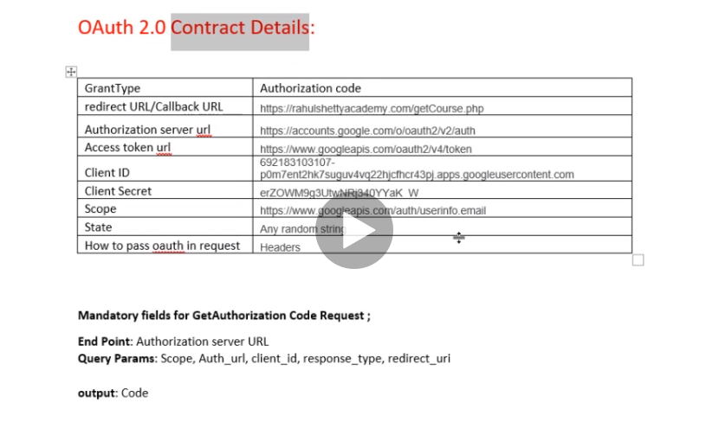

# Now let automath auth 2.0

The main goal is to hit the url

First we need the url and the query parameter which is access token but remember we dnt have access token so we will leave it blank.

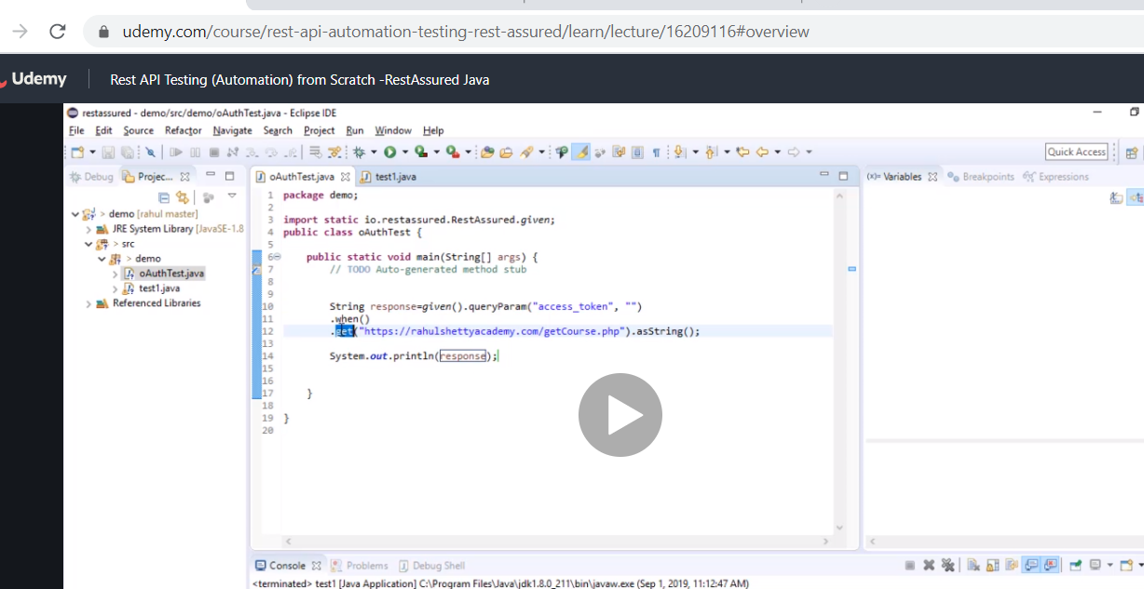

# (shortcut)Now this is a basic way and another method to run the automation to do a get and string faster than the json .

It just convert it straight and save the response.

Now if you run this it will fail because id it didn’t need auth it will work but since it needs it, it will fail till u give it access token

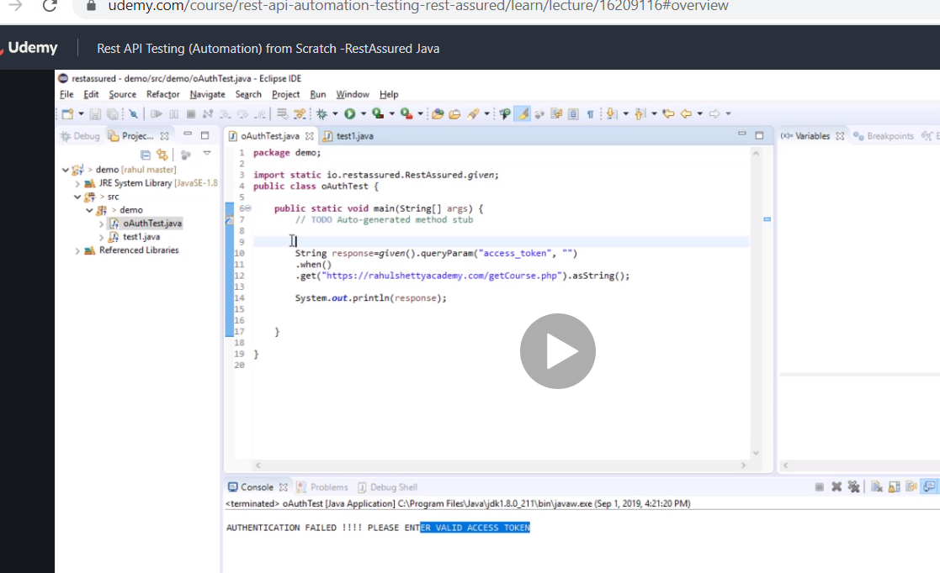

First we will come back to the access token first lets get access code

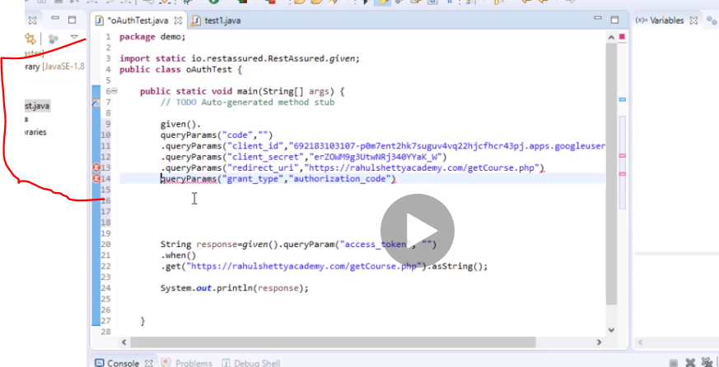

Remember all this parameters are given to you by the developer.

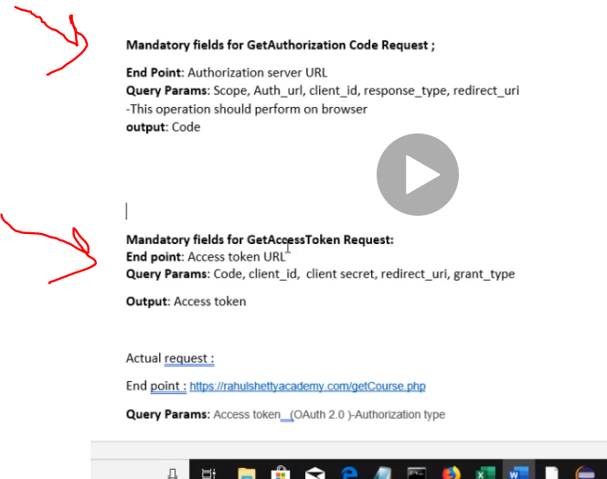

Make sure it matches with your documentation

So we will post to get a response

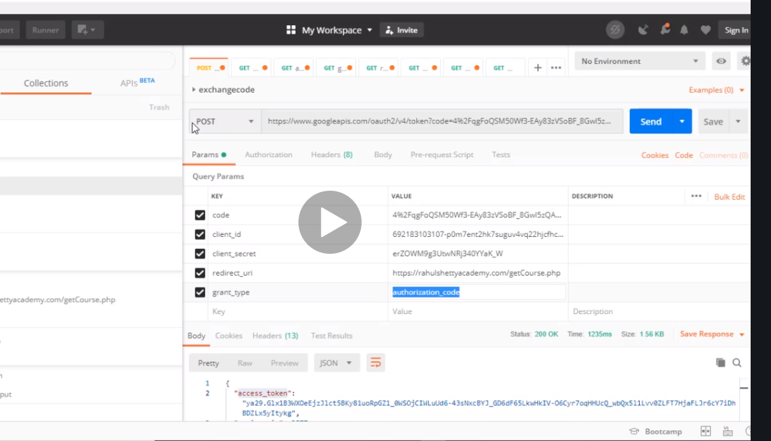

The response is raw json but it is converted to string with this as.string shortcut….remember if we didn’t need authorization we could have just used the one on top and get it easy simple

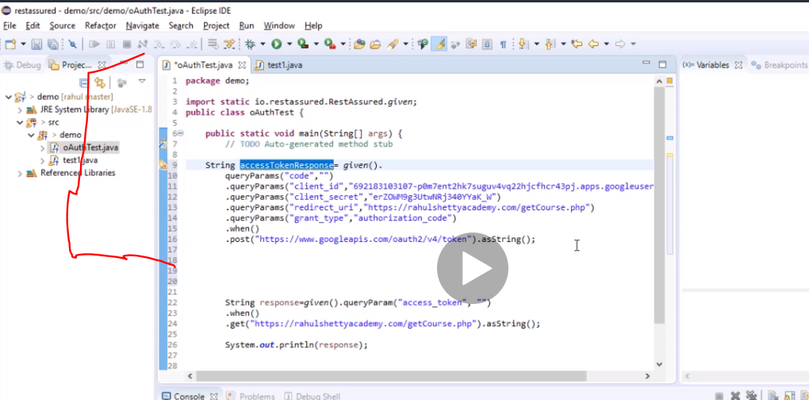

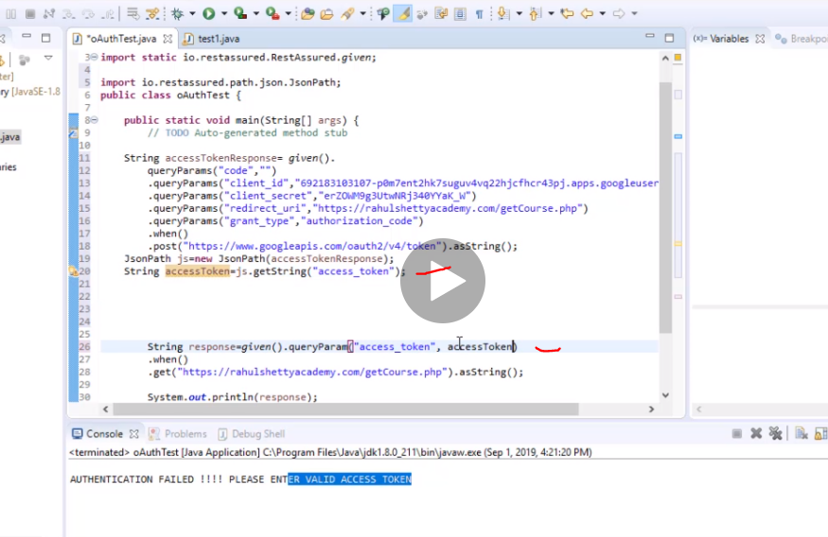

Now we get access token and then we put it back into string response.

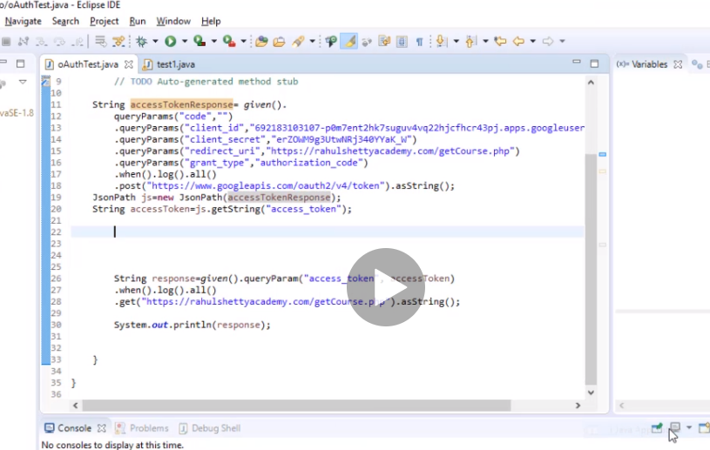

Now manually we go to the browser and log in and the authorisation code is there we copy the ur to postman and post we get the token then finally we take the token and add it to the original link that we put in the browser…it fails first f you try it in postman but after you get token and try it again it works.

But when automating shockingly it seems it’s the last thing we are doing getting automation code last before token??

Ahhhh I remember……. We need to add selenium because te only way to hit the url is with selenium and that is how we will generate the code….which will just run through and automate it.

How cool it is

Back to the first step

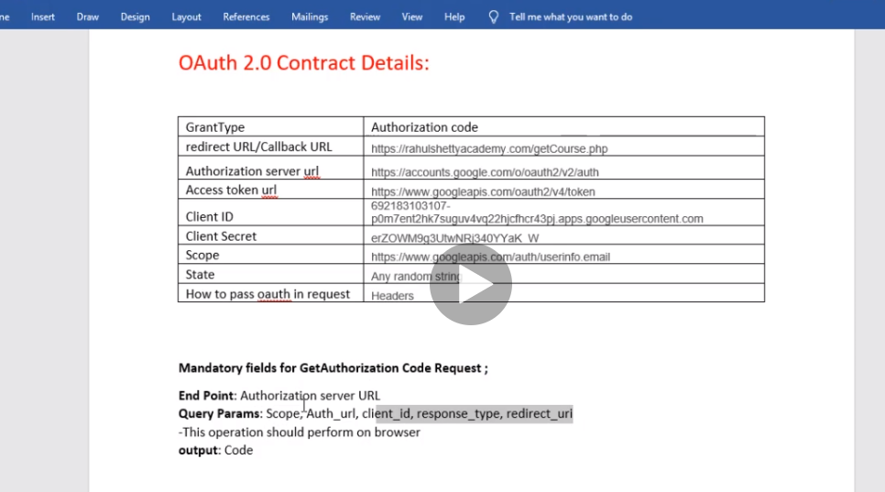

Now we have to input al this to get the output=authorisation code

Remember ask developer to give you all this details add them construct them and then use it to hit the url

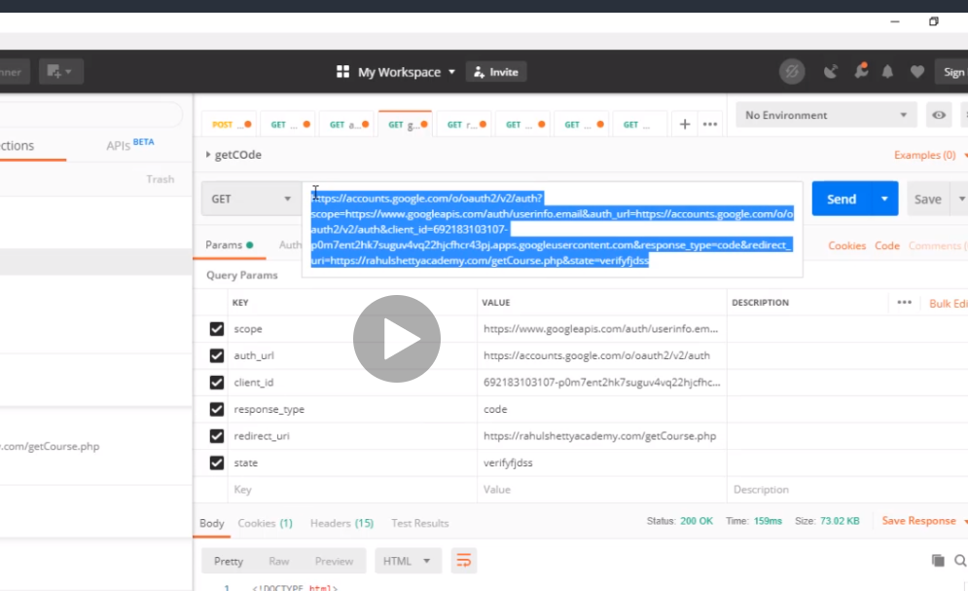

So paste the url in the driver.

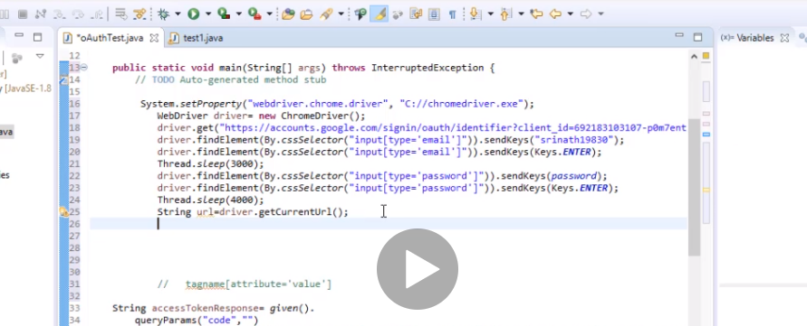

The url it gets will contain the authorisation code but how do we extract the code from the url and pass it into the authorisation code?

So curious to know

Now we will use the concept of split….remember…

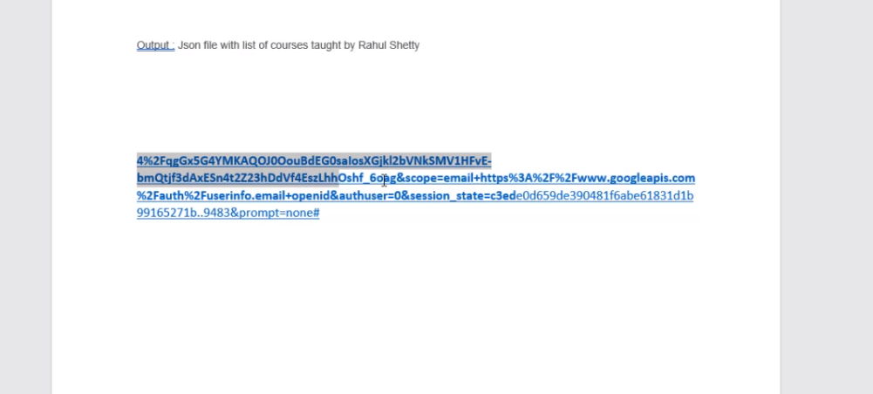

When you do a split, it splits like if you do (&scope) it takes everything up to &scope

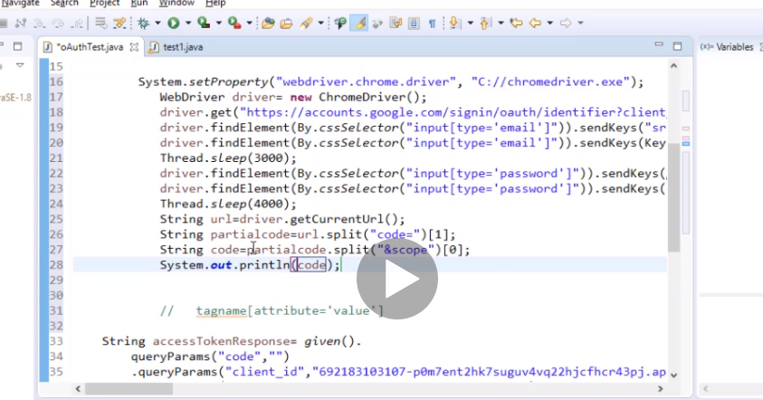

So the code we want is in the first array split.

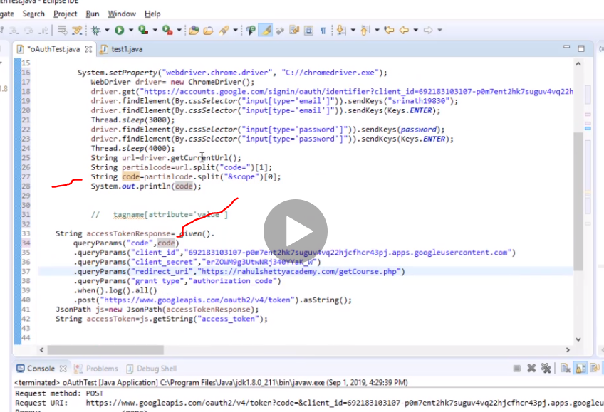

Now u see we take the code and put it hear. How cool it is

# The three step is now complete for dealing with auth but one problem rest assured cant handle special characters

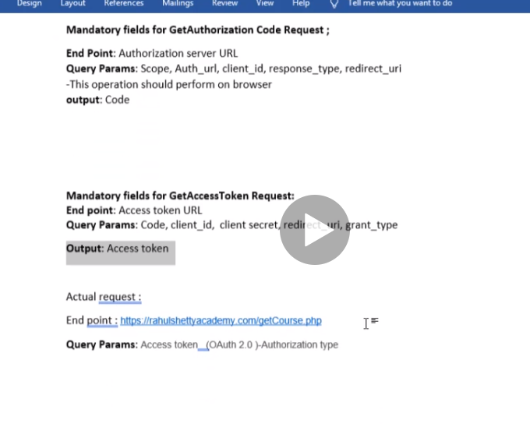

Now take note there is a method that stops rest assured from encoding the code and messing it up

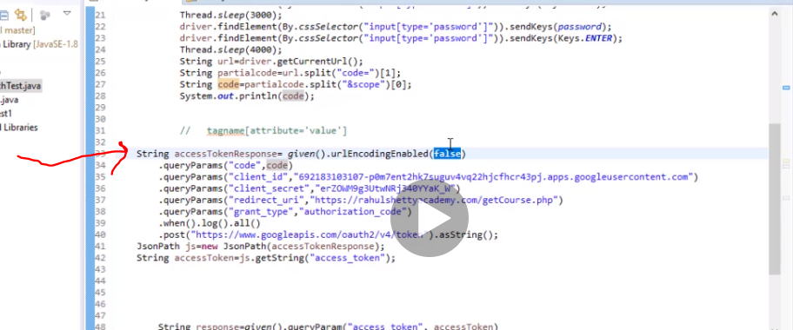

However google stop people from using authomation so now has to be done manually just paste the string and then split and bingo but if its just any other website then we can authomate completely

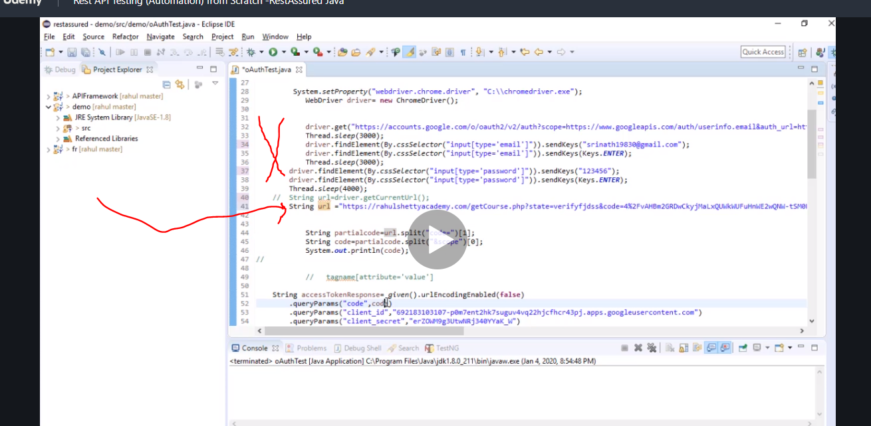

You may not need all that.

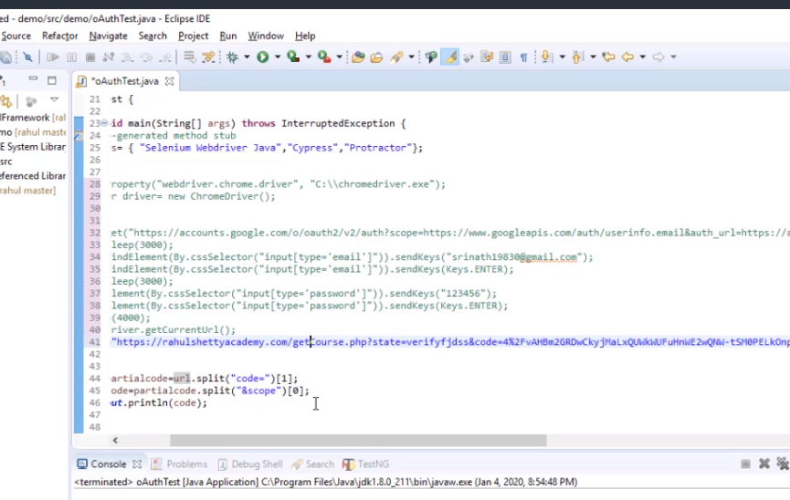

# 2nd grant type…client credentials….

Just needs client id and client security

If interaction does not involve users just owner and resources….

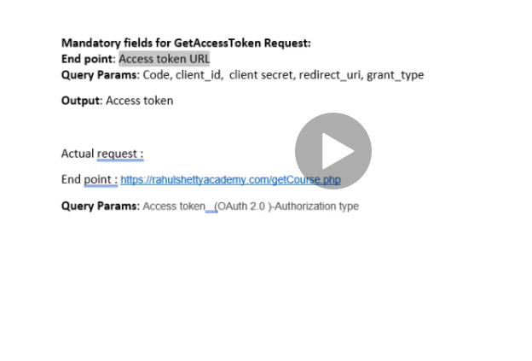

Start with step 2 here unlike authorisation code step 1

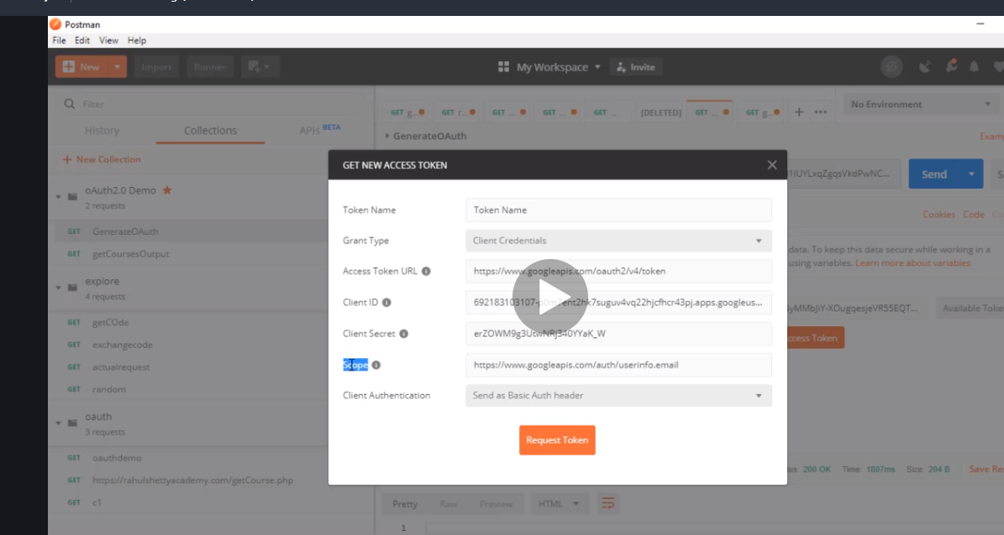

Just ask dev for it

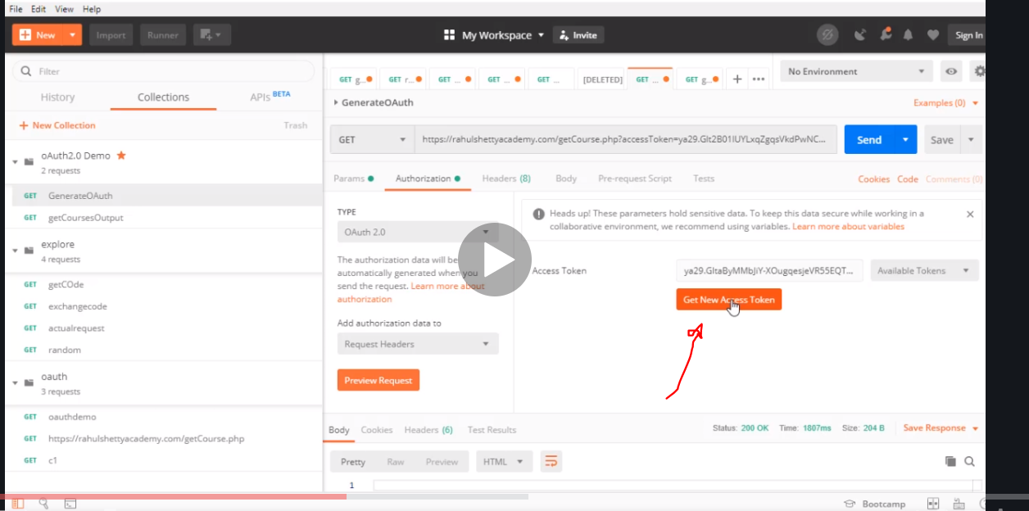

You can just click that in postman and just select the type of grant …authorisation or client credentials

Automate it from step 2…just get the token once the dev gives you all the details and just plug it in

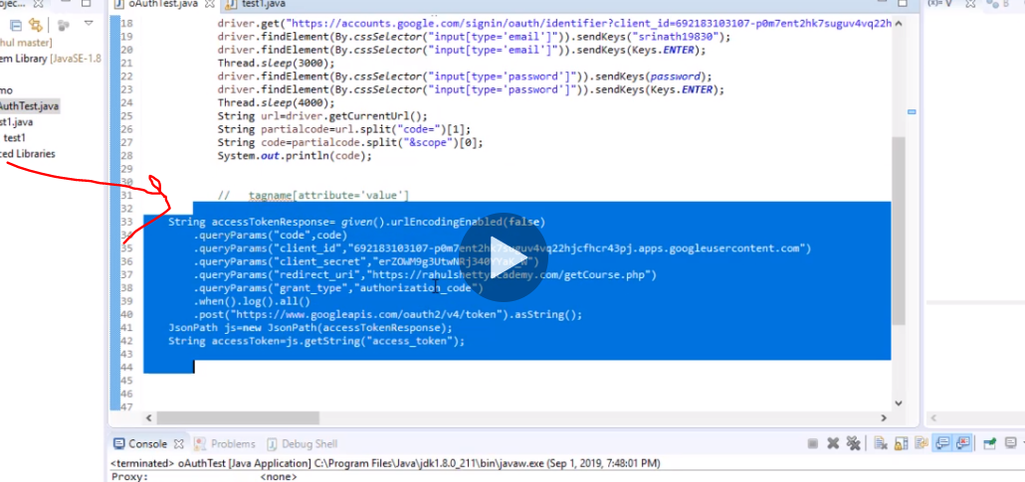

You wnt need query parameter for code redirect url and redirect url

# Serialization

This is very important. Build your payload.

Send it get it and scan your request to

Serialization Convert java object to request body

# Now pojo code

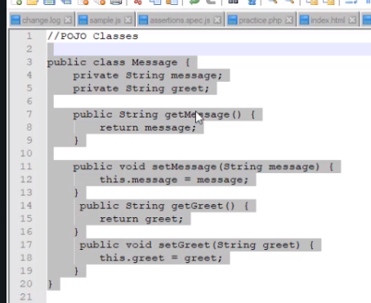

Create getters and setters

So rest assured converts pojo classes into json format

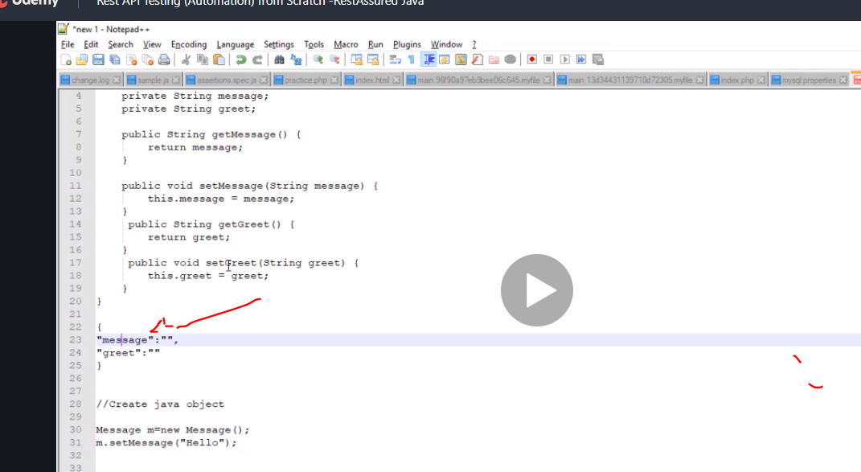

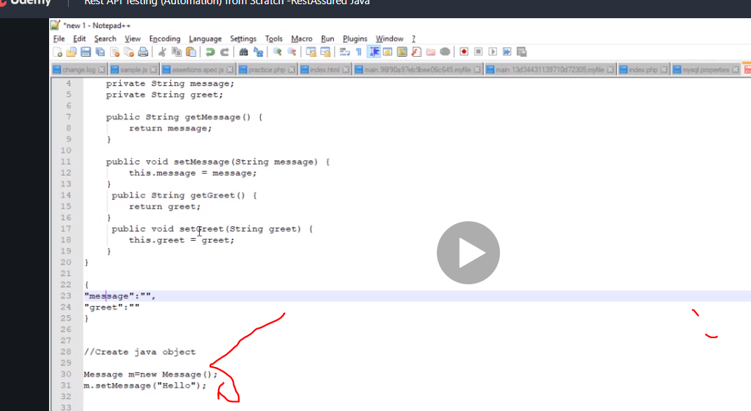

So when you put value there it goes to pojo and from pojo ggoes to json body

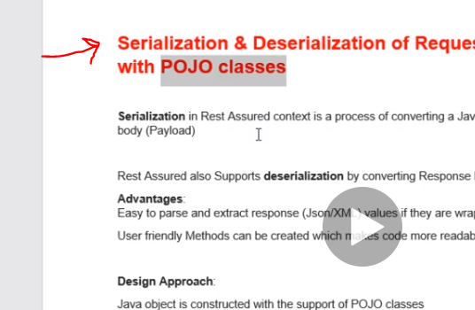

So the geng beng here is when you have a payload, look at the structure of the payload and then design a pojo class for it

By looking at the payload body above we could tell we had two variable message and greet….so you create two pojo cariables.

So create pojo and pass all setters to it.

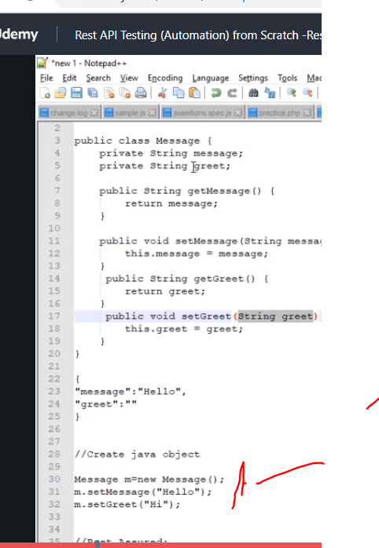

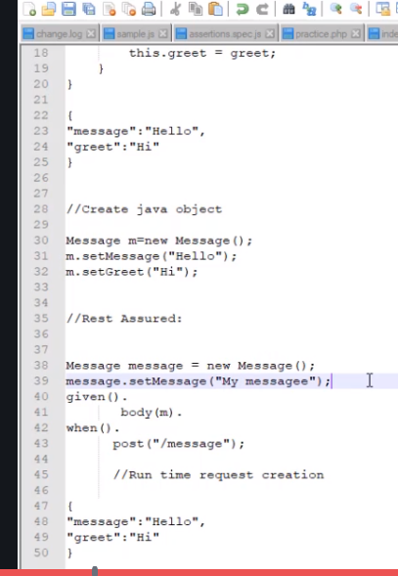

3 complete steps pojo , java object and rest assured.

# Deserialization

In the case of serialization setters played the gengbeng roll but with deserialization the gengbeng is with getters….

With this you are able to extract the method In your response

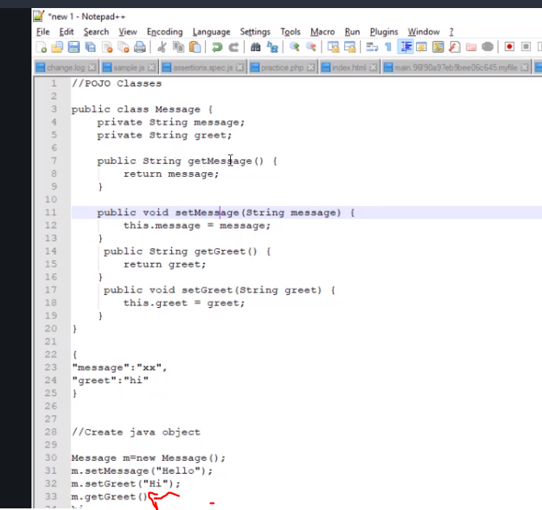

# External libraries for derilisation

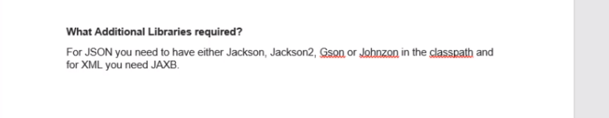

Download

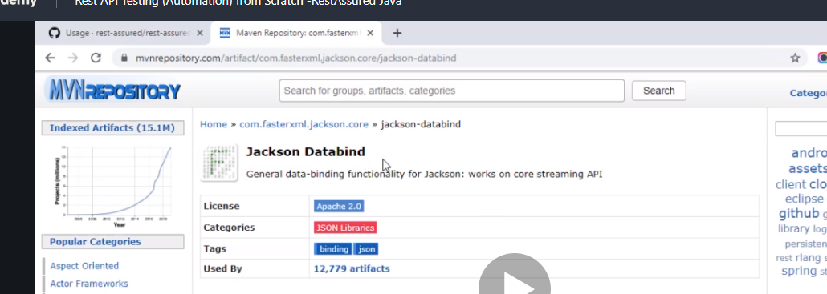

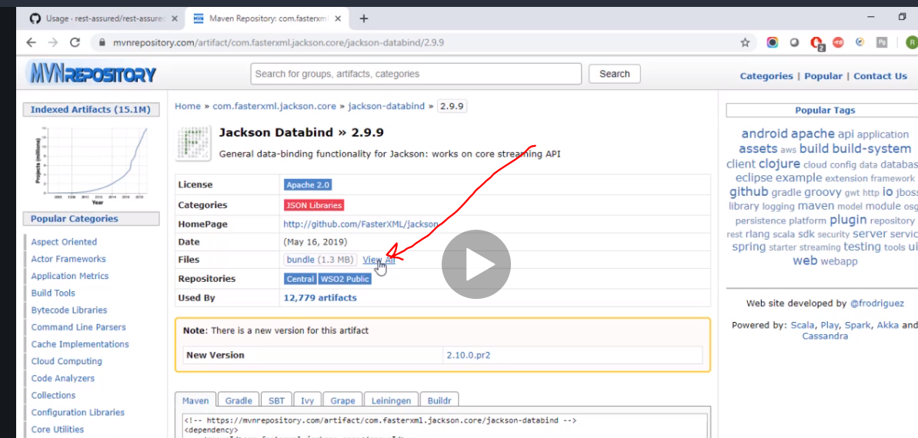

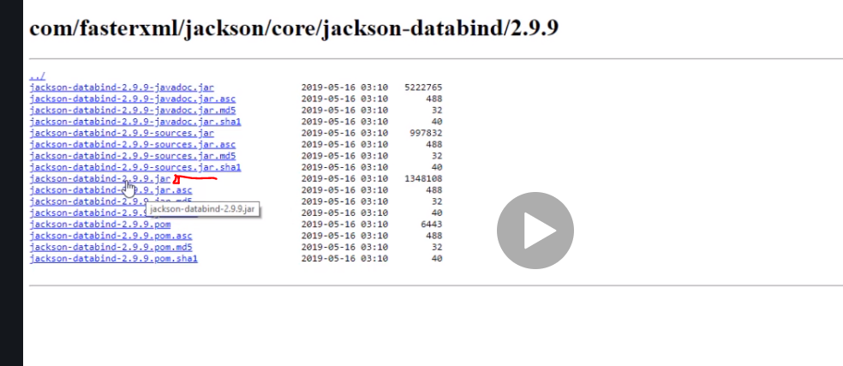

Also download Jackson core and notation and all same version.

Download gson

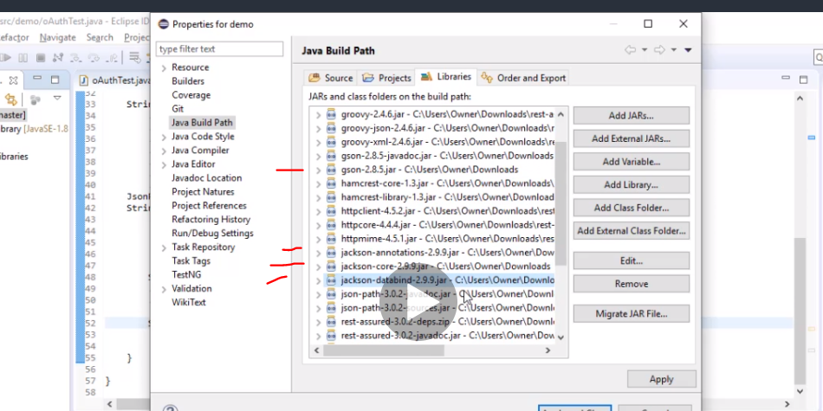

Now your project is ready for deserialization and deserialization

Now lets make a start

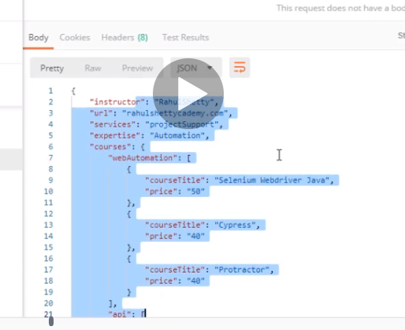

Now copy a response body just a random one to explain the main point and paste in jsooneditor

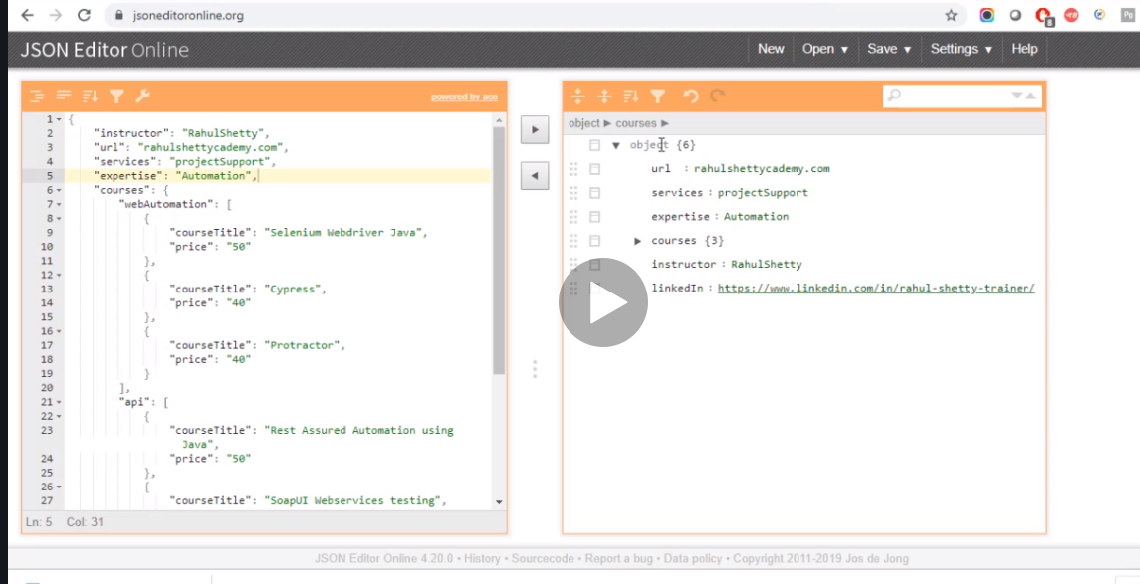

Here how many variables do we have? 6 means we will create 6 variable with 6 getters and setters methods

First create a pojo

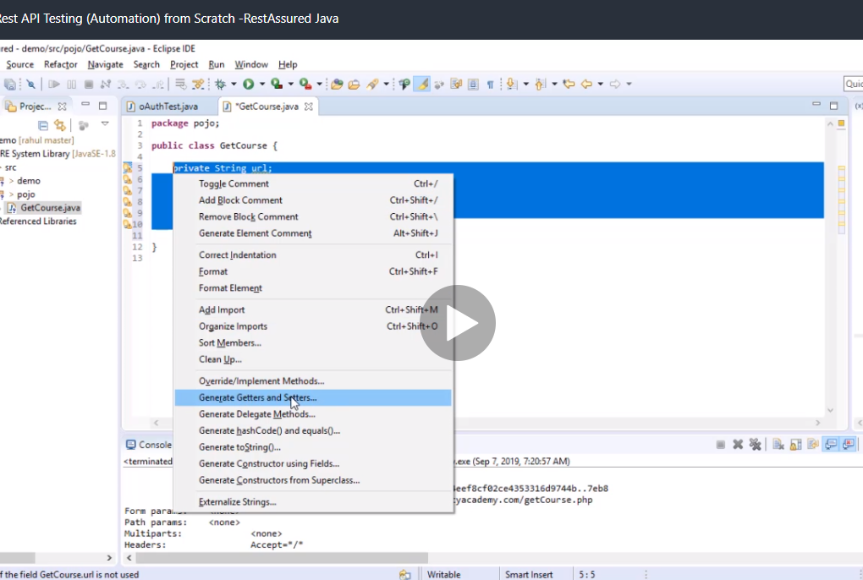

Do alt +shift+ s after selecting all to generate getters and setters

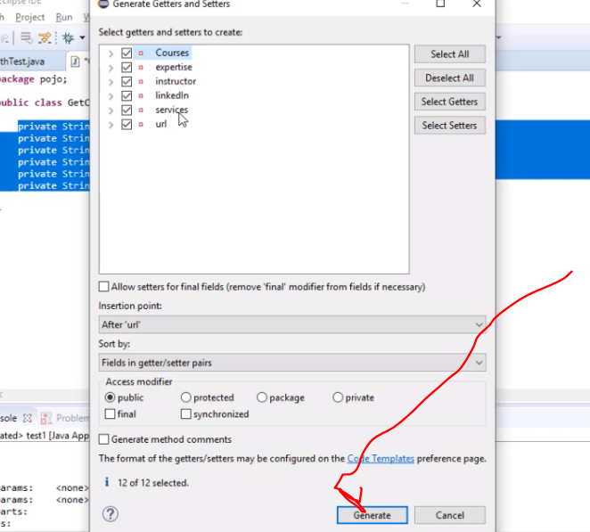

Now take note this looks straight forward and its easy but sheety chose a complicated scenario if you notice……

Courses is a parent with 3 children

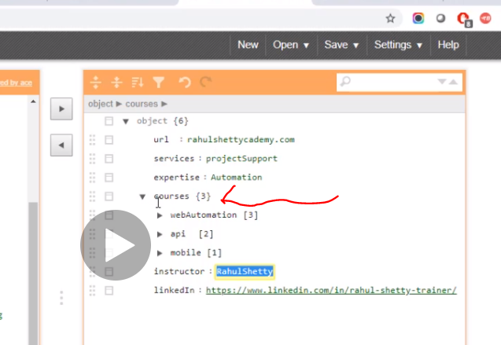

It is a nested json. Json inside a json

Also notice it is not only an nested json it is also an array

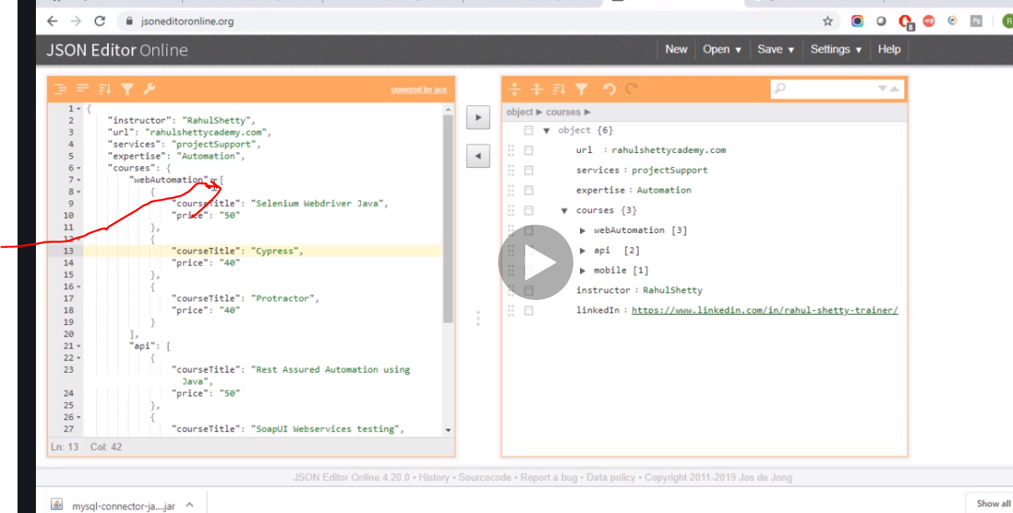

So we have to solve this first and then we build pojo

Now object(6) is the main json…forget about it lets handle the child json courses(3)

Now lets create another pojo for courses

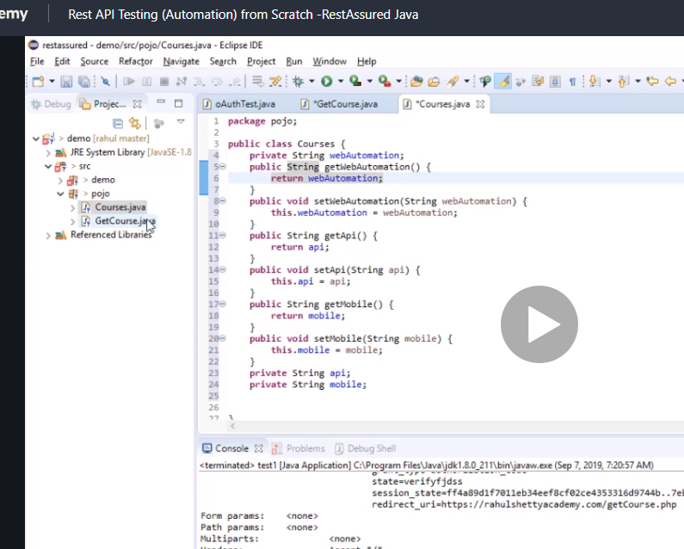

Now we need to inject the child mini json pojo into the main pojo json for courses

So in main json change the string to courses because its no longer a string it is now injecting from mini json

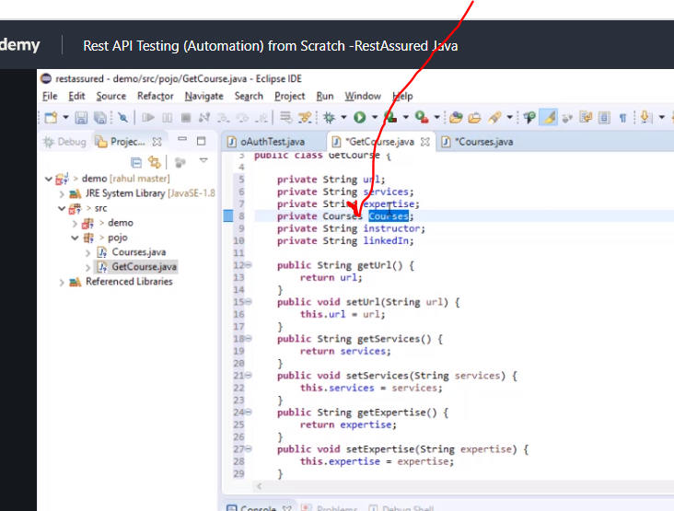

Change the getters and setters for courses as well as they are not strings

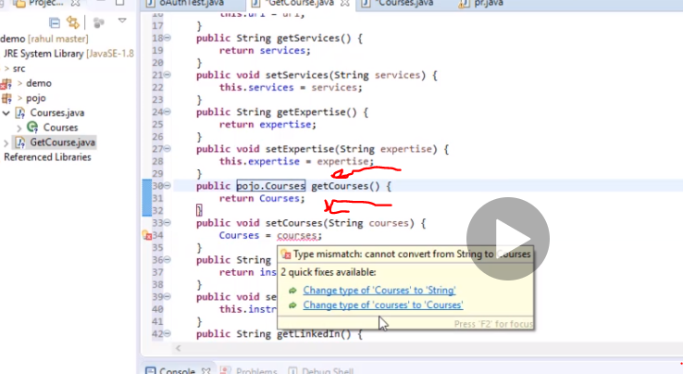

Another issue

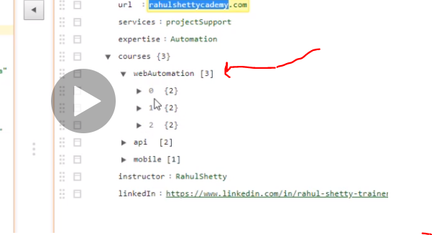

Web automation has arrays in it aswell

Now we need to create three more child classes and apply the same concept to inject them

The real variables are inside so it will soon be solved

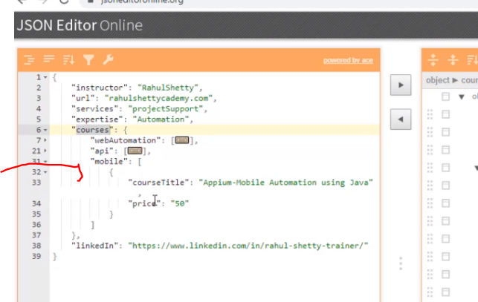

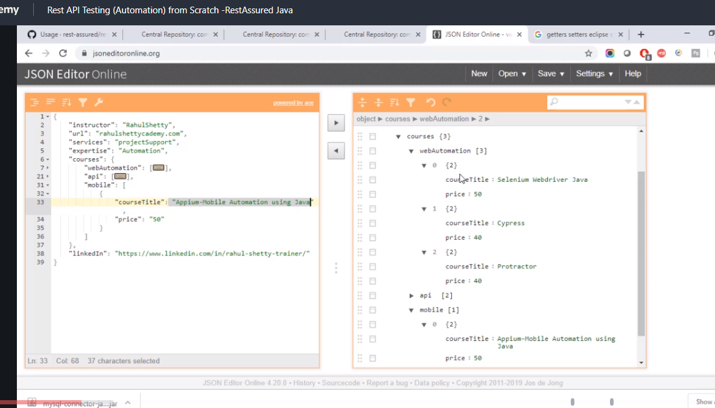

Just select one json from the arrays dnt panic its same.

You can see they all have course title and price.

So give them string return types because they are real strings…..both of them

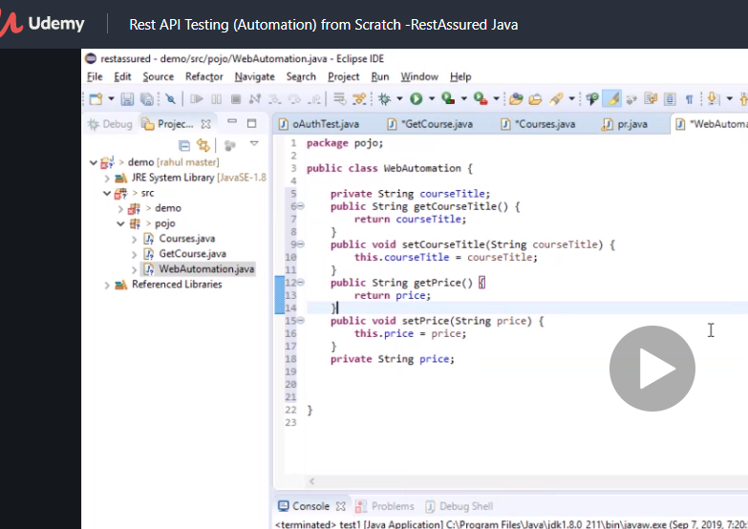

Now we copy this and create for api and mobile

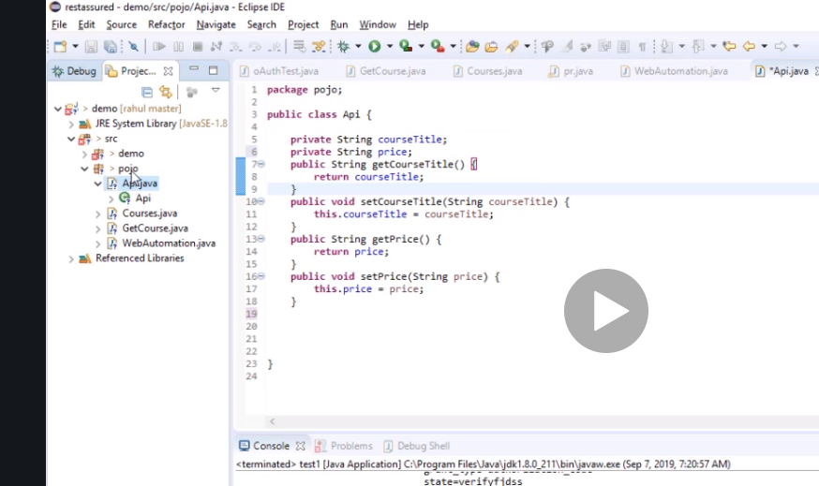

And mobile

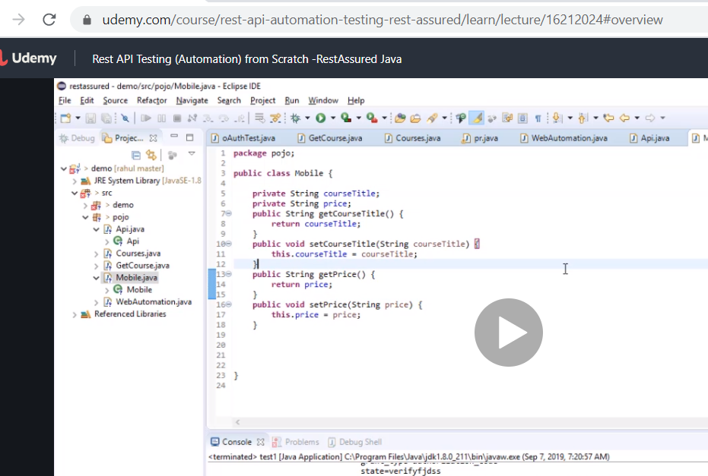

Now three child classes created so we need to inject it into the parent courses

Now remember what we did before since we are now using webautomation, mobile and api classes in the parent, they cant be strings so we have to change it

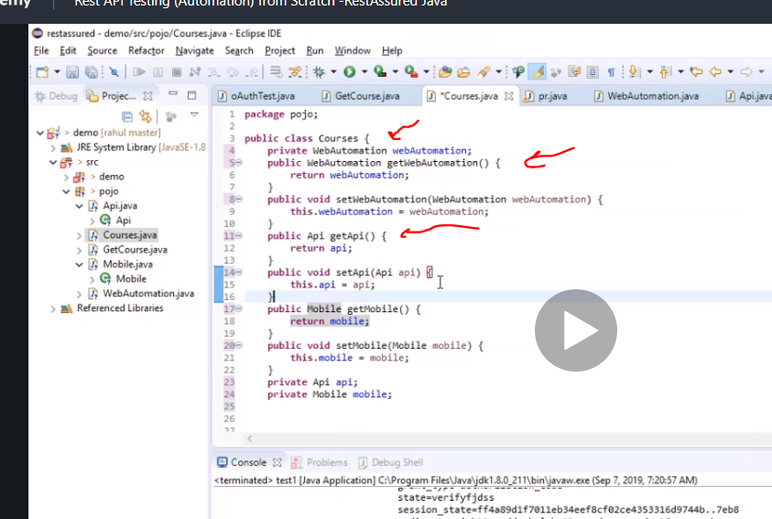

So change them and use getter and setters like we did before instead of manually changing all.

But remember its an array so you have to tell it to expect an array and not just those elements

So we need to add list and do the getter setter again

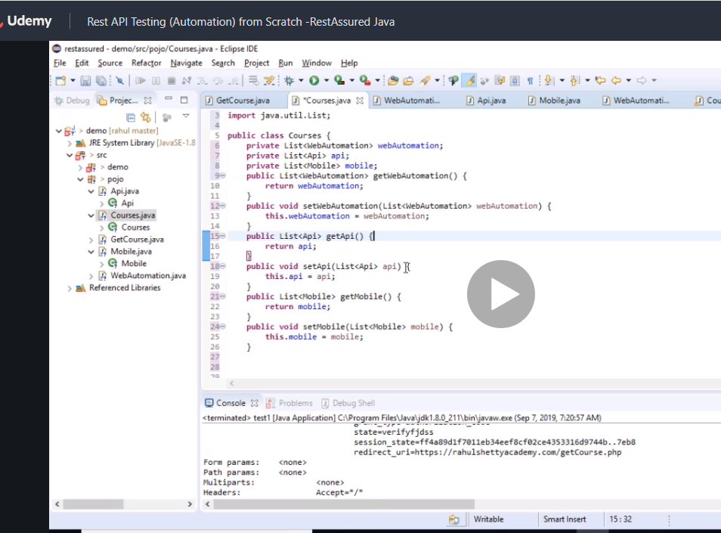

So to build your pojo it goes like this

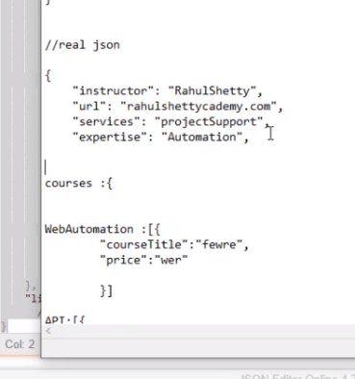

Insturtor to expertise no nested json so easy courses that’s how to write a nested json array.

# DEserilise

To desearialise what we are doing here remember we created a method

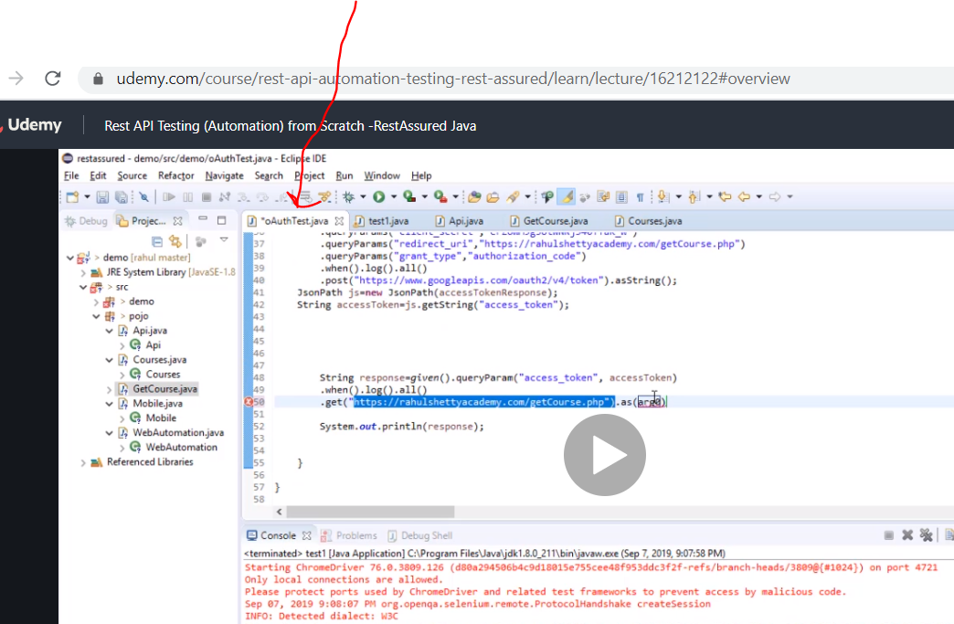

With oauth…. Now remember the as.string now we are removing it and instead we are using the parent class which is GetCourses

Now we have attached our pojo class to our actual response

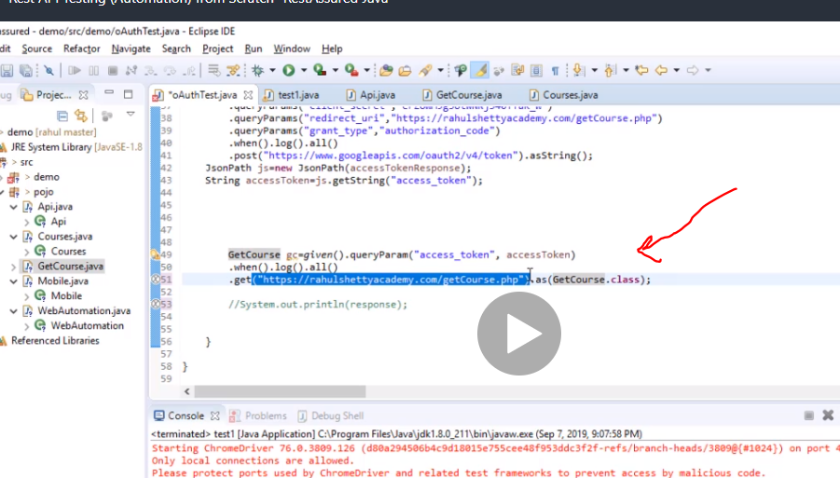

In addition you need to add this to let it know if to expect json or xml

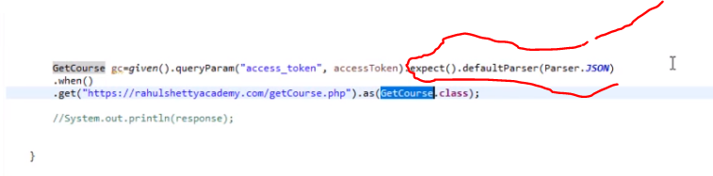

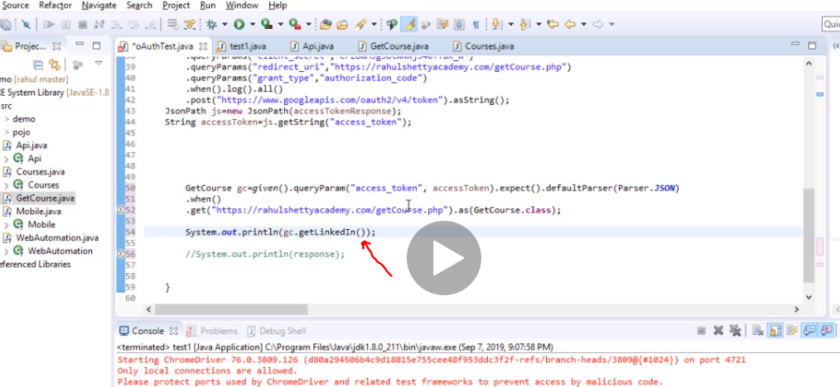

Now this will get the value of the get linkedIN property value from json just by calling the method, how cool it is

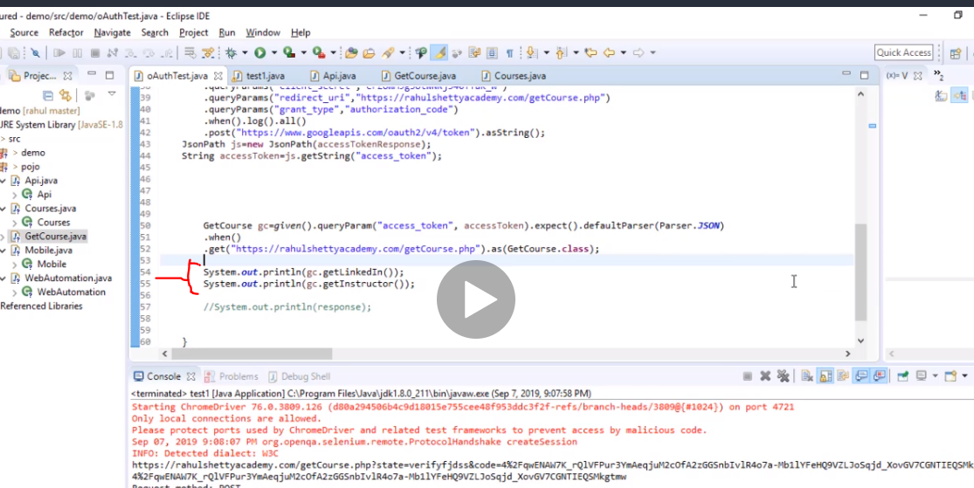

Now lets run it now

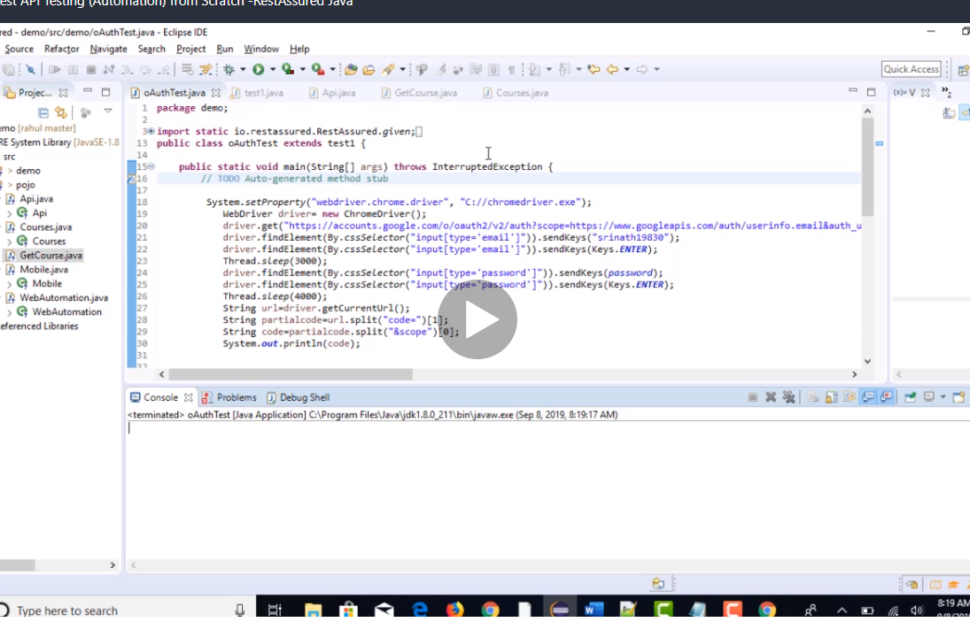

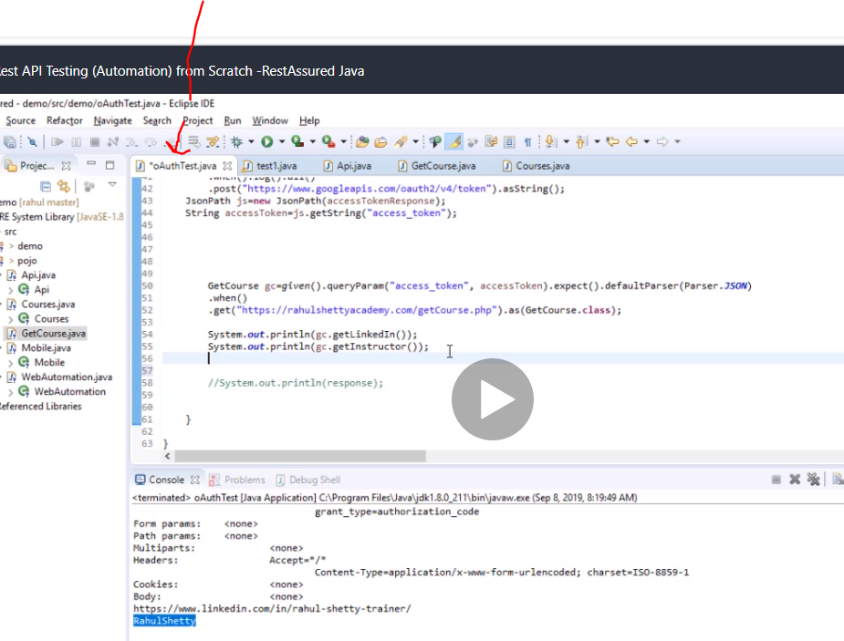

Works.

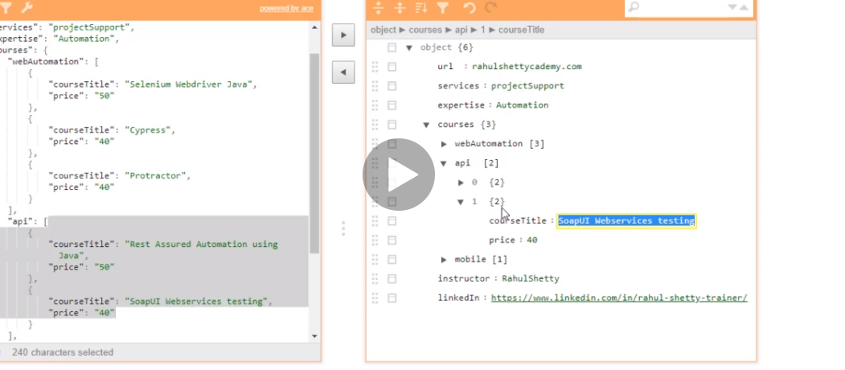

Now we want to navigate to soupUI webservices testing and pull the price

We have used index but the problem is if it changes then there is a problem hene we need a

dynamic way to get it with iteration for loop and if

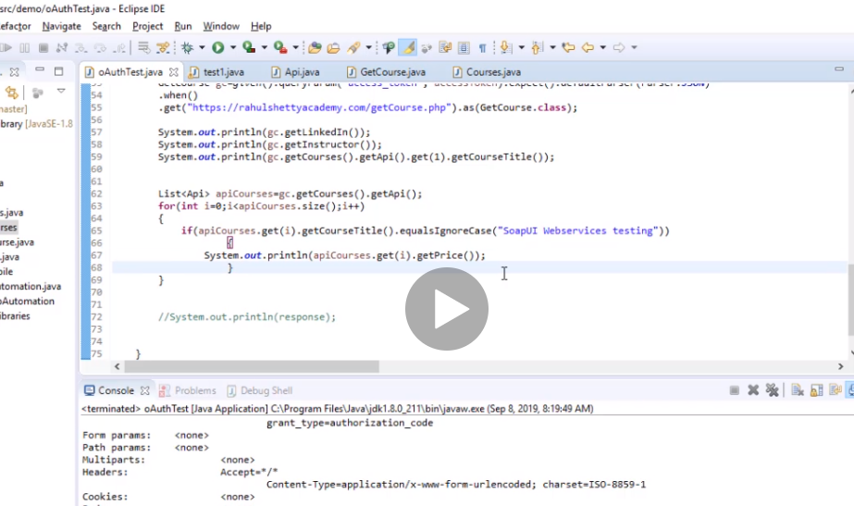

Note we have done all this with java basic nothing json extract.

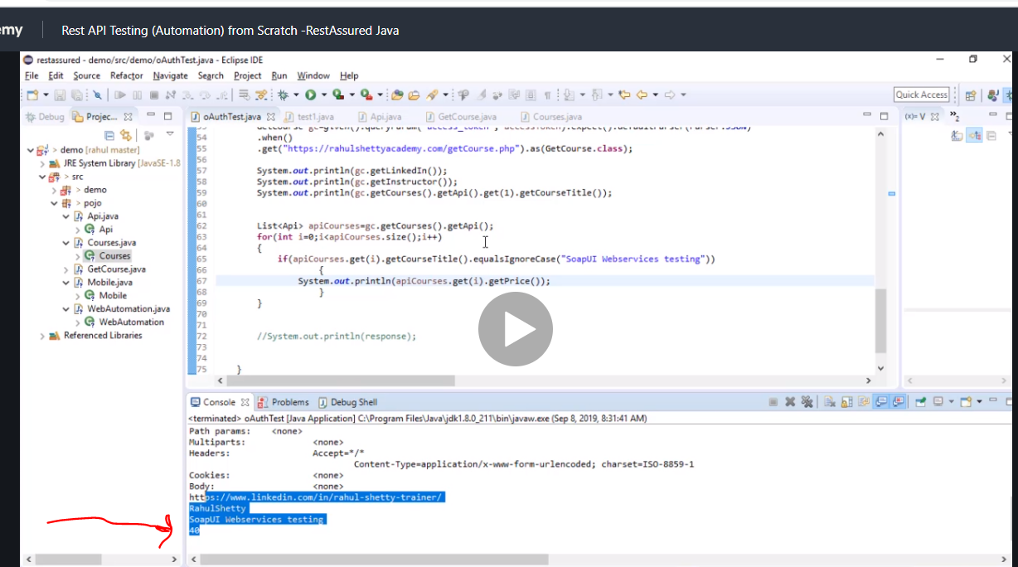

# Now get the titles for web automation and print it also use arraylist

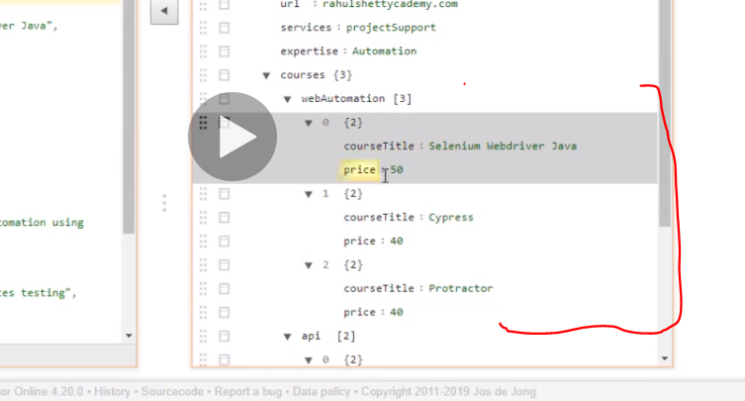

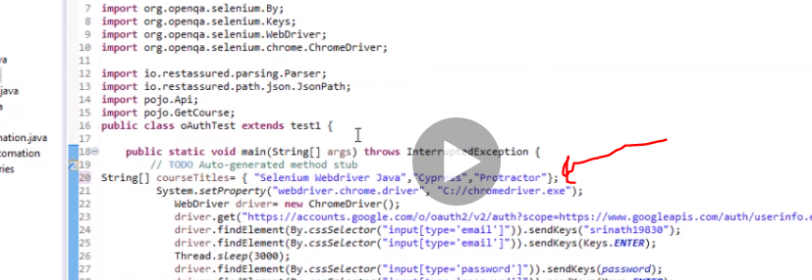

Add that line 20 then

Array list is used to add stuff to the array list.

We also converted the line 20 coursetitle to an array list so we can compare it

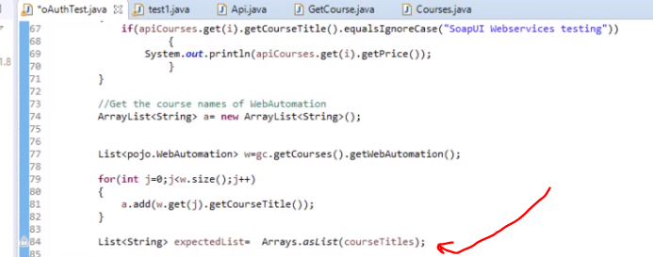

Now we compare the two lists

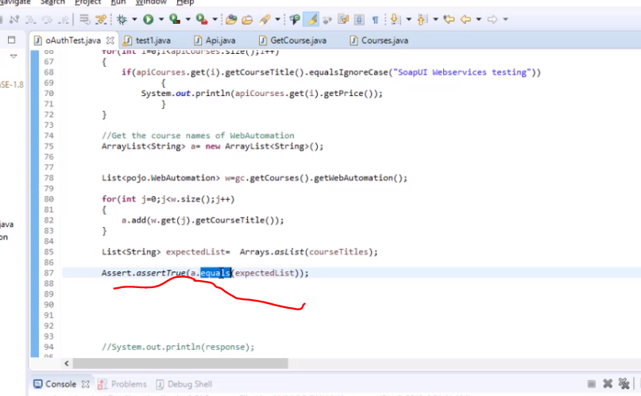

Deserialization has to do with get method.

# Serialization

Has to do with set method.

Convert java object to json. Reverse of serialization.

Now lets use serialisation concept

First what does the payload look like?

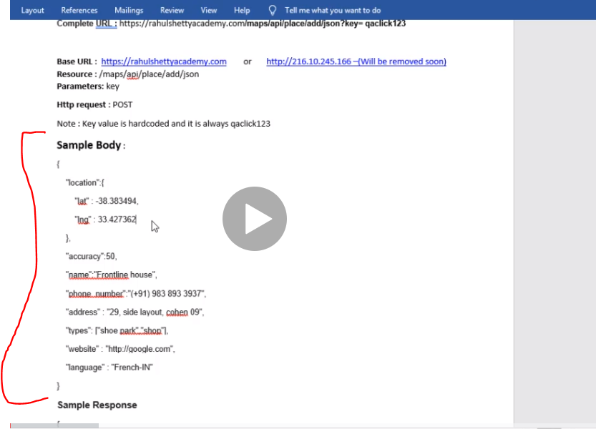

Ita a http post request as you can see

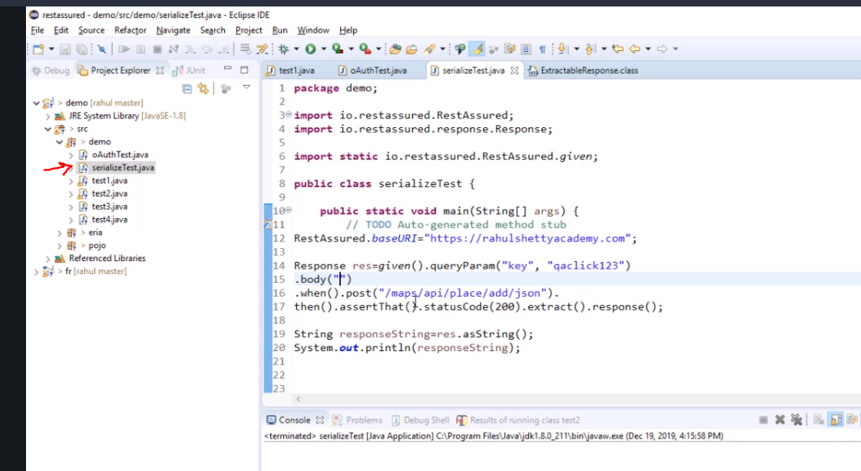

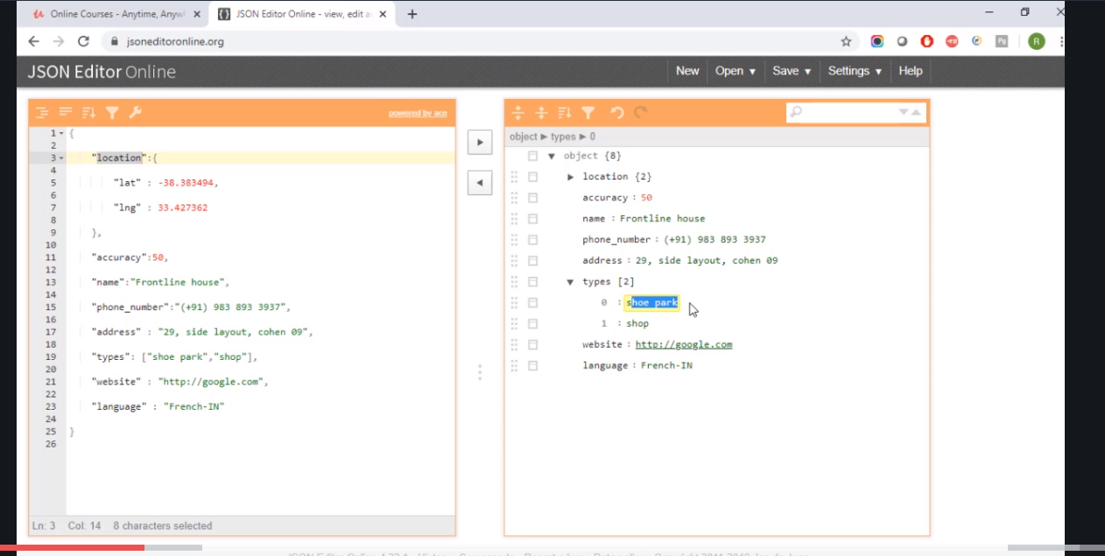

Some nested json and array here.

First create a main json like we did for all of them , then if need be create mini jsons for the rest and them inject them all to the main json.

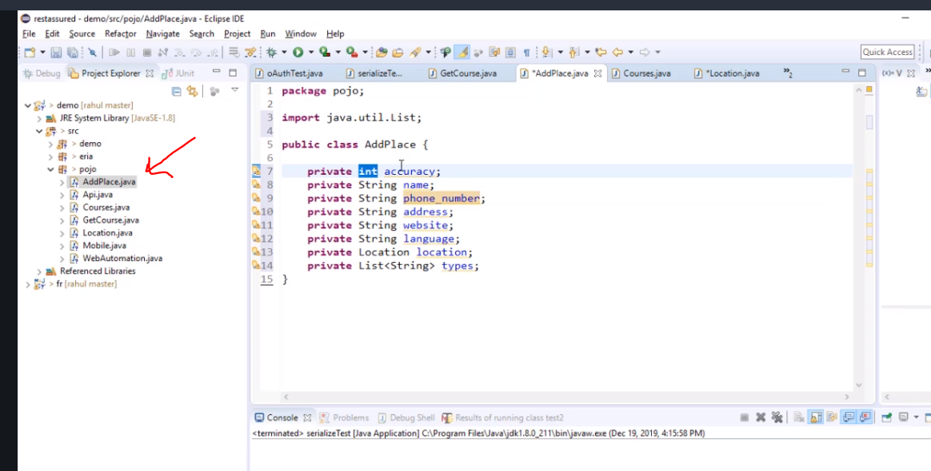

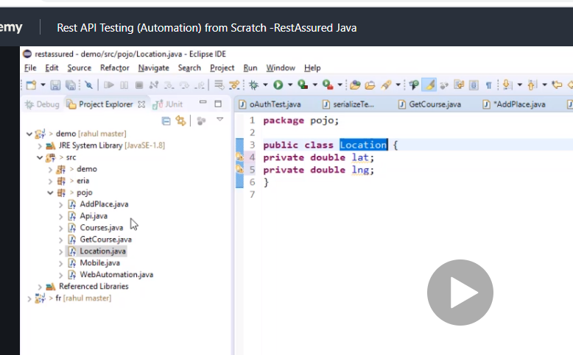

Has negative number so we use double. This is the mini json for location

Now get setters and getters….

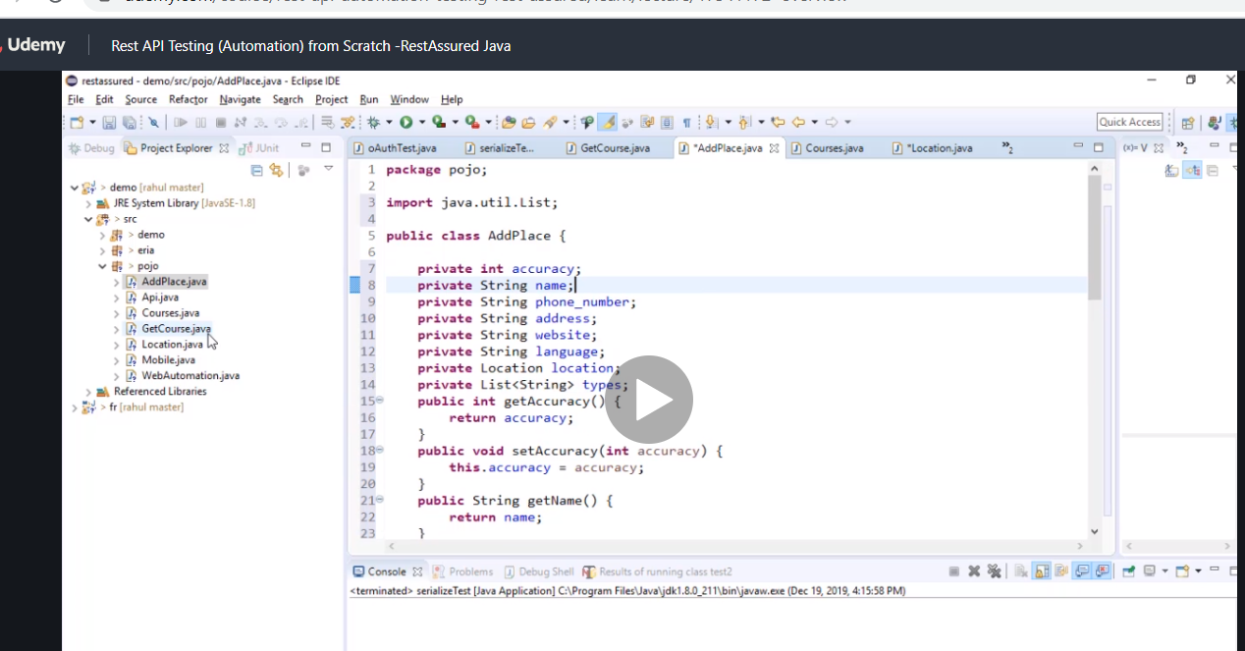

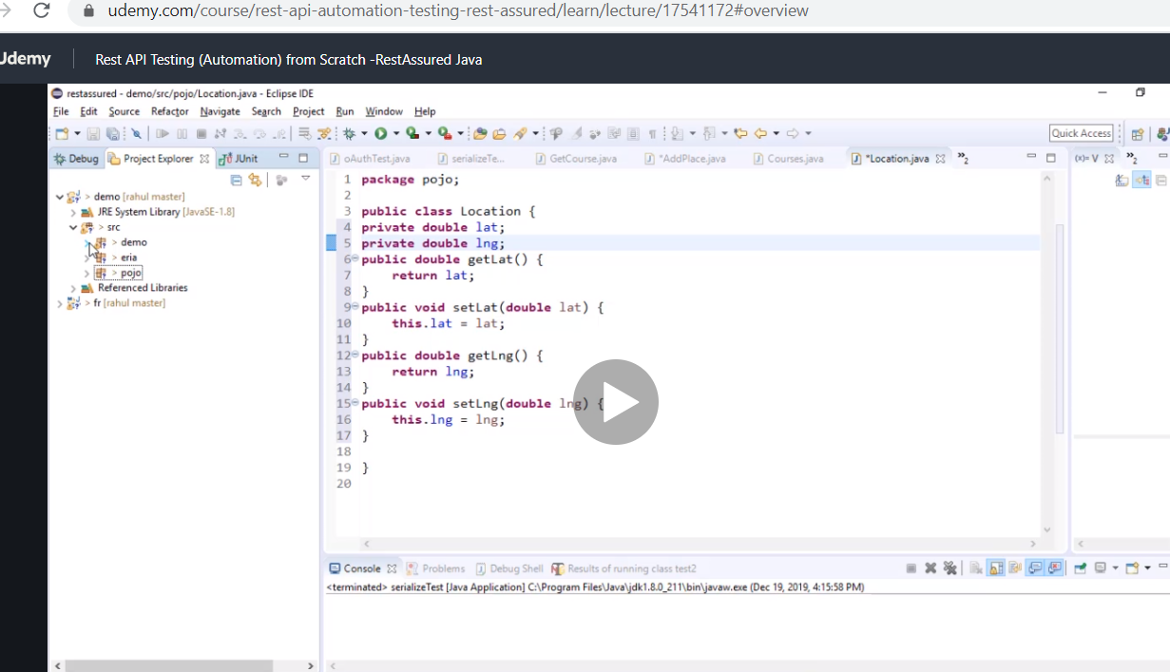

Now we set the body pay attention to how we intelligently set location and also how we created an object for the list of arrays and added things to the list

# Create an array list and add strings into the list cool

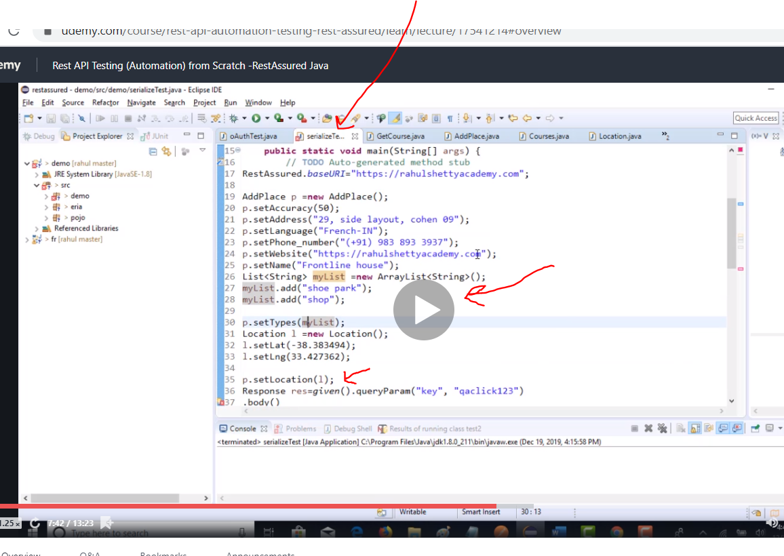

Now simply pass p…..which is the object for our body.

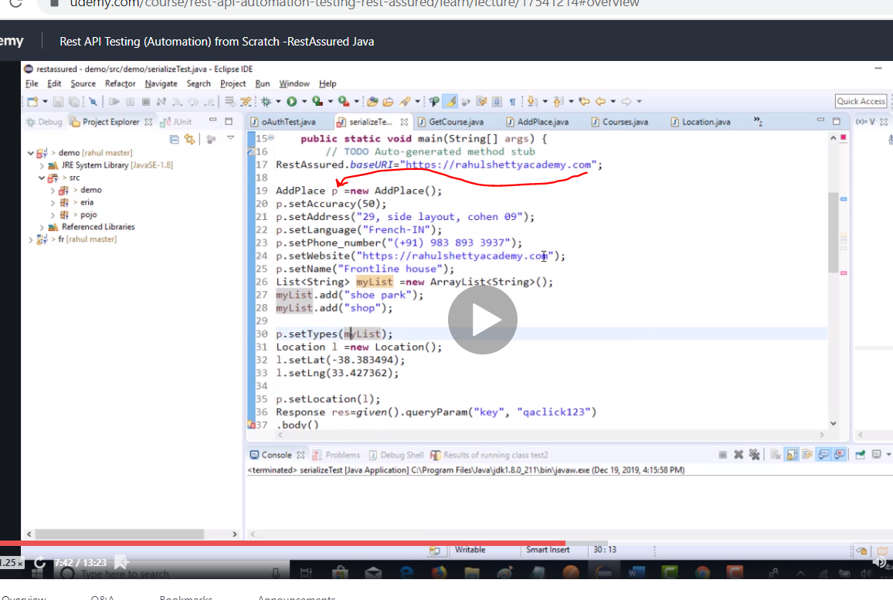

Now we put p in the body

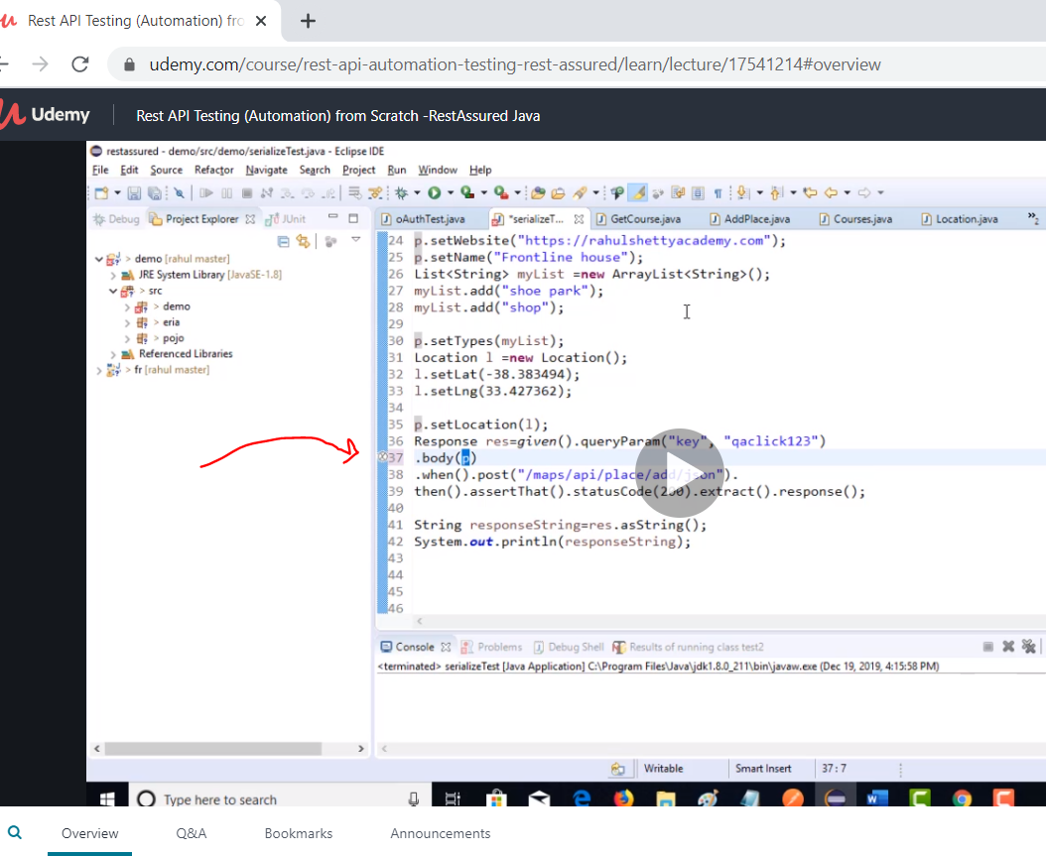

# Request and respect builders

When we have same request why not make it unique instead repeating…that’s what this is for automation.

Then a build method will build all the values.

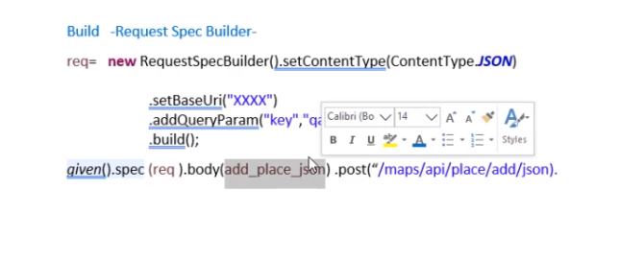

Req is the request to use multiple times .

Spec builder class is used instead of duplicating

This is request builder

Then we have response builder

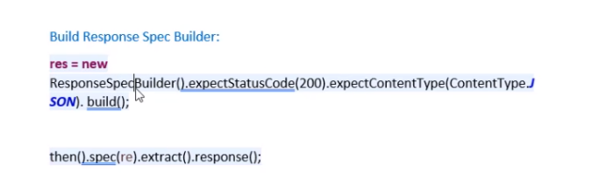

# Now practical example of spec

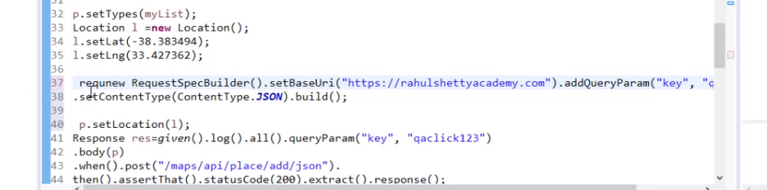

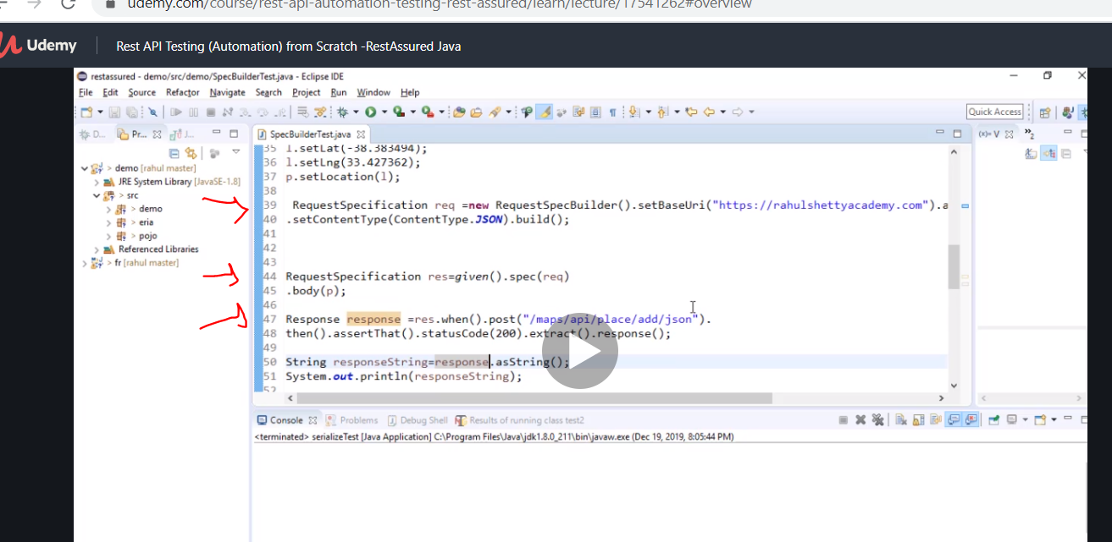

Compare the difference remember the spec builder class was a copy of serialisation so compare the changes to see how he used it

So ths is the idea for request we use set and for response builder we use expect

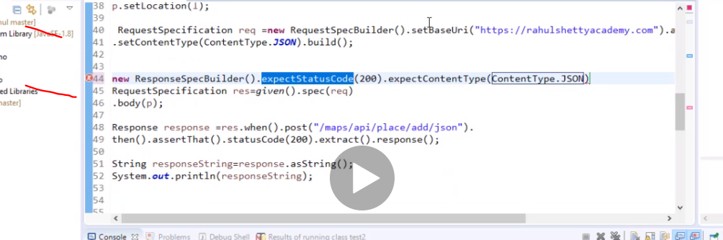

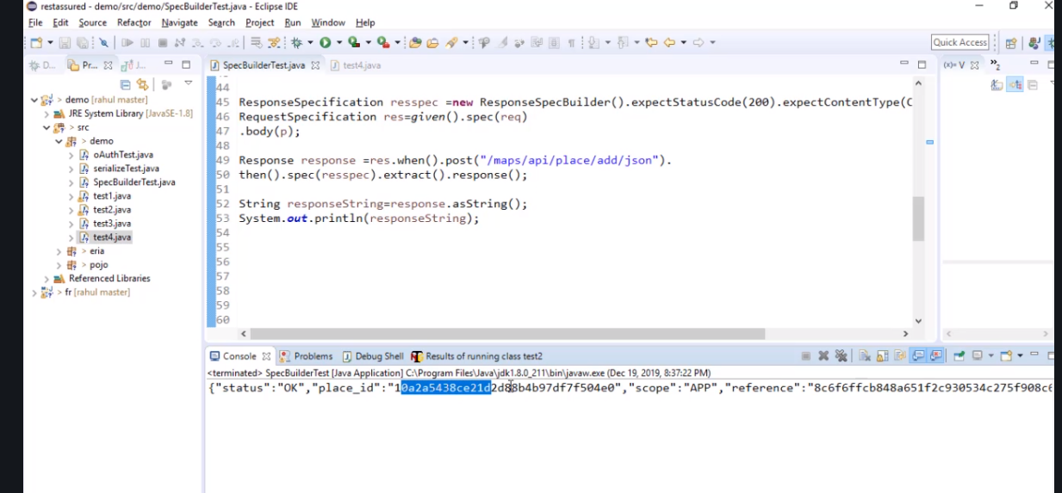

# Now we need to build the framework